  - OMMERCIAL ENTERPRISE

It all began in 1998…..

Since its inception, we have provided our Clients with solutions for systems and infrastructure that employ a mastery of technology with technical program management to achieve successful project implementation. Combining expertise in program management, powerful budget modelling, detailed construction documents, and thorough construction administration, we incorporate technology designs into buildings that help our Clients' operations to succeed.

We still find that a collaborative approach with clients, staff and sub- contractors delivers the projects that exceed client’s expectations’.

Our portfolio includes POWER PLANT; PROCESS EQUIPMENTS; PETROCHEMICAL; AUTOMATION and CALIBRATION SERVICES

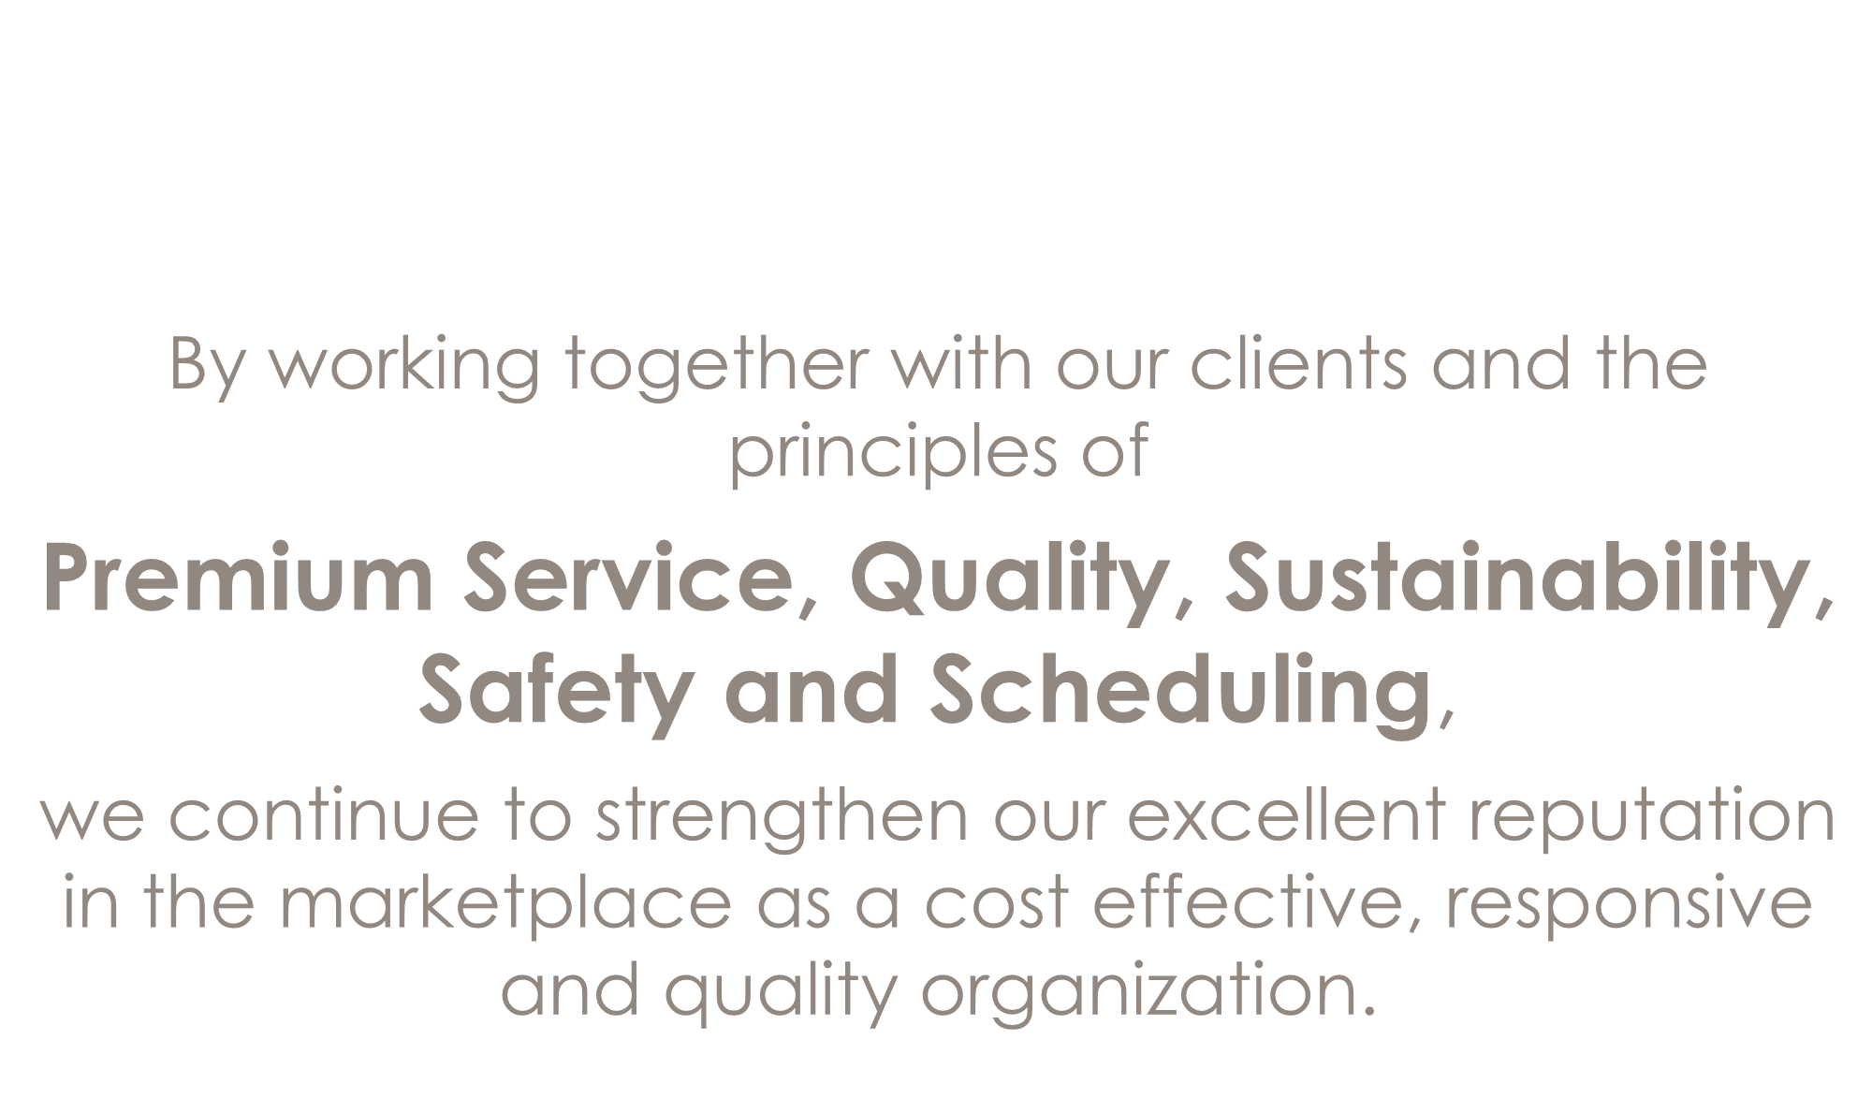

By working together with our clients and the
principles of

Premium Service, Quality, Sustainability,
Safety and Scheduling,

we continue to strengthen our excellent reputation in the marketplace as a cost effective, responsive and quality organization.

Expertise

POWER PLANT
- HFO/Gas Fired Power Plants
- Coal Fired Power Plants
- Combined cycle Power plants (CCPP)

PROCESS EQUIPMENTS
- Metering systems (RMS)
- Process Plants and its ancillary
facilities

PETROCHEMICAL
- Liquefied Petroleum Gas (LPG)
Terminal and filling system.
- Condensate Fractionation plant (CFP)/
NGL.
AUTOMATION
  - Gas fiscal metering
  - Valve
  - Sensor
  - Intrinsic safety solution

CALIBRATION SERVICES (MEASURING TOOLS, VALVES, FLOW METERS).

WELL KNOWN INDUSTRIAL BRANDS...........

!XAllied roup High quality turbine repairs.
PowerG
KSE Electricals Pvt. Ltd.
The World of T&D Hardwares

fER LAM
TECHNOLOGIES
faPEPPERL+FUCHS

THERMAL PROTECTION & INSULATION FOR INDUSTRIAL APPLICATIONS

e
DE JONG EUROPE

HITA.A:!H
h1$pill!' e it Ille Ne-1:
8Didrikson Associates, Inc.
·.'f.'! T rtine, Generator & Drive System Controls

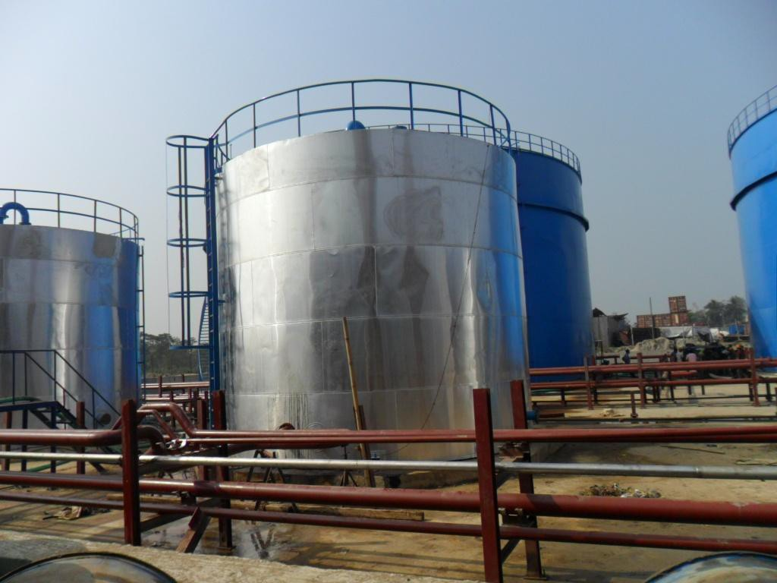Highlights

Acorn Infrastructure Services Ltd (AISL)

Located in Jhuldia, Chittagong, Bangladesh, 110 MWe HFO based power plant by 8 units Caterpillar Model 16CM43 showcases our expertise in Erection and Supply in HFO based Power Plant.

Our Scope Included:
    - Process Piping
    - Supply of Valves, Metering
devices, Expansion Joint

Completion date: 23rd Nov 2011 Work Value: USD 1.2 Million

Completed Tank Farm area

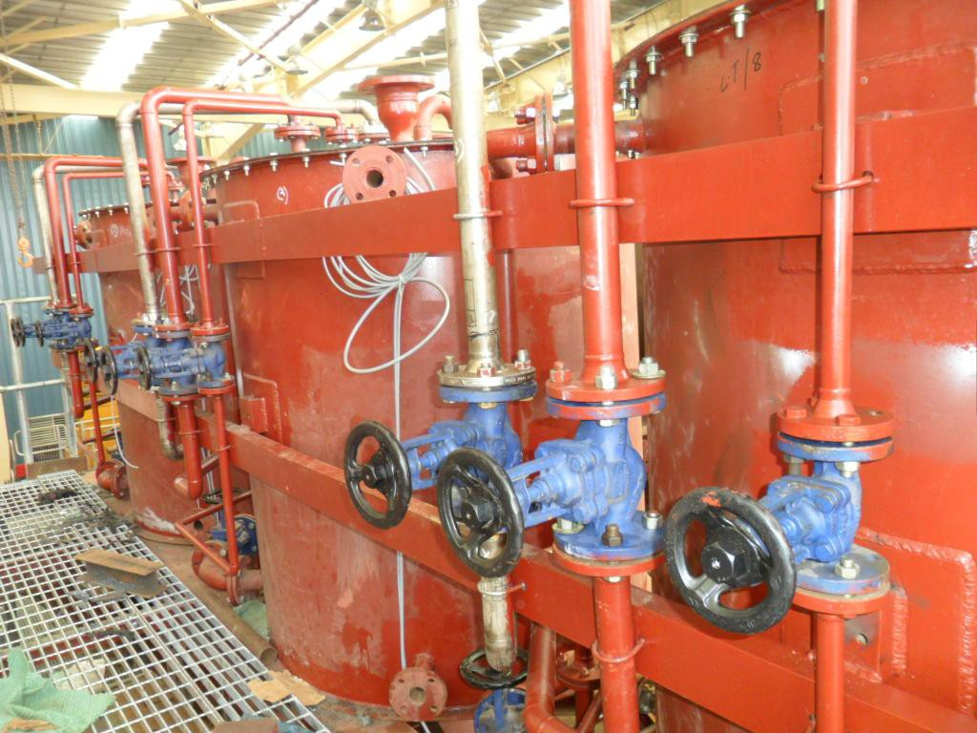
Expansion Tanks

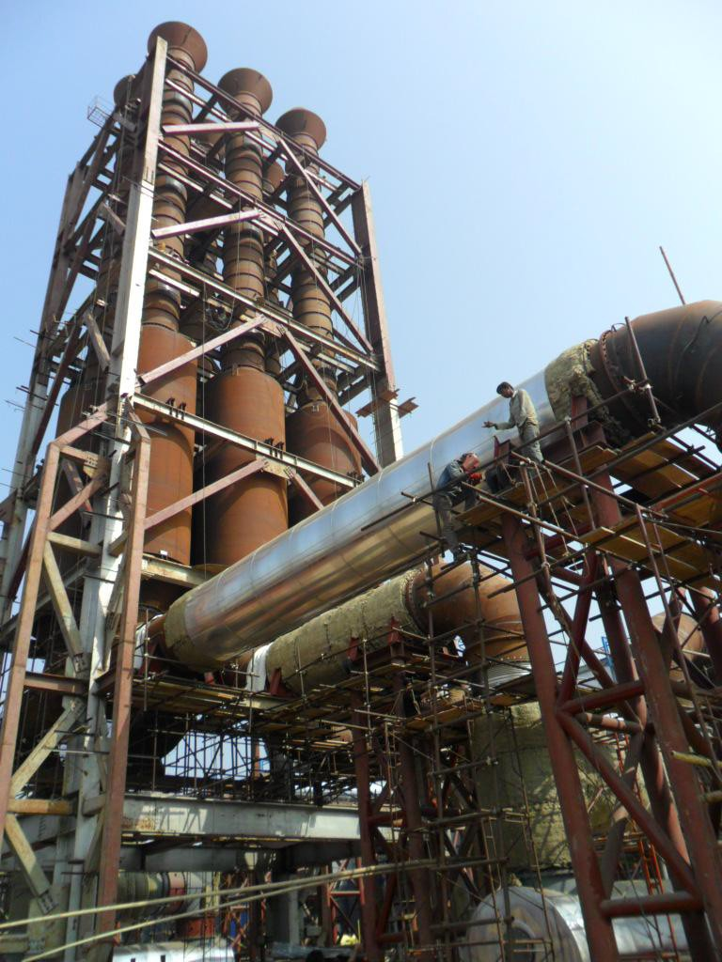
Exhaust Stack of 6 Engines

Highlights

Super Petrochemical (Pvt.) Ltd

Name of Project : Super
Petrochemical (Pvt.) Ltd

Plant Capacity: 3000 Barrels per day (HDS) into Xylene, LPG, Motor Gasooline blend.

Our Scope Included:
- Total Mechanical Erection
of piping and other
mechanical equipment Inside
Battery limit.

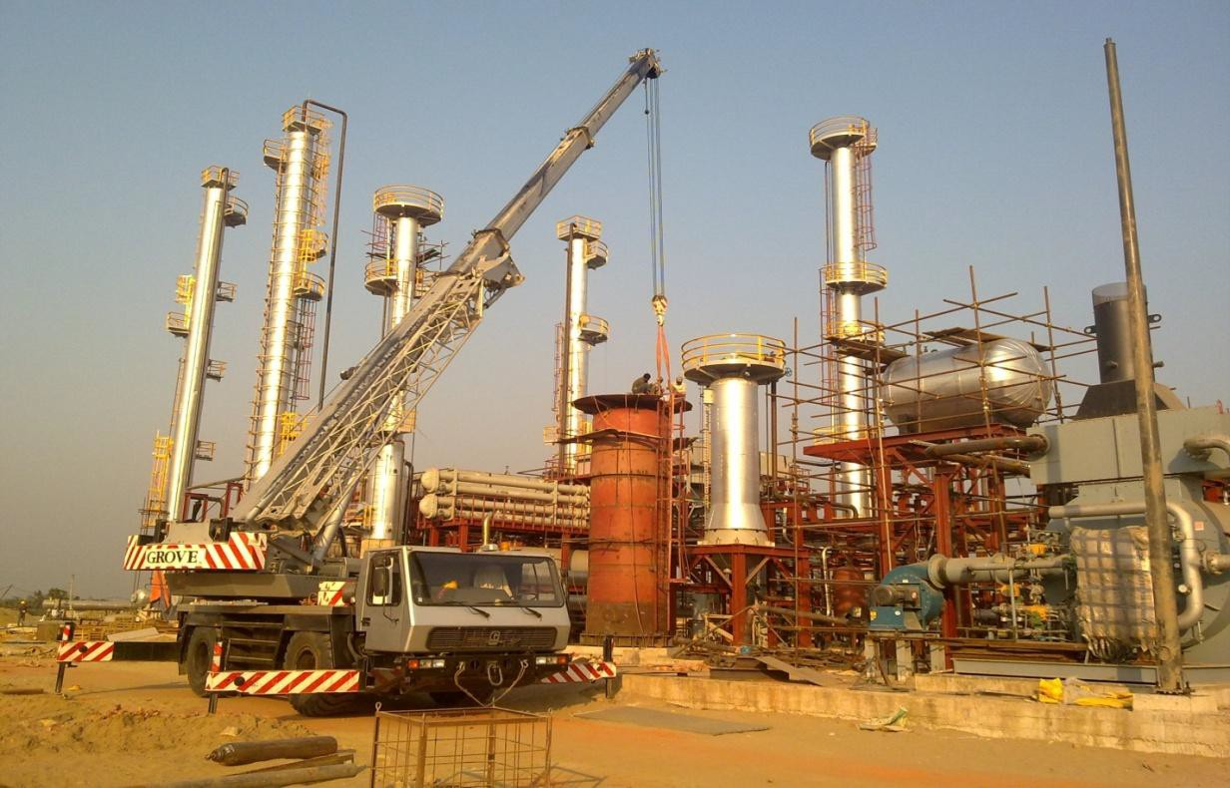Completion date: 20th May, 2012)
Value: BDT 2,50,00,000.

Client: SPL Location: Dangarchar, Chittagong, Bangladesh

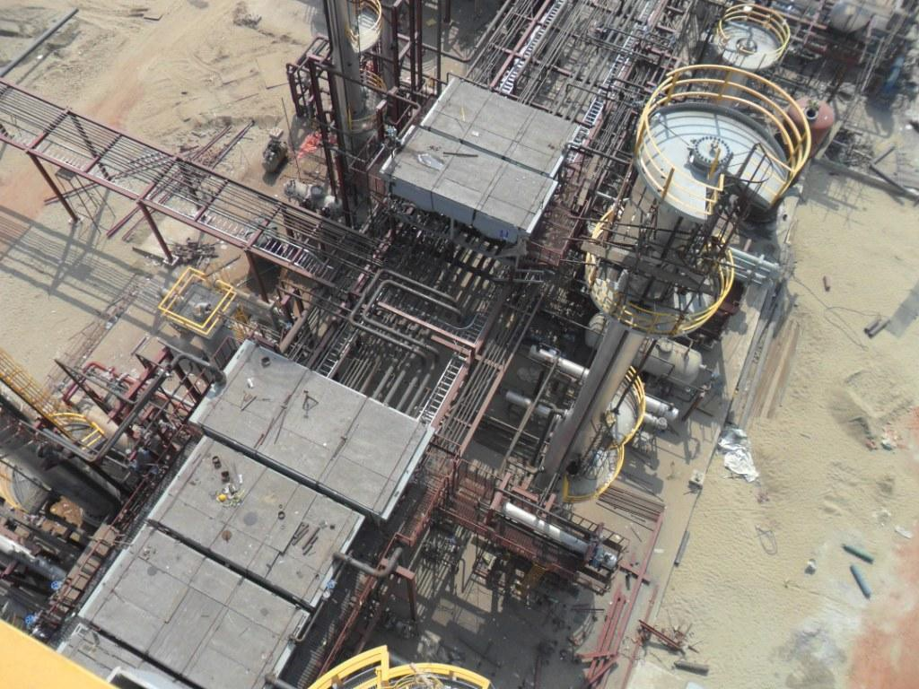Highlights

Super Petrochemical (Pvt.) Ltd

Location: Dangarchar, Chittagong, Bangladesh

Other Projects………

Sikalbaha 60 MW Power plant, Chittagong.

Procuring Entity: BPDB

Our Scope Included:
    - Procurement of Speeder Gear for Turbine
Governor of Sikalbaha 60 MW Power Station.

Completion Value: Euro 1,22,200

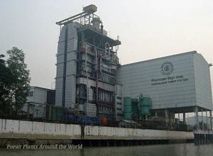

3. Procurement of Spares for Ignition Flame Detection System of Sikalbaha 60 MW Power Station.

Completion Value: USD 33,750
- Procurement of Turbine Supervisory System
of Sikalbaha 60 MW Power Station.

Completion Value: USD 4,33,500

Other Projects………

Tongi 80 MW Power Plant

Name of Power Plant: Tongi 80 MW Power Plant Procuring Entity: BPDB
Our Scope Included:
  - Procurement of Electrical Spares Parts for ( of
GBC, Nitrogen Plant, Air Compressor & PLC) for
Tongi 80 MW Power Station.

Completion Value: USD 40,500

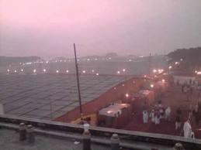

Client: Tongi 80 MW Power Plant,
Gazipur, Bangladesh
  - Air Compressors spares of Tongi 80 MW GTPS

Completion Value: BDT 97,854

Other Projects………

Procuring Entity: DESCO

Our Scope Included:
    - Procurement of Tools & safety Accessories against
ICB No.04/2009,Lot-G (Group-1) of Package-5 under
Client: DESCO
ADB Loan No:2332-BAN:Sustainable Power Sector
Development Project, Part-D:Distribution System
Efficiency Improvements in DESCO area.

Completion Value: USD 2,37,885

    - Transformer Test set and Auxiliary tools

    - 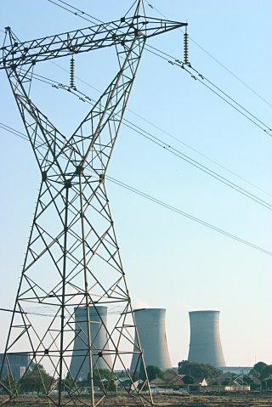Portable Test equipments for Transformers

Completion Value: USD 4,32,000

Completion Value: USD 3,00,000

Other Projects………
BPDB

Bangladesh Power Development Board (BPDB), established in 1972, is the authority for planning, construction and operation of power generation and transmission facilities throughout Bangladesh and for distribution in urban areas except metropolitan city of Dhaka and its adjoining area.
Ashuganj Power Station Company Ltd. (APSCL), Electricity Generation Company of Bangladesh (EGCB), North West Power Generation Company Ltd. (NWPGCL) and West Zone Power Distribution Company Ltd. (WZPDCL) have already started functioning as company under BPDB.

OUR SCOPE INCLUDED:

      - HGPI for Fenchuganj 90 MW PS
Completion Value: USD 5,69,000

      - Hot gas path components for Major overhaul for 80 MW tongi GTPS Completion Value: USD 7,90,000
      - 11 KV Fiber Glass (Ins.) Hot Stick-180 Sets
Completion Value: USD 1,29,300

      - Combustion Parts and Buckets for Barisal GTPS
Completion Value: USD 3,40,500

