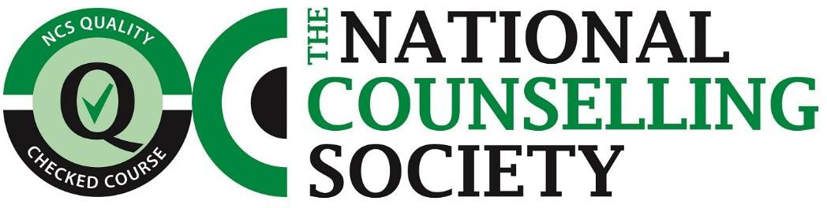

National Counselling Society’s training provider Terms and Conditions.

- The training provider agrees to abide by the Society’s Code of Ethics and Complaints Procedure, details of which are available online or through the Society's office.
- The training provider accepts the provisions of the Society’s Constitution.
- The training provider offering a course(s) Quality Checked by the National Counselling Society is required to use the allocated Quality Checked logo on all of their advertising materials, certificates and on their website. They must do so by following the instructions for use below.
- The training provider is required to turn the logo, when used online, into a hyperlink which links to the Society’s home page.
- The training provider can only use the allocated NCS Quality Checked logo by clearly indicating the course which is Quality Checked by using the words “(course) is Quality Checked by the National Counselling Society.” The training provider cannot use the logo in any way which gives the impression that (a) it is the training provider rather than the course which is Quality Checked or (b) that any other non NCS recognised course is Quality Checked.
- The training provider must only use the logo that is provided by the National Counselling Society and must not alter it in any way, shape or form.
- The training provider must follow any instruction from the National Counselling Society, regarding updates to the logo.
- The National Counselling Society will monitor the logo for proper use and reserve the right to query or withdraw the use of the logo by any training provider.
- If Quality Checked status of the course(s) ceases between the training provider and the National Counselling Society then the logo must be removed from all website and promotional materials within 14 days of expiration of Quality Checked status.
- By using the logo the training provider acknowledges that it is not them that has been Quality Checked by the National Counselling Society, it is the specific course(s) that are Quality Checked.
- The training provider is not permitted to mislead anyone as to what the Quality Checked status means.
- The training provider is not permitted to display the logo before receiving permission by the National Counselling Society to do so.
- We reserve the right to request a removal of the logo from your website, if it has been deemed as being used inappropriately or not in accordance with these terms and conditions.

I hereby acknowledge and agree to abide by the National Counselling Society’s terms and conditions. I also confirm that I am authorised to sign these terms and conditions on behalf of the training provider.

Training Provider Name…Liberty Talking Therapy…………………………………………………………………………………………

Email address (the logo will be sent to this address)…………………………………………………............

Name of Signatory………………………………………………………………………………………………………………….

Signed…………………………………………………………… Date………………………………………………………………

deputyceo@nationalcounsellingsociety.org www.nationalcounsellingsociety.org 19 Grafton Road, Worthing, West Sussex, BN11 1QT

