Key Stage One

Enjoy Reading for Pleasure and Enjoyment
- Did you choose this book? Why?
- What did you like about the text? Why? What did you dislike about the text? Why?
- Would you read the book again? Why? Why not?
- Would you recommend the book to your friend? Why? Why not?
- What will you read next?
- What books do you like to read?
- Do you have a favourite book that you like to read?
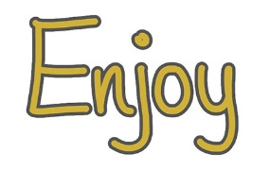
- Is this a new book that you haven’t read before? Do you know anything about it already?
- Do you enjoy reading?
- What do you read at home?
- Who is your favourite author?
- Which books have you enjoyed that we have read together? And why have you enjoyed them?

Decode Word reading and decoding skills
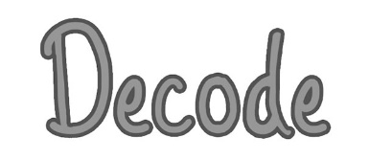
- What do you do if you are stuck on a word?
- Where do you start reading the word? Where do you look first?
- When you blend those sounds together, what word does it say? Can you tell me the word?
- Are there any clues in the word?
- Does it look like any other words you know?
- Can the pictures help you?
- Do you know what the word means or can you work out what it means (in this sentence)?
- What other word could the author have used that means the same sort of thing?
- Does the sentence make sense with that word?

Define 1a: Draw on knowledge of vocabulary to understand texts
- What word in the text tells you…?
- Find and copy (one word/phrase/sentence) that tells you…
- The author uses this word ______What does it mean?
- The writer uses words such as ______to describe _______. What does this tell you about _______?
- The writer uses words such as ______to describe _______. How does it make you feel?
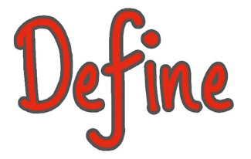
- Find and copy a word that describes how…
- Find and copy a word that means the same as…
- In the story, ______ is used repeatedly. Why?
- Draw a line to match the words to their meanings.
- How has the writer made you and/or ______feel?
- Which words and /or phrases make you think/feel _______?
- (enter quote from the text) What does this tell you about…?
- Which words mean the same as…? (‘words’ meaning ‘group of words’ or ‘phrase’)
- Why is…a good name for…?
- (enter quote from the text) What does this sentence tell you about…?

Retrieve 1b: Identify and explain key aspects of fiction and nonfiction texts, such as characters, events, titles and information
Which…? What…? How…? Where…? When…? Why…? Who…?
- Draw a line to match these characters to events.
- Give one example of ________
- Which character ______?
- Where/when does _______ take place?
- What did _______ look like?
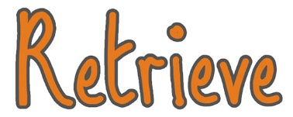
- How did _______ feel? Why?
- Who was ______?
- Where did ________ live?
- Who are the characters in the book?
- Who is the narrator?
- Where in the book would you find __________?
- What happened in the story?
- How does the _______ help me to find information in this book?
- What did…say (enter quote from the text)?
- Which two…did…?
- Think about the whole story…
- Find and copy two…
- One…does something different… What are they doing differently in…?
- Draw four lines to match these…to what the text says…
- What did the…usually…?
- The…did not like… Why not?
- Complete the sentence(s).
- Put ticks in the table to show…

Sequence 1c: Identify and explain the sequence of events in texts
- Number the sentences below to show the order they happened in the _________
- Which of these events happened first?
- What happened after __________?
- What happened before ___________?
- Which of these events happened last?
- Use three sentences to describe the beginning, middle and end of this text?
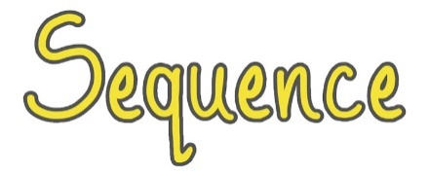
- Sum up the story in ______ words
- Sort these sentences/paragraphs/chapter headings from the story
- Think about the whole story…

Infer 1d: Make inferences from the text
- Why do you think _______?
- How do you know that _______?
- When do you think ________?
- How can you tell that ________?
- True or False
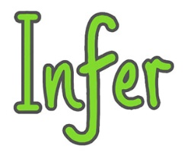
- Why did _________?
- How do you feel about ________?
- Can you explain why _______?
- How does __________ feel?
- The…explains how… (followed by tick boxes)
- Complete the sentence(s).
- ___________, why?

Predict 1e: Predict what might happen on the basis of what has been read so far
- What do you think will happen next?
- What do you think would happen if ______?
- What do you think will happen to _______? Why do you think this?
- Where do you think _______?
- Can you think of another story, which has a similar theme, e.g. good vs evil? Do you think this story will end the same way?
- How is _________ like someone you know? Do you think they will act in the same way?
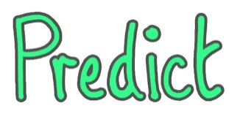

Content Domain | Examples from Recent KS1 SATs
1a – define

1b – retrieve

1c – sequence

1d – infer

1e – predict

Question Type | Examples from Recent KS1 SATs
Tick box

Short response

Extended response

Matching

Sequencing

True or False

Find and Copy
Other

