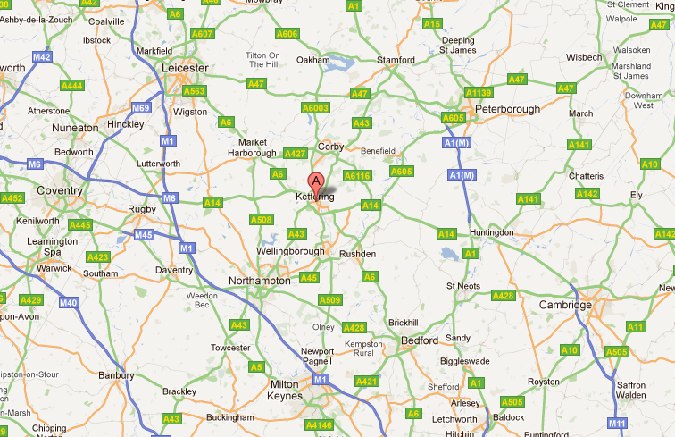

***Cakes / Cupcakes***

***Within 10 miles – Free delivery for orders over £10***

***Within 20 miles – Free delivery for orders over £20***

***Over 20 miles – please call for delivery cost***

***N.B. Delivery radius shown are approximate***