Come Fly with Me
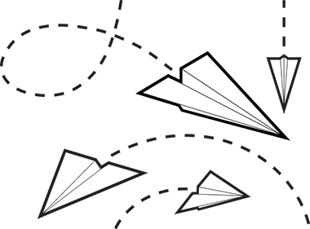

I. Problem:
How does the type/weight of paper affect how far a paper airplane will fly?

II. Background:
The National Science Education Standards (NSES p. 23) defines scientific inquiry as "the diverse ways in which scientists study the natural world and propose explanations based on the evidence derived from their work. Scientific inquiry also refers to the activities through which students develop knowledge and understanding of scientific ideas, as well as an understanding of how scientists study the natural world." The Science as Inquiry Standard in NSES includes the abilities necessary to do scientific inquiry and understanding about scientific inquiry.
Scientific inquiry reflects how scientists come to understand the natural world, and it is at the heart of how students learn. From a very early age, children interact with their environment, ask questions, and seek ways to answer those questions. Understanding science content is significantly enhanced when ideas are anchored to inquiry experiences.

Scientific inquiry is a powerful way of understanding science content. Students learn how to ask questions and use evidence to answer them. In the process of learning the strategies of scientific inquiry, students learn to conduct an investigation and collect evidence from a variety of sources, develop an explanation from the data, and communicate and defend their conclusions.

Not sure how to make a paper airplane? Scan the QR Code for assistance:

III. Hypothesis:
Create a hypothesis predicting which type of paper will fly farthest.

IV. Materials:

Notebook Paper
Computer Paper
Construction Paper
Cardstock Paper
Drawing Paper
Any other kind of paper that might be available

V. Procedures:
- Take one sample of each type of paper available.
- Fold the paper into airplanes. BE CONSISTENT!! Each paper must be folded the same way.
- Launch each airplane three different times. What are some variables that can affect your data?
- Record the distance traveled into your data table.
- Write a detailed, multi-paragraph conclusion with the theme of scientific inquiry.

VI. Data:
Create a data table in your journal that is appropriate to express your data. You will also graph your data collected. What kind of graph would be the most appropriate for the data you collected?

VIII. Conclusion:
Write a detailed, multi-paragraph conclusion with the theme of scientific inquiry. Consider the following things in your conclusion:

  - Use elements from the introduction in the conclusion. Their structure must be similar. If you are having difficulty writing the conclusion, re-read the introduction for ideas about what to write.
  - Include an analysis of the results when writing a conclusion or discussion section of a lab report. Link the results to what you read in the literature, review or other sources mentioned in the introduction.
  - Discuss whether or not the results supported your hypothesis. If they did not, discuss why not.
  - Suggest biases that may have affected the experimental design. Discuss how they can be eliminated in the future. Discuss the possibility of using a different methodology or design.
  - Write about how the experiment can be improved in future replications.
  - Discuss the significance of the experiment, if it resulted in the creation of new knowledge, added support to a recently developed theory or aided in the formulation of new questions to be researched. Consider also that the experiment may have been a complete waste of time.

Come Fly with Me
Data Sheet

Type of Paper | Distance Traveled  #1 | Distance Traveled  #2 | Distance Traveled  #3 | Average Distance Traveled
- Lined Paper

- Computer Paper

- Card Stock

