Late Spring 2018 MaryJoBrown.org

NEWS FLASH!!! Mother Nature is through torturing us (We Hope!) You know what that means?? Time to clean out those closets and drawers—pack up your discards in kitchen size trash bags and join with us in our 3rd annual textile drive.

HERE ARE THE DETAILS:

Once again we are partnering with the Epilepsy Foundation of New England and collecting any and all textiles:

Household items such as bed linens, towels, table linens etc.

Clothing: men, women, children including shoes, boots, handbags

To lighten the work of loading onto the truck, please place in kitchen size trash bags.

You will receive a thank you letter from us as well as a receipt from the Epilepsy Foundation for tax purposes.

DEADLINE: All donations must be in our possession by May 27th.

HOW TO DONATE:

Contact: Christina Brown: christina@maryjobrown.org 781 775 3755
Or
Sharon Macone sharon@maryjobrown.org 781 662 6095

Proceeds will be included in our annual donation to Floating Hospital for Children at Tufts Medical Center in Boston.

Just to catch up:
In February we shipped out three more big boxes of goodies to our favorite Marines aboard the U.S. Theodore Roosevelt. Led by Gunnery Sargent Brian Auten, we were fortunate enough to be able to include art work and handmade Valentines from students in the 5th grade at Horace Mann Silverhill Charter School in Haverhill as well as the kindergarten students of Mrs. Gregoire at the Moody School in Haverhill.

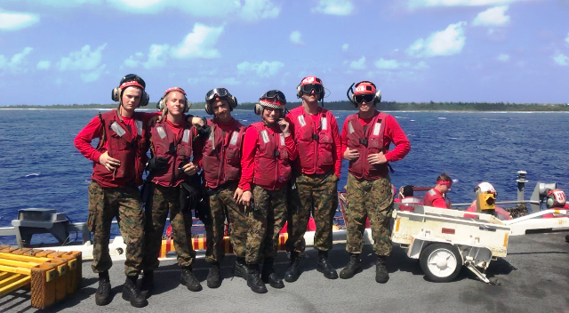

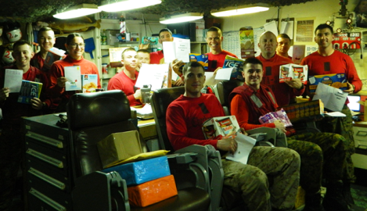

As of this writing, barring any last minute changes, these Marines are heading home in May—we wish them all good things and thank them for their service.

That is all for now—we will be sending out our next newsletter on or before July 4th.

Save the date: Luau #7 will be on Sunday October 14th

May all your dreams come true!

