3/25/2020
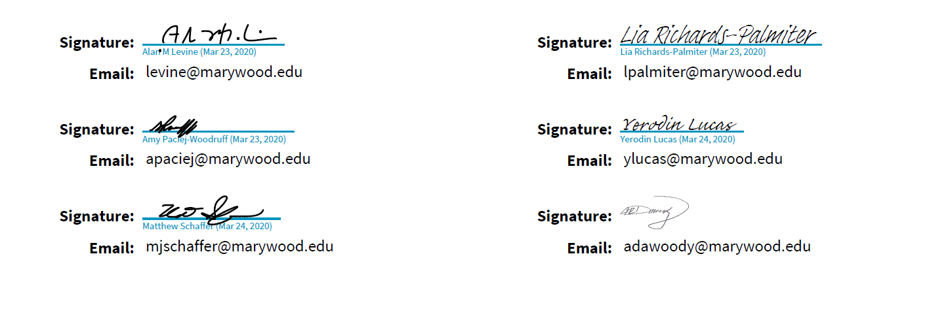

MARYWOOD UNIVERSITY
COLLEGE OF PROFESSIONAL STUDIES

An Examination of Racial/Ethnic Minority Student Engagement in Career Development Activities and Barriers to the Career Development Process While Attending a Predominantly White Institution of Higher Education: A Quantitative Case Study

By

Christina R. Brundage

A Dissertation in Human Development

Submitted in Partial Fulfillment
Of the Requirement for the Degree of

Doctor of Philosophy

May 2020

Acknowledgements

I would like to first extend my gratitude to my family for all of the love and support they have given me throughout this journey. My children, Hailey and Liam, have and will always be my greatest accomplishments but they are also the reason why I have pushed myself so hard to achieve my dreams. There is no limits to what you can accomplish as long as you stay true to yourself and work hard for what you want. I am so proud to be their mother and know that they both have the brightest of futures in front of them.
To my husband, Phillip, who has supported me and been my rock when things got tough and late nights and lack of housekeeping became the norm. You gave me the strength, and the help that I needed to push through those times and scale the walls that often blocked me from finishing. I cannot tell you how grateful I am to be able to share this life with you and see what the world has in store for us next.
To my parents and my aunt who always reminded me how proud they are of me. Especially my mother who during late night conversations would let me know that I am strong and can do anything I set my mind to. I know grandma and grandpa are also by my side in spirit cheering me on and standing proud. I just wish they were here to see this accomplishment in person. I love all of you so much and can’t express how much I appreciate your support and patience.
Dr. Alan Levine, Dr. Lia Richards-Palmiter, and Dr. Amy Paciej-Woodruff. You have all been the most amazing support system and mentors and I could not have asked for a better dissertation committee. Dr. Levine, you were a constant cheerleader, a mentor, a motivator, and you continually challenged me to consider other aspects of my dissertation that overall made me a better researcher. I am forever grateful for your guidance and support. Dr. Richards-Palmiter, you have been a mentor to me for a great deal longer than this portion of my education. You have made me strive to seek out my dreams and find my passion. You are also a true friend and confidant. I am truly thankful to have you in my life and as a key member to help me achieve this degree. Dr. Paciej-Woodruff, I have always admired you and felt honored to have you as a member of my committee. Your mentorship and amazing advice truly made a big impact in achieving this dream and for that I am forever grateful.
I also want to thank my amazing coworkers who have given me the strength and support that I needed to accomplish this great feat. Antonia, Bev, Michelle, Lia, and Meghan, you are the dearest of friends and the best coworkers a girl could ask for! Being able to work on a daily basis with such strong, intelligent, compassionate, and downright amazing women is an honor and I know I am a better person because you are all in my life.
Finally, to my cohort of amazing doctoral students who have trudge along with me throughout the years, especially Meg, Brooke, Sr. Kevin, and Kim. You are such amazing women and I am honored to have gone on this journey with you. You all have made this experience one I will never forget. Not only have you been great friends and supporters but you have also shared your lives and experiences with me that I will forever embrace now as a part of the person I have become. From the late night texts to the panic we faced during this crazy pandemic, I am so thankful to have you all in my lives!

Table of Contents
Chapter 1 Introduction 1
Theoretical Framework 4
Social Cognitive Career Theory 4
Super’s Theory of Career Development 6
Conceptual Framework 8
Purpose of the Study 10
Research Question 11
Subproblems 11
Hypothesis 12
Definition of Terminology 12
Delimitations 15
Limitations 16
Assumptions 16
Significance 17
Chapter 2 Review of Literature 19
Introduction 19
Barriers 22
Social Barriers 23
Financial Barriers 24
Cultural Barriers 25
Systemic Barriers 26
Effects to the Career Development Process 27
Psychological Implications 27
Imposter Phenomenon 28
Conclusion 29
Chapter 3 Methodology 31
Research Design 31
Participants 31
Instrument 32
Procedure 35
Data Analysis 36
Supplemental Analyses 37
Chapter 4 Results 39
Introduction 39
Response Rate 39
Demographic Information 40
Subproblems 41
Research Question 44
Reliability 45
Supplemental Analyses 46
Results Summary 52
Chapter 5 Discussion 53
Introduction 53
Discussion 54
Study Limitations 56
Recommendations for Future Research 57
Conclusion 58
References 62
Appendices 65
Appendix A ERC Application 66
Appendix B ERC Approval Letter 79
Appendix C 2012 CSS Survey 81
Appendix D 2013 CSS Survey 86
Appendix E 2014 CSS Survey 91
Appendix F 2015 CSS Survey 108
Appendix G 2016 CSS Survey 113
Appendix H 2012 CSS Codebook 119
Appendix I 2013 CSS Codebook 131
Appendix J 2014 CSS Codebook 141
Appendix K 2015 CSS Codebook 154
Appendix L 2016 CSS Codebook 163
Appendix M Permission for Data Access Letter 172
Appendix N Transformation of Variables and Score Instruments 173
Appendix O Engagement Questions 175
Appendix P Approval of Instrument Letter 176
Appendix Q Barrier Questions 177
Appendix R Frequency Distribution for Engagement Scores 178
Appendix S Frequency Distribution for Barrier Scores 180

List of Tables
Table 1 Demographic of Participant Population 40
Table 2 Descriptive Statistics for Engagement and Barrier Score Population 42
Table 3 Independent-Samples T Test for Engagement and Barriers 44
Table 4 Effect of Race on Engagement and Barrier Scores 45
Table 5 Cronbach Alpha Reliability of Race on Engagement and Barrier Scores 45
Table 6 Responses to Engagement Experiences 48
Table 7 Responses to Barrier Experiences 50

List of Figures
Figure 1 Social Cognitive Career Theory (SCCT) 6
Figure 2 Super’s Theory of Career Development 8
Figure 3 Researcher’s Integrated Conceptual Framework Model 10

Abstract
Engagement in career development activities and barriers to the career development process were examined in racial/ethnic minority (R/EM) undergraduate students who attended a Mid-Atlantic, faith based, primarily White institution of higher education (PWI). A secondary analysis was conducted using the Higher Education Research Institute’s (HERI) College Senior Survey (CSS) for years 2012 through 2016 for the identified PWI. Constructs were created from the CSS variables to form an engagement score and a barriers score in order to determine differences in R/EM career development experiences. Independent-sample t tests, a one-way multivariate analysis of variance (MANOVA), and descriptive statistics were completed to answer the research question and subproblems. Additional supplemental analyses were conducted through independent-sample t tests and a two-way multivariate analysis of variance (MANOVA). A significant difference was found when comparing White/Caucasian students and R/EM students. R/EM students had lower engagement scores when faced with higher levels of barriers. Additional supplemental analysis showed that although weak, there is a significant relationship to race and the engagement and barriers scores of students and when students experience more barriers the amount of engagement decreases.
Understanding the experiences and obstacles that this population faces while attending PWIs can help ensure that future R/EM students receive the necessary support they need in the career development process so that they can achieve higher levels of self-efficacy, develop career readiness skills, and set and attain the career goals. The results of this study may offer insight into the experiences and barriers that this population faces so that institutions such as PWIs can provide improved programming and services that meet their individual cultural needs.

Chapter 1
Introduction
There are many factors that college students face in the career development process but racial/ethnic minority (R/EM) students tend to encounter issues or barriers that often intervene in the development process and hinder their willingness or interest in engaging in activities that promote their career development. These issues, which are often influenced by the social, economic, and political climates, are aspects of the R/EM student career development experience which can be very different from what their majority, White, peers encounter at primarily White institutions (PWIs) of higher education (Nelson Laird, Bridges, Morelon-Quainoo, Williams, & Salinas Holmes, 2007; Durodoye & Bodley, 1997). PWIs have generally lacked the resources needed to support R/EM students because of a deficiency in knowledge and understanding of the obstacles and barriers that this population faces during their lifetime. These institutions typically develop their services, programming, and resources around the majority population and fail to consider the needs of the minority students which lends to reduced acclimation to the campus, lower R/EM retention rates, and disengagement with various activities that support the career development process. Studies have found that minority students, such as African Americans, tend to be more engaged and willing to participate in their collegiate experience when attending schools serving primarily minority student populations such as historically Black colleges and universities (HBCUs) (Nelson Laird et al., 2007). This factor alone would suggest that PWIs, who seek diverse student enrollment, need to address the deficiency in organizational practices in supporting this population by increasing their understanding regarding the R/EM student experience and what the organization can do to help improve R/EM engagement in activities that aid in achievement of key skills and competencies in relation to student career development.
Understanding the experiences and obstacles that undergraduate minorities’ go through while attending PWIs of higher education is vital to ensuring students develop skillsets and career competencies that promote career readiness, self-efficacy and attainment of career goals (Dickinson, Abrams, & Tokar, 2017). R/EM student needs have often been overlooked during the design, implementation, and use of college level supportive services and programming which was based on the needs for assisting the majority population at PWIs. It is also important to have a greater understanding of the obstacles and barriers that inhibit students from engaging in beneficial career activities and how these barriers shape the career decisions and goal attainment. These barriers can have a negative effect that impedes students’ willingness to engage in vital career development activities and reduces self-efficacy levels that help them believe they have the abilities to attain their own career goals (Lent, Brown, & Hackett, 2000).
With a greater knowledge of student engagement in career development activities and understanding for the barriers they face during the career development process, PWI colleges and universities can provide improved programming and increase support of undergraduate, racial/ethnic minority (R/EM) students which will help improve outcomes and further encourage this population of students to engage in activities as often as their White peers. PWIs can create and modify their programming, supportive practices, and develop additional resources that encourage R/EMs to participate in experiences that shepherd their career development process and build upon career skills that promote career readiness, self-efficacy and the attainment of career goals (Dickinson, Abrams, & Tokar, 2017).
There is also a deficiency of research in the area of racial differences in R/EM student career development versus their majority peers, including perceptions of career readiness, self-efficacy, and attainment of career goals. Studies that have been conducted focusing on the aspect of race in career development have found a direct correlation that supports the relation of self-efficacy and outcome expectations (Scheuermann, Tokar, & Hall, 2014; Dickinson, Abrams, & Tokar, 2017). With limited information on R/EM student engagement in activities promoting career development and the overall effect on outcomes of student career programming for the minority populations at PWI colleges and universities, it is imperative to explore what R/EM students are participating in with regard to activities that lend to the improvement and the attainment of important competencies that prepare them for the transition into life after college.
Foundational theorist for career development focused on the majority, Caucasian population for their studies resulting in a lack of research in the area of racial differences in student career readiness, self-efficacy, and attainment of career goals. With little information on the overall outcomes of racial/ethnic minority (R/EM) student career programming and participation in career focused professional, it is important to understand how R/EM students engage in career related activities through which they garner professional development skills, improve their self-efficacy, and feel more inclined to set higher career goals. Because these facets of career development lend to the successful achievement of transition into the professional phase of their lives, it is necessary to have a better grasp on what R/EM students are currently participating in to better understand what we can do as supportive higher education professionals in order to help them become more engaged in this vital activities and have a more positive experience where they can achieve successful career development.
This research study is relevant to higher education institutions, primarily those serving underrepresented populations of students. The proposed study utilizes data collected through the College Senior Survey conducted by the Higher Education Research Institute & Cooperative Institutional Research Program (HERI).
Theoretical Framework
Two theories guide this research: Lent, Brown, and Hackett’s Social Cognitive Career Theory based on Bandura’s foundational Social Cognitive Theory and Super’s Self-Concept Theory of Career Development.
Social Cognitive Career Theory
Social Cognitive Career Theory (SCCT) has been utilized in the investigation of career development for decades. In order to critically evaluate the research conducted in this study, it is imperative that the supporting research include utilization of SCCT, provide additional value to the understanding of minority career development, and enhance the understanding of supporting services for undergraduate minority students that contribute to their college to career transition (Mejia-Smith & Gushue, 2017).
A review of recent literature the use of SCCT to understand the student perception of career development, self-efficacy, and career goals. The social cognitive aspect of SCCT incorporates an individual’s self-efficacy, career outcomes and goals (Tatum, 2018). While fewer studies focused on the minority students in PWIs, key studies focused on the aspect of race and gender in relation to achieving career objectives. With higher educational organizations becoming increasingly diverse and student outcomes becoming a major incentive for student enrollment, it is imperative to evaluate the career development of not only minority students on campus but to also compare the reported student perceptions of their majority peers in order to address the holistic and developmental needs for equally supporting both the minority and majority career potential.
Examining social cognitive variables of career development with minority undergraduate students can help solidify career interests and improve career decision making skills (Hui & Lent, 2017). SCCT can be utilized as a guided pathway for the understanding the career development of students based on their racial background, gender, socioeconomic status (SES), societal influences on self-efficacy, and overall career goals or outcomes which aid in shaping the behavior of the individual (Hui, Lent, 2017; Mejia-Smith & Gushue, 2017). By understanding the cultural differences and utilizing SCCT to evaluate students career development, perceived career readiness, self-efficacy, and determination to achieve career goals, PWIs can make appropriate modification of programming to address the different needs that minority students have in order to achieve a successful college to career transition.
Another social construct where programming aimed at improving minority student career development is critical consciousness where students within an ethnic minority learn to critically analyze specific social conditions that oppress their advancement towards their career goals (Cadenas, Bernstein, & Tracey, 2018). Minorities that have been the emphasis of recent research include African Americans, Asian Americans, Latina/os, first generation students, and gender with a focus on females. Because of these complexities involving the demographics labeling these students within the category of minorities, it is imperative that we understand the population in order to prepare higher level programming that will enable this population to achieve these career aspirations. There are significant implications within the research that support the need for further studies focusing on understanding minority career development within higher education. With a lack of career theory that can serve as a foundation for the necessary programming for this population of students, further research is needed to understand the cognitive personal variables and variables that help in measuring student self-efficacy and outcome expectations (Raque-Bogdan & Lucas, 2016).

Figure 1
Social Cognitive Career Theory (SCCT)
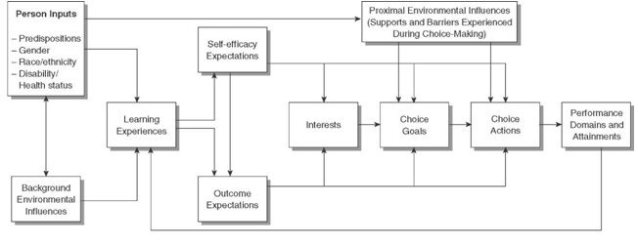
Note. Simplified diagram of Lent, Brown, and Hackett’s (2000) career development model derived from a modified version of Bandura’s Social Cognitive Theory.

Super’s Theory of Career Development
Donald Super’s career development theory focuses on the way an individual constructs and negotiates their career as they encounter different experiences and learn how to deal with various situations, learn from their experiences, and develop coping skills in order to successfully attain their careers (Savickas, 1997). His Self-Concept Theory of Career Development recognizes the transitions and changes that individuals go through as they mature and it encompasses a life-span approach on how occupational decisions are made along with how a person adapts to certain experiences. Super’s theoretical framework, although primarily based on Westernized American, White (Caucasian) populations, focused of self-concept and has been found relevant to Black, South Africans due to the theories abilities to emphasize interrelationships within ones various life-roles (Stead & Watson, 1998).
In addition to the theoretical connection to race, within Super’s life-span development is a critical stage for college age students. The stage of exploration, during years fifteen through twenty-four, are important for student vocational development where they need to successfully manage key tasks that help them understand their interests, skills, values, and career goals (Super, 1990). The Life-Rainbow, or archway of career development, shows how complex experiences, intrapersonal, and environmental influences act as determinants when forming ones career (Super, Savickas, & Super, 1996). This also involves physical, mental, and environmental factors, during the exploration years of development which help shape and implement student self-concept.
Super’s life-space segment of the Life-Career Rainbow has also been utilized as a valuable tool in the career counseling process to help students identify their current and ideal roles and then identify barriers or challenges that they would have reaching their career goals (Okocha, 2001). Although the primary focus for undergraduate students would be within the exploratory phase, not everyone progresses through the various stages at the same time or at specific fixed ages but instead, Super focused on readiness to make career decisions, by completing stage-appropriate career tasks (Super, Savickas, & Super, 1996).

Figure 2
Super’s Theory of Career Development
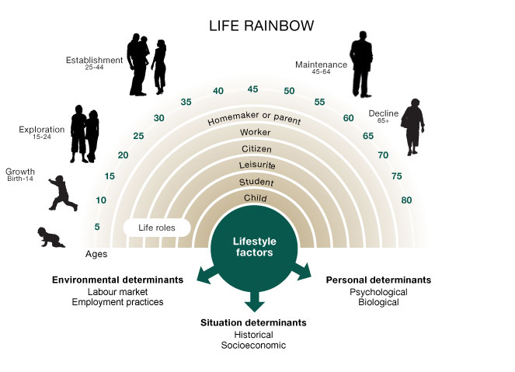
Note. Donald Super’s Life-Career Rainbow diagram showing various age related milestones in the career development process (Super, Savickas, & Super, 1996).

Conceptual Framework
Super’s Theory of Career Development along with Social Cognitive Career Theory can be utilized as a guiding path for conceptualizing the career development process of R/EM undergraduate students based on their engagement in activities that provide them with valuable experiences along with outlining the effects of carrier barriers that can often prolong the developmental process. By understanding the cultural differences and barriers that R/EM undergraduate students face, Super’s career theory and SCCT can be utilized to evaluate the students’ career development journey which encourages or impedes the students’ achievement of career readiness, self-efficacy, and determination to achieve career goals. Evaluating the engagement of student participation in career development activities can help recognize whether or not there is a need for modification of programming to address the obstacles that minority students face in their willingness or ability to participate in activities that can enhance their potential to achieve a successful college to career transition.
In Figure 3, the combination of Super’s career theory along with SCCT shows a potential journey in the career development process through which R/EM students may travel along. Many R/EM students face obstacles or barriers in the career development process and when this occurs, some may be prevented from or make the decision not to participate in career development activities that promote self-efficacy, career readiness, and the attainment of career goals. Those that engage in career development activities even after facing barriers are able to attain these key areas that support their growth and help the students reach their career goals often before those that avoided or were prevented from participating in these activities. This is not saying that students that do not participate in activities that support their career development will never reach the same level of attainment that those who did participate, it merely suggests that it may take them longer and still require some level of engagement in activities to reach those milestones that support their attainment of goals.
When students face career uncertainty after facing a barrier and choose to avoid career development activities they will find difficulty successfully attaining their career goals. This does not mean it is the end of the road for that individual. While this may result in taking a part-time job that is not related to their professional education, for example, it allows the individual to participate in an experience that provides skill building, exposure to other occupations, has the potential to build self-efficacy, and can lead to setting of career goals. For those students, it is a cyclical process.
Figure 3
Researcher’s Integrated Conceptual Framework Model
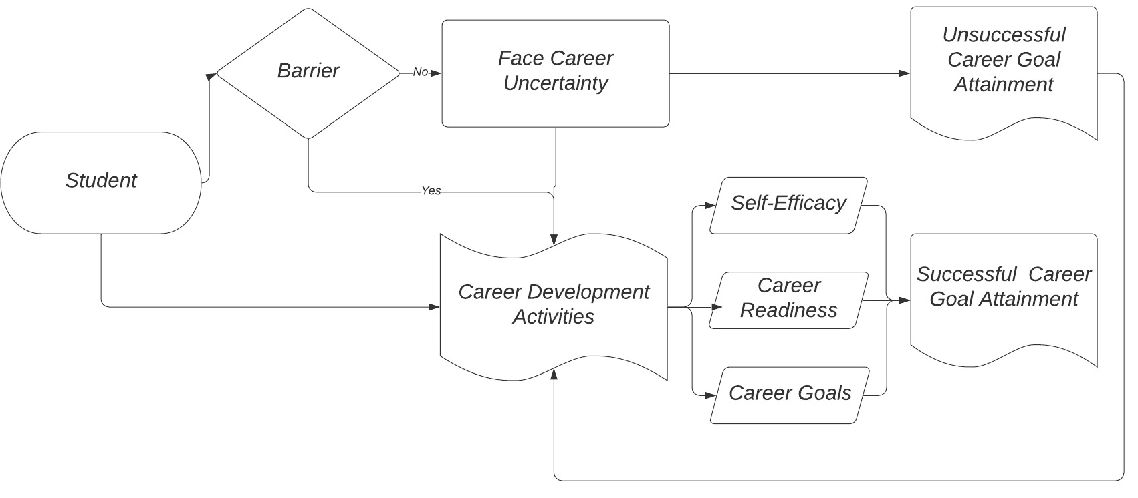
Note. The researcher’s conceptual framework model for student career development when faced with barriers. An integration of SCCT and Super’s Theory of Career Development.

Purpose of the Study
The purpose of this comparative research case study is to examine the differences between racial/ethnic minority (R/EM) undergraduate students and their White, majority peers’ engagement in career development activities and barriers they experience in the career development process while attending a primarily White institutions of higher education (PWIs). The independent variable, RACE, is defined as either White (Caucasian) or Racial/Ethnic Minority (R/EM) and will be used along with the dependent variables, ENGAGEMENT SCORE and BARRIERS SCORE in order to determine if there are any significant differences between the two groups. If a significant difference is found, PWIs can then explore the potential reasons for the disparity and take action towards rectifying the inequalities on their campuses so that all students have ample opportunities to participate in vital activities that lend to their career development and overall achievement of their goals. Additionally, PWIs can implement necessary steps to reduce the number of barriers that their students face while enrolled at their schools.
Research Question
What are the differences between racial/ethnic minority (R/EM) undergraduate students and their White, majority peers’ engagement in career development activities and barriers experienced in the career development process while attending a primarily White institution of higher education?
Subproblem One
What is the engagement score in career development activities for R/EM undergraduate students attending a primarily White institution of higher education?
Subproblem Two
What is the engagement score in career development activities for White, majority undergraduate students attending a primarily White institution of higher education?
Subproblem Three
What is the barriers score for R/EM undergraduate students attending a primarily White institution of higher education?
Subproblem Four
What is the barriers score for White, majority undergraduate students attending a primarily White institution of higher education?
Subproblem Five
What is the difference in engagement scores in career development activities between R/EM undergraduate students and their White, majority peers?
Subproblem Six
What is the difference in the barriers scores of R/EM undergraduate students and their White, majority peers?
Hypothesis
H_{o}. There are no differences in engagement scores or barriers scores between R/EM undergraduate students and their White, majority peers while attending a primarily White institution of higher education.
H_{a}. There are differences in engagement scores or barriers scores between R/EM undergraduate students and their White, majority peers while attending a primarily White institution of higher.
Definition of Terminology
Racial/Ethnic Minority (R/EM)
The term minority refers to a population or group that is distinct because of their culture, ethnicity, or race but coexists as a subordinate with a more dominant group (“Minority”, n.d.). The minority populations at PWIs are the smaller ethnic student percentages that make up the remaining population that Caucasian or White students do not account for. Minorities that have been the emphasis of recent research include African Americans, Asian Americans, Latina/os, first generation students, and gender with a focus on females. For the purpose of this research study, first generation students will not be included in the category of R/EMs. This study will consist of R/EM students who have identified themselves as African American/Black, American Indian/Alaska Native, East Asian, Filipina/o/x, Southeast Asian, South Asian, Other Asian, Native Hawaiian/Pacific Islander, Mexican American/Chicana/o/x, Puerto Rican, South American, Other Latina/o/x, and Other.
White, Majority Peers
White, or as it is often referred to as Caucasian, is a racial identification that classifies a group of people typically with European decent, who often have light skin pigmentation (“Caucasian”, n.d.). With approximately 60.4% of the U.S. population estimated in 2018 to fall within the racial classification of White (White alone, not Hispanic or Latino), this population serves as a majority, defined as being more than half of the total number or amount, of the population and for the purposes of this research study, will reflect on the larger percentage of White population of undergraduate students enrolled at a college or university (“U.S. Census”, n.d.; “Majority”, n.d.).
Engagement in Career Development Activities
This is the active participation in activities that impact and support the career development process. Hirschi, Freund, and Herrmann (2014) define further constructs of activities that are categorical career behaviors which include career planning, exploration, networking, and feedback-seeking for example. Career development is defined as a lifelong process of experiences that support an individual’s development in seeking, processing, and obtaining information regarding one’s self, their educational and occupational opportunities, lifestyles, and role models (Hansen, 1976). In this study, student engagement in career development activities will be evaluated by specific activities addressed in HERI’s College Senior Survey of 2019. Some of these activities include experiential learning activities, such as internships and study abroad, as well as participation in a mentorship, other employment, clubs, organizations, and volunteer experiences for example. In this study, engagement will be measured by calculating the cumulative score of the number of activities (maximum of twenty) that the student indicated they engaged in while attending a primarily White institution of higher education. The engagement score will range from 0 (No Engagement) to 20 (High Level of Engagement)
Barriers
Barriers that students may face in their career development process can be defined as events or conditions that can be found within the individual or in the individual’s environment that have the potential to make the career development process difficult (Swanson & Woitke, 1997). Lent, Brown, and Hackett (2000) noted that barriers often have a negative impact that impede a person’s ability or willingness to set career goals and participate in activities that put forth an effort towards attaining those goals. In this study, barriers will be measured by calculating the cumulative score of the number of barriers (maximum of twenty) that the student indicated they experienced while attending a primarily White institution of higher education. The barrier score will range from 0 (No Barriers) to 20 (High Level of Barriers).
Predominantly White Institutions of Higher Education
Brown II and Dancy II (2010) define predominantly white institutions as means of classification to describe higher educational organizations where Whites account for 51% or more of the student population. In this study, data will be received from a Mid-Atlantic regional PWI that has participated in the College Senior Survey for a minimum of five consecutive years and have been deemed primarily White institutions of higher education because of their ration of 51% or higher of White (Caucasian) students enrolled at their institutions.

Delimitations
Although this is a national survey, the researcher will only be using the data from students attending one Mid-Atlantic region, primarily White institutions of higher education which does not reflect the entire undergraduate student population. The PWI was identified through HERI’s public database of schools participating in the survey. Based on the PWI’s consistent yearly participation in the College Senior Survey (CSS), the available data from 2012, 2013, 2014, 2015, and 2016 will be requested for a secondary analysis case study. The researcher will only utilize the data from these years due to the Higher Education Research Institute’s (HERI) regulation for embargoing data within the past three years.
Additionally, the researcher will limit the population size of the CSS by using only the data from students who have attended the reporting PWI college or university for a term of three or more years and are within the defined exploratory age of fifteen through twenty-four. Of the selected population, the researcher will specifically request and utilize variable information that lends to the evidence of engagement in career development activities. The small sampling of variables taken from the entirety of the survey will be used as representation of the type of activity that lends towards career development along with selected variables that represent barriers that the students my encounter due to their race.
Finally, while the IPEDS’s data indicated that the population for the 2018 year represented a 73% White/Caucasian population and 27% R/EM population, this study had an overwhelming response from White/Caucasian participants at 93.1% and only 6.9% of the participants identifying as R/EM students. Because this study was conducted over a five year period, the ratios may have slightly changed, but with a lack of responses from the minority population that had the opportunity to participate, the scores are not reflective of the experiences that those students had.
Assumptions
The assumptions for this study include: the students that responded to the study answered honestly; the data that was received from the Mid-Atlantic PWI of higher education was accurate and as requested by the researcher; the sample of data is representative of the racial/ethnic minority population of undergraduate students at the primarily White institutions of higher education; and although the purpose of the College Senior Survey was not to examine the differences in racial/ethnic minority undergraduate student and White undergraduate student engagement in activities that support their career development and the racial barriers, there is sufficient variables that serve as examples of activities that reflect student participation and barriers to determine if there is such a difference.
Significance
Undergraduate minority students attending primarily White institutions (PWI) of higher education have often experienced social inequity in the career development process that is a vital to a successful college to career transition (Mejia-Smith & Gushue, 2017). This population of students can greatly benefit from a more supportive educational climate where they are encouraged to reach their career goals and participate in programming which includes activities such as workshops, in class projects and assignments, internships, and a culminating capstone experience that focuses on showing the students’ development of communication, leadership, teamwork, problem solving and critical thinking, and professionalism and work ethic competencies (“Are College Graduates Career Ready?”, 2018). Understanding the differences in students’ cultural background in order to develop effective programming and strategies to improve student career development is imperative when analyzing and interpreting the data from this type of research (Byars-Winston & Rogers, 2018).
Student participation in activities that support their career development at PWI of higher education will allow R/EMs exposure to various social situations and allow students to learn how to critically analyze specific social conditions that oppress their advancement towards their career goals (Cadenas, Bernstein, & Tracey, 2018). Improving minority students’ outlook of expectations focused on career outcomes will help them achieve their career aspirations by building self-confidence and allowing them to set higher standards of goals for themselves (Raque-Bogdan & Lucas, 2016). Because of these complexities involving the demographics by labeling these students within the category of racial/ethnic minorities, it is imperative to understand this population in order to prepare higher level programming and create a supportive campus climate that will encourage them to achieve these career aspirations.
This study can provide significant findings within career focused research that helps PWIs understand racial/ethnic minority engagement in career development activities within higher education and can lend to the building of better relationships and an environment that meets the academic, social, and occupational needs this population of students has for transitioning from college to career. With a lack of career theory that can serve as a foundation for the necessary programming for racial/ethnic minority students, further research is needed to understand the level of student engagement in activities that support career development of R/EMs. Recent research on undergraduate racial/ethnic minorities has clearly suggested that there is a distinction in R/EM student and White student perceptions of career readiness, self-efficacy, and career goals, which influence student success in occupation achievement upon graduation.
A study conducted by Bounds (2017) supported the notion that the career decision process of ethnic minorities is significantly affected by student ethnic identity, self-concept, and self-efficacy. This is a clear indication that this population of students have different needs compared to their White, majority peers. Additional or improved programming that is designed to fulfill these needs will lend to greater levels of self-efficacy and confidence in attaining their career goals. Utilizing the data collected from this study can assist PWIs with recognizing whether or not there is a need for change at PWIs of higher education in order to meet the racial/ethnic minority student’s career needs.
The data collected from this study can provide a better understanding of whether or not there is discourse in the engagement levels and lead to better practices and services that can further enhance programming offered to this population of students in order to improve their overall career outcomes at PWIs.

Chapter 2
Review of Literature
Introduction
1954 became a pivotal moment for not only K-12 educational organizations but also for higher education when the Supreme Court ruling of Brown v. Board of Education shattered racial barriers by desegregating the American public education system (Strayhorn & Johnson, 2014). With this major milestone in racial equality, K-12 organizations began making the transition to integrating their schools while higher education organizations took a much longer approach to adapting to the concept of a new, non-segregated educational system. Although racial/ethnic minority (R/EM) students were no longer mandated to attend separate post-secondary colleges and universities, they still continued to find themselves facing inequalities in receiving supportive services, experiencing racial disparities and discrimination, and lacking the same achievement levels as their majority peers within the higher education organizations, especially organizations classified as primarily White institutions (PWIs) of higher education (Roksa et al., 2017).
One such area where studies have shown evidence of such inequalities is in the career development of R/EM college students. In general, there are many factors that college students face in the career development process but R/EMs tend to encounter additional issues or barriers that can intervene in the process. These issues or barriers, which are frequently influenced by societal, financial, cultural, environmental, and organizational factors, are aspects of the R/EM students’ career development experience which often times is very different from what their White, majority peers’ experience (Durodoye & Bodley, 1997; Luke, Diambra, & Gibbons, 2014; Nelson Laird, Bridges, Morelon-Quainoo, Williams, & Salinas Holmes, 2007; Storlie, Mostade, & Duenyas, 2016).
Today, as postsecondary schools seek to further diversify their campuses, colleges and universities are looking for ways to support the needs of their minority population of students with services and provide an inclusive environment where they can achieve their educational dreams and successfully transition into the workforce. Unfortunately, many higher education institutions lack the resources and appropriate support for racial/ethnic minority student career development. Such is the case for many colleges and universities classified as primarily White institutions of higher education which makes it important to study the career development experience of not only R/EM students but to also evaluate the barriers or issues that may prevent R/EMs from engaging in career development activities which support their overall development and attainment of career goals.
While a major goal of postsecondary schools is to prepare their students for a successful college to career transition and life after graduation, it is student outcomes that remain a major factor in making sure that their students are achieving their own professional goals and finding employment (Ritzer & Sleigh, 2019). A college’s student outcomes are often a top priority in the selection process and in order to ensure attractive success rates, it is imperative that all students achieve the development of key career competencies which promote career development and readiness, support the increase in self-efficacy levels, and enable students to achieve their career goals (Dickinson, Abrams, & Tokar, 2017). Competencies such as effective communication, strong leadership traits, the ability to work in a team environment, problem-solving skills, and a great work ethic, for example, are attributes that employers seek in job candidates and by engaging in relevant career development activities, students will gain confidence in their career readiness, have higher self-efficacy levels, and set and attain their professional goals (“Key Attributes”, n.d.; Dickinson, Abrams, & Tokar, 2017).
R/EM students are more susceptible to experiencing issues or barriers because of their race and can be discouraged from participating or engaging in valuable experiential learning opportunities such as activities that foster the development of these key competencies. This also can hinder the development of higher levels of self-efficacy. An important aspect in the career development process, certainty of initial career choice, was also found to be significantly predicted by career decision self-efficacy (Pulliam, Ieva, & Burlew, 2017).
Research on undergraduate minorities has clearly suggested that there is a distinction in student perceptions of career readiness, self-efficacy, and career goals, which influence student success in occupation achievement upon graduation. Therefore, it is an aspect of the career development process that needs further support when working with R/EM students. Self-efficacy is often influenced through experiences in both accomplishments and failures, watching or modeling others, encouragement or discouragement, and how the individuals reacts to stress (Bandura, 1997). Students often arrive on campus with little experience in the decision making process which is often seen when there are lower levels of self-efficacy (Luke, Diambra, & Gibbons, 2014). In a study conducted by Lent, Morris, Penn, and Ireland (2018), self-efficacy was found to be a reliable predictor of decisional outcomes. Other research, conducted by Pulliam, Ieva, and Burlew (2017), found that career decision self-efficacy significantly predicted initial career choice which reaffirmed previous research studies.
Research conducted on undergraduate minorities has clearly suggested that there is a disparity in the student perception of career readiness, self-efficacy, and career goals which can negatively influence student success in occupational achievement upon graduation. R/EM undergraduate students attending PWIs have often experienced social inequality in the career development process which is a vital contributor to a successful college to career transition (Mejia-Smith & Gushue, 2017). In addition, other recent literature has examined the use of Social Cognitive Career Theory (SCCT) in order to better understand student perceptions of the career development process, self-efficacy building, and ability to set and attain career goals through the social cognitive aspect of SCCT which focuses on those key areas of student development (Tatum, 2018). While fewer studies have been directed towards R/EM undergraduate students at PWIs, key studies have honed in on race and gender in relation to achieving career objectives. There are significant implications within research that support the need for studies focusing on gaining a better understanding of the minority students career development process but with a lack of career theory that is based on R/EMs, foundational theory such as SCCT can support studies and provide a better understanding of the cognitive aspects of career development, improved self-efficacy levels, and overall career outcome expectations and attainment (Raque-Bogdan & Lucas, 2016).
R/EM students attending PWIs can greatly benefit from improved programming that has been designed with the students’ needs in mind so that they are able to advance their career development which also leads to greater career preparation, higher levels of self-efficacy, and attainment of career goals. More effective programming and more adequate strategies that can improve R/EM student experiences while attending PWIs can aid in supporting the career development process, encourage participation in valuable experiential learning activities, and eliminate some of the cultural career barriers that this population of students face.
Barriers
Counseling and vocational psychologists have continually sought to increase their knowledge for understanding how barriers shape the career decisions and career paths of R/EM students (Mejia-Smith & Gushue, 2017). Career barriers were defined earlier as events or conditions that can be found within the individual or in the individual’s environment that have the potential to make the career development process difficult (Swanson & Woitke, 1997). Student perceptions of barriers have a direct and indirect effect on their occupational aspirations and outcomes (Kim & O’Brien, 2018). R/EM students, in particular, face several potential cultural barriers to their career development and can have a major impact on their ability to attain their career goals (Constantine, Erickson, Banks, & Timberlake, 1998).
Barriers often cause a negative effect that impedes a student’s ability or willingness to engage in career development activities, set career goals, or work towards achieving their goals (Lent, Brown, & Hackett, 2000). Barriers that an R/EM undergraduate students encounter may be mitigated by social, financial, cultural, and systemic obstacles that influence students’ self-efficacy levels and overall career development (Durodoye & Bodley, 1997).
Social Barriers
R/EM students attending PWIs have often experienced social inequity in the career development process which supports the students’ college to career transition (Mejia-Smith & Gushue, 2017). Social injustices that inhibit the career development process stem from the greater social system, the family, the community, and society, but not from the students themselves (Crucil & Amundson, 2017). Social oppression and social isolation can be found within the campus environment when minority students, such as undocumented immigrants and those that are transitioning from racially segregated communities, attend PWIs of higher education (Cadenas, Bernstein, & Tracey, 2018; Keels, 2013). For students facing these challenges, it is imperative for colleges and universities to have a professional support system that is not only sympathetic to the needs of this population and is also willing to provide additional resources and programming to combat social barriers.
Social privilege, as a social injustice, promotes disparities between the Caucasian and minority populations on college and university campuses and often creates barriers in the career development of R/EM students. (Crucil & Amundson, 2017).
Minority students, while attending college, are also frequently faced with challenges of racial disparities, racism, and discrimination which are external challenges that differ from those of the majority student population (Fouad & Byars-Winston, 2005). Nationally, nearly 90% of African-Americans and 77% of other minority populations have experienced racially motivated discrimination compared to a much smaller 21% of Whites (Ogunyemi et al., 2019).
R/EM students can also experience racism and discrimination through microaggressions. Sue et al. (2007) defined microaggressions as intentional or unintentional, verbal or nonverbal, insults, invalidations, and indignities that are directed towards an individual or group who is a member of a minority population. They are categorized as microassaults, microinsults, and microinvalidations. While microassaults are usually conscious and deliberate acts of derogation towards a minority, microinsults and microinvalidations are subtle snubs that entail hidden messages within the insult that demeans the individual’s heritage or identity and an invalidation which excludes or nullifies an individual’s thoughts or feeling pertaining to their culture (Ogunyemi et al., 2019).
Financial Barriers
Financial barriers, such as merit-based acceptance criteria into colleges and universities, hinder the educational training of low socioeconomic R/EMs and therefore has a major impact on their employment and income based outcomes (Müller, 2014). With financial aid still an insufficient means for minority students to attend college, fewer R/EMs are able to take advantage of educational opportunities that majority or White students are often privileged with.
DACA students, for example, face additional challenges that include ineligibility of the same rights that U.S. citizens have, such as voting and federal aid, uncertainty in prospective careers, financial and familial pressures, and higher levels of psychological distress due to their immigration status (Cadenas, Bernstein, & Tracey, 2018).
Cultural Barriers
The exploration of ethnic identity is a critical implication within the career development process and is a major life experience for minorities where they can build confidence in performing career-related tasks by achieving a better understanding and connection with their cultural group’s beliefs and attitudes (Kim & Choi, 2018). R/EM students with a strong sense of ethnic identity are found to seek out occupational information including information on cultural issues within specific work areas as compared to student with conflicting views on their ethnic identity (Kim & Choi, 2018).
To be effective, career counseling must incorporate different variables and processes from different cultural contexts (Fouad & Byars-Winston, 2005). Understanding the differences in students’ cultural background in order to develop effective programming and strategies to improve student career development is imperative in supporting this population of students (Byars-Winston & Rogers, 2018). R/EM students often struggle with finding how they fit in relation to their family lives and as college students in regards to their culture, values, and life roles, which all affect their career development (Storlie, Mostade, & Duenyas, 2016). This population of students face obstacles to their development process that majority, Caucasian students, often do not experience because of their cultural identity or lack thereof.
It is important for individuals working with R/EM students on their career development to consider the role that the student’s family plays in the student’s life and consider conducting inclusive counseling sessions where the family also plays an integral part in helping the student in their career path (Crucil & Amundson, 2017). Parks-Yancy (2012) found that on occasion, this population of students felt overwhelmed with the aspect of juggling family and school obligations due in part to the lack of understanding of the demands that college places on the student’s time. Hui and Lent (2018) suggest that support from families of some R/EM students may help in an increased level of self-efficacy and outcome expectations.
In a study conducted by Storlie, Mostade, and Duenyas (2016), Latina college students attending a PWI of higher education reported a conflict of their collegiate life and their cultural values and life roles which led to a feeling of isolation and loneliness, all which greatly impact their attainment of academic and career goals.
Unfortunately, many R/EM students do not have the support system available to them or may even be the first in their family to attend a university or college. The familial support may also be hampered by lack of knowledge regarding career opportunities and the process of career development provided through their collegiate experience (Parks-Yancy, 2012). This can result in a severe lack of support where there isn’t career advice or encouragement in the pursuit of their career aspirations.
Systemic Barriers
PWIs have not effectively supported or retained R/EM students compared to those institutions who are primarily serving minority populations. Rodgers and Summers (2008) suggested that colleges and universities serving R/EMs consider developing a better model for supporting this population by considering minority student motivation and self-systems in regards to their racial or ethnic identities. Positive identification within an ethnic group can aid in greater self-efficacy, ability to complete career related tasks, and perceive fewer career barriers (Mejia-Smith & Gushue, 2017).
Students within higher education are coming from increasingly diverse backgrounds and when higher education professionals such as career counselors work with this population it is important to incorporate the students beliefs, values, and worldviews to be effective (Fouad & Byars-Winston, 2005). Because cultural values and life roles are often significant aspects of R/EM students’ lives, it is imperative that professionals within student development, retention, and career preparation at higher educational organizations explore the impact that these have on the overall development process (Storlie, Mostade, & Duenyas, 2016).
Effects to the Career Development Process
In a study conducted by Roksa et al. (2017), researchers found that negative experiences had a significant negative correlation to R/EM student development of critical thinking skills, a highly sought after competency that employers look for in qualified job candidates. When student professional skills development is derailed it hinders the opportunity to achieve key competencies and blocks students from participation in experiential learning activities in order to avoid negative racial situations.
Psychological Implications
Barriers to the career development process often cause adverse psychological afflictions such as emotional distress, lack of self-confidence, fear of failure, and other emotional problems including anxiety and depression (Bullock-Yowell, Katz, Reardon, & Peterson, 2012). Psychological and emotional repercussions of negative experiences such as racial stereotyping, microaggressions, and the campus racial environment include self-doubt, discouragement, and significantly impacts student academic performance and goal attainment (Ogunyemi et al., 2019).
When racial/ethnic minority students experience psychological distress it can negatively impact students’ self-efficacy levels which can have a significant effect on the career development process. A study focusing on R/EM students found that when they enter PWIs with higher levels of self-efficacy and are exposed to their first instance of failure, are at risk for self-doubt and may begin to question whether or not they have the abilities to be successful, thus potentially causing negative effects on their self-efficacy (Rodgers & Summers, 2008).
These types of afflictions can severely interfere in the development of key components of self-efficacy development, self-concept, and goal attainment which creates additional barriers to the overall student career development process (Dickinson, Abrams, & Tokar, 2017).
Imposter Phenomenon
Another affliction that R/EMs may experience in the career development process, is imposter phenomenon (IP) (Peteet, Montgomery, & Weekes, 2015). Clance and Imes (1978) defined IP as an internal experience where one has thoughts of intellectual and professional incapability despite evidence that contradicts those thoughts. With IP, there is not only fear of failure but also fear of success where they do not wish for success or want to acknowledge their success. Variables that have been found that attribute to the appearance of IP include low self-esteem, inappropriate attributional styles, having perfectionist tendencies, and fear of being exposed (Neureiter & Traut-Mattausch, 2016). With the psychological health and well-being of R/EM students playing a large role in fostering the development of IP, it is necessary for higher educational institutions to provide supportive services as well as create a nurturing climate for learning where they experience a high affirmation of belonging and have the opportunity to explore and achieve their ethnic identities (Peteet, Montgomery, & Weekes, 2015).
Conclusion
While Brown v. Board of Education may have set a precedence for the integration of minorities into public education, it did nothing to discourage the social, cultural, financial and systemic barriers that still inflict inequality for racial/ethnic minority education including their career development. Although higher education has strived to produce 21st century learners who are more globally sensitive than previous generations, there is still severe discourse that causes barriers to the career development process which impacts R/EM students’ ability to achieve high levels self-efficacy, self-confidence, and attain their professional career goals.
While PWIs often find frequent disengagement with minority populations, studies have found that minority students, such as African Americans, tend to be more engaged and willing to participate in their collegiate experience when attending schools serving primarily minority student populations such as historically Black colleges and universities (HBCUs) (Nelson Laird et al., 2007). Recent literature has shown that race can severely impact the career development process and cause adverse psychological consequences. This evidence shows that PWIs, through a holistic organizational approach, need to adopt better resources and acquire further knowledge for providing a more diverse learning environment, quality services designed with minority student programming in mind, and appropriate support to meet the needs of R/EM students. To do so, PWIs must achieve a better understanding about the ethnic minority student experience and how these types of organizations can help improve the development of key skills and competencies in relation to student career development while also supporting this population by providing an educational environment that supports their complex needs. The educational learning environment of higher educational organizations need to combat the negative implications of racial discrimination and disparities and help to eliminate the negative stereotypes and views that create a hostile campus which promotes additional psychological afflictions and derails the learning and career development process (Ogunyemi et al., 2019).
Higher educational organizations must also provide greater cultural outreach efforts across multiple learning contexts where there is a significant need to support diverse student populations, especially within the academic curriculum (Stebleton & Diamond, 2018). Exploring the impact of cultural values on career development will improve R/EMs' sense of belonging and develop a better support system for students attending PWIs of higher education (Storlie, Mostade, & Duenyas, 2016). A study conducted by Kim and Choi (2018) found that students with a strong sense of support from their ethnic groups often participate in social interactions with members of that group where they can build on knowledge and skills needed for successfully performing future career-related tasks.
When higher educational institutions and professionals working with R/EM students acquire a better knowledge of the needs and cultural implications that are relevant to this population’s career development, they will be able to begin making progress on assuring a greater level of equality within the career fields and also support a greater yield of student outcomes that will ultimately benefit the college or university itself.

Chapter 3
Methodology
Research Design
A quantitative case study was conducted through secondary analysis of data collected by the Higher Education Research Institute & Cooperative Institutional Research Program (HERI) through the College Senior Survey (CSS) of 2012, 2013, 2014, 2015, and 2016. While the original intentions of the survey was to measure the overall impact of college and provide further support and insight into student cognitive and affective growth during college, the CSS also served as an exit survey for seniors who transitioned from their undergraduate years of college. The survey included critical aspects of student engagement, interaction, development, aspirations, and future plans (HERI, n.d.) The CSS provided researchers with a better understanding of student learning experiences in and out of the classroom, student confidence in science and research, leadership, and future aspirations and plans (Berdan Lozano & Tilman, 2016). The independent variable that was used for the secondary analysis was RACE and the two dependent variables included ENGAGEMENT SCORE and BARRIERS SCORE.
Participants
Based on the available dataset through HERI’s 2012, 2013, 2014, 2015, and 2016 College Senior Survey (CSS), the population of student participants that was utilized for this study included graduating undergraduate college seniors that are enrolled at a faith-based, primarily White institution of higher education in the Mid-Atlantic region of the United States. The original cumulative sample size provided to the researcher included 1628 participants that responded to the PWI’s HERI’s 2012, 2013, 2014, 2015, and 2016 College Senior Survey (CSS). The population of students was then further reduced when removing students that did not fit the inclusion criteria of the study. The inclusion criteria included:
- Between the ages of eighteen and twenty-four.
- Attended the reporting PWI for a minimum of three years.
- Will be graduating with a minimum of a Bachelor’s degree at the time of the survey.
The PWI that had been selected by the researcher was identified through HERI’s database of colleges and universities that had participated in the CSS for at least five consecutive years. The college or university, through the Integrated Postsecondary Education Data System’s (IPED’s) website, was found to have a racial distribution of White, or Caucasian, students representing 51% or higher which classifies the organization as a PWI. The Mid-Atlantic, faith-based, PWI that was selected for this study reported for 2018 an undergraduate enrollment of 1,934 with 73% of the population classified as White and 87% of the student population being twenty-four years old or younger (College Navigator, 2018).
The identified PWI supplied the survey’s electronic SPSS datasets with the requested variables and stripped all identifiable information for the specified five years upon ERC/IRB approval. See Appendix A for the ERC application and Appendix B for the ERC approval letter. After attaining the datasets, the data was combined to form one large dataset representing five years’ worth of student engagement and potential barriers.
Instrument
The College Senior Survey (CSS) data was provided by the identified PWI. The CSS, was a survey instrument designed by HERI which received University of California Los Angeles IRB approval. The survey provided by HERI was used at colleges and universities who managed their own distribution and had access to HERI forms and documentations that supported the dissemination and collection of the survey data. Please see Appendices C, D, E, F, and G for the 2012, 2013, 2014, 2015, and 2016 College Senior Survey (CSS) and Appendices H, I, J, K, and L for the associated codebooks that identify the variables within the CSS instrument.
The researcher requested the data from HERI’s CSS of 2012, 2013, 2014, 2015, and 2016 from the identified PWI that had participated in the CSS survey for at least five consecutive years. HERI had publicly made a list of institutions that had participated in the past. Based on that list, the researcher identified a school that participated for five consecutive years consisting of 2012, 2013, 2014, 2015, and 2016 due to HERI’s policy of embargoing data from the last three years. The Integrated Postsecondary Education Data System (IPEDS) was used to verify that the school qualifies as a PWI and had a White to minority ratio of at least 51% White population or higher. The school that was identified for the study had been contacted and provided a permission letter to access the data, pending ERC approval. See Appendix M for permission letter. The data received back from this PWI had no identifiable information on the participating school or the responding individuals.
The independent variable that was utilized for the secondary analysis was RACE and the two dependent variables included ENGAGEMENT SCORE and BARRIERS SCORE. The engagement score will be calculated by whether or not the student has participated in career development activities. These identified activities from the CSS included twenty variables from the survey that supported career development. In order to formulate the appropriate scoring, transformation of the variables took place to create a uniform point system that would reflect in a cumulative engagement score. See Appendix N for the transformation of both variables. Each activity was scored with 0 (No Participation) and 1 (Yes, Have Participated). An engagement score ranging from 0 (No Engagement) through 20 (High Level of Engagement) was then calculated by creating a computed variable in SPSS. Please see Appendix O for the selected questions that formulated the engagement construct. Although the instrument was used for secondary analysis, a professional review was conducted for both ENGAGEMENT and BARRIERS to verify the validity of the selected questions/variables. Please see Appendix P for the approval letter.
Transformation of the variables also took place to create a uniform point system that would reflect in a cumulative barriers score. Twenty questions/variables were identified as potential barriers from the CSS surveys. Each barrier will be scored with 0 (No, Have not experienced) and 1 (Yes, Have experienced). The barriers score was found by calculating a variable within SPSS based on whether or not the student had identified or experienced barriers that could potential hinder their career development. The barriers score ranged from 0 (No Barriers) through 20 (High Level of Barriers). Please see Appendix Q for the selected questions that formulated the barriers construct.
Transformation also took place for the students identified RACE. SPSS 26 was used to transform the multiple races into one variable labeled RACE. Seven specific races were identified from all five years of the survey and due to the fact that each year had slightly different responses, each year’s survey for RACE was transformed separate and prior to being added into the main dataset in order to have a consistent response rate. The seven races that were identified include:
- White/Caucasian
- African American/Black
- American Indian/Alaskan Native
- Asian American/Asian
- Native Hawaiian/Pacific Islander
- Latino/a
- Other race/ethnicity
Following the creation of the new variable RACE, a second variable, RACE_COMP, was created to include just the comparison population of White/Caucasian or Racial/Ethnic Minorities. White/Caucasian students were classified into the first group and all others were included in the second group.
The data was then be used to do a comparison of R/EM and White undergraduate student engagement scores along with their barriers scores to determine if there are difference in the two populations.
Procedure
As required, the researcher requested an exempt review from the Exempt Review Committee of the Institutional Review Board at Marywood University. Due to the fact that this study posed no greater than the minimal risk of everyday activities and included no identifiable information, the researcher was granted exemption. Once approved, the proposal and proof of exemption was sent to the identified PWI school in order to obtain access to the datasets.
After receiving the 2012, 2013, 2014, 2015, and 2016 College Senior Survey data set from the selected Mid-Atlantic, faith based PWI of higher education, the data was imported into SPSS Version 26. The appropriate data cleaning was completed, and participants who did not meet the requirements of three or more years enrolled at their current college or university and at or between the ages of fifteen and twenty-four were removed from the dataset. Finally, a secondary analysis was conducted to determine if there are differences in R/EM undergraduate student and White student engagement in career development activities and difference in the barriers these students face while attending a PWI.
Data Analysis
IBM SPSS Version 26 was used to conduct a secondary analysis of the data collected and cleaned by the researcher in order to answer the following questions.
The Research Question
What are the differences between racial/ethnic minority (R/EM) undergraduate students and their White, majority peers’ engagement in career development activities and barriers experienced in the career development process while attending a primarily White institution of higher education?
The research question will be analyzed using a one-way multivariate analysis of variance (MANOVA) to assess if mean differences exist.
Subproblems
Subproblem One. What is the engagement score in career development activities for R/EM undergraduate students attending primarily White institutions of higher education?
Subproblem Two. What is the engagement score in career development activities for White, majority undergraduate students attending primarily White institutions of higher education?
For sub questions one and two, descriptive statistics were used to determine the mean engagement scores by which R/EM undergraduate students participate and White undergraduate students participate in the selected career development activities.

Subproblem Three. What is the mean barriers score for R/EM undergraduate students attending primarily White institutions of higher education?
Subproblem Four. What is the mean barriers score for White, majority undergraduate students attending primarily White institutions of higher education?
For sub questions three and four, descriptive statistics were used to determine the mean barriers scores that R/EM undergraduate students and White undergraduate students face while attending primarily White institutions of higher education.
Subproblem Five. What is the difference in engagement scores in career development activities between R/EM undergraduate students and their White, majority peers?
Subproblem Six. What is the difference in the barriers scores of R/EM undergraduate students and their White, majority peers?
For sub questions five and six, the differences were evaluated by performing an independent-samples t test for each dependent variable to determine if there was a significant difference between the means of the two groups of students for engagement and barriers.
Supplemental Analyses
Supplemental analyses were conducted on the demographic data to examine the various variables for differences in engagement in career development activities and barriers that students faced in the career development process. The following supplemental analyses were considered:
The difference in gender (male vs. female) for the engagement score was measured using an independent-sample t test.
The difference in gender (male vs. female) for the barriers score was measured using an independent-sample t test.
The relationship between race and the amount of loan debt was measured using the Pearson R correlation.
The difference in loan debt for White/Caucasian students and R/EM students was measured using and independent t test.
The relationship between race and the engagement and barrier score was measured using the Pearson R correlation.
The effect of race and gender on the engagement and barrier score was measured using a two-way MANOVA.

Chapter 4
Results
Introduction
In examining the differences in White/Caucasian students in comparison to their Racial/Ethnic minority peers regarding their engagement in career development activities and the barriers they face in the career development process, several analyses were conducted.
Response Rate
Prior to the analysis, data was screened and cleaned, and missing data were addressed. The original number of participant in the dataset included 1628 students. The following factors reduced the number of cases.
- 143 participants were removed because they were not within the age range of eighteen to twenty-four.
- 223 participants were removed because they were not in attendance at the selected PWI for three or more years.
- 33 participants were removed because they did not identify that they were graduating with a bachelor’s degree.
- 33 participants did not identify their race and therefore could not be included.
- 296 cases of missing data were found in the responses that calculated towards an engagement or barriers score and therefore were removed.
Following the cleaning of the data, the assumptions of normality were met with skewness and kurtosis indicating a normally distributed sample. The final study sample consisted of 900 participants.
Demographic Information
The study participants included male students (N = 211, 23.4%) and female students (N = 689, 76.6%). The study population consisted primarily of White/Caucasian students (N = 838, 93.1%) with the remaining students classified as Racial/Ethnic minority students (N = 62, 6.9%). Participants ranged in age from eighteen to twenty-four (M = 22.54). Additionally, participants reported an average of $44,453 in student debt owed as of June of the year of their graduation, although 23.8% (N = 214) did not respond to the question (Table 1, p. 40).
Table 1
Demographic of Participant Population (N = 900)

Variable |  |  | N |  | %
Race | White/Caucasian  African American/Black  American Indian/Native Alaskan  Asian American/Asian  Hispanic/Latino/a  Other |  | 838  6  2  15  28  11 |  | 93.1%  0.7%  0.2%  1.7%  3.1%  1.2%
Gender  Age  Aid: Family Resources  (Parents, Relatives, Spouse, etc.)  Aid: Own Resources  (Income from Work, Work-Study, etc.)  Aid: Need Not Repay Back  (Grants, Scholarships, Military, etc.) (N = 890)  Aid: Must Be Repaid  (Loans, etc.) (N = 885) | Female  Male  Twenty-one  Twenty-two  Twenty-three  Twenty-four  None  Less than $1,000  $1,000 to $2,999  $3,000 to $5,999  $6,000 to $9,999  $10,000 or more  None  Less than $1,000  $1,000 to $2,999  $3,000 to $5,999  $6,000 to $9,999  $10,000 or more  None  Less than $1,000  $1,000 to $2,999  $3,000 to $5,999  $6,000 to $9,999  $10,000 or more  None  Less than $1,000  $1,000 to $2,999  $3,000 to $5,999  $6,000 to $9,999  $10,000 or more |  | 689  211  14  484  305  97  153  148  136  124  95  244  232  324  190  85  32  37  71  60  105  139  174  341  132  26  52  123  163  389 |  | 76.6%  23.4%  1.6%  53.8%  33.9%  10.8%  17.0%  16.4%  15.1%  13.8%  10.6%  27.1%  25.8%  36.0%  21.1%  9.4%  3.6%  4.1%  8.0%  6.7%  11.8%  15.6%  19.6%  38.3%  14.9%  2.9%  5.8%  13.7%  18.1%  43.2%

Subproblems
Subproblem One
Sub question one, “What is the engagement score in career development activities for R/EM undergraduate students attending primarily White institutions of higher education”, was analyzed using descriptive statistics exploration. The engagement score ranged from 0 (No Engagement) to 20 (High Level of Engagement). The mean engagement score of the R/EM student population was 10.66 (+/-2.936), the median score was 10.00, and the min was 5 with a max of 16 (Table 2, p. 42).
Subproblem Two
Sub question two, “What is the engagement score in career development activities for White, majority undergraduate students attending primarily White institutions of higher education”, was analyzed using descriptive statistics exploration. The engagement score ranged from 0 (No Engagement) to 20 (High Level of Engagement). The mean engagement score of the R/EM student population was 11.58 (+/-2.729), the median score was 12.00, and the min was 3 with a max of 19 (Table 2, p. 42). Frequency distribution was also evaluated for the engagement scores (see Appendix R for the engagement frequency distribution table).
Subproblem Three
Sub question three, “What is the mean barriers score for R/EM undergraduate students attending primarily White institutions of higher education”, was analyzed using descriptive statistics exploration. The barriers score ranged from 0 (No Barriers) to 20 (High Level of Barriers). The mean barriers score of the R/EM student population was 5.35 (+/-2.776), the median score was 5.00, and the min was 0 with a max of 13 (Table 2, p. 42).
Subproblem Four
Sub question four, “What is the mean barriers score for White, majority undergraduate students attending primarily White institutions of higher education”, was analyzed using descriptive statistics exploration. The barriers score ranged from 0 (No Barriers) to 20 (High Level of Barriers). The mean barriers score of the R/EM student population was 4.67 (+/-2.289), while the median score was 5.00, and the min was 0 with a max of 14 (Table 2, p. 42). Frequency distribution was also evaluated for the barriers scores (see Appendix S for the barriers frequency distribution table).
Table 2
Descriptive Statistics for Engagement and Barrier Score Population

Variable | Race | m | SD | min | max
Engagement Score  Barrier Score | White/Caucasian  R/EM  White/Caucasian  R/EM | 11.58  10.66  4.67  5.35 | 2.729  2.936  2.289  2.776 | 3  5  0  0 | 19  16  14  13

Subproblem Five
Sub question five, “What is the difference in engagement scores in career development activities between R/EM undergraduate students and their White, majority peers”, was analyzed using an independent-samples t test. A Levene’s Test for Equality of Variance indicated equal variance between the two groups p = .471. The independent-samples t test comparing the mean engagement score of the White/Caucasian students and the R/EM students found a significant difference between the mean of the two groups (t(898) = 2.551, p < .05). The mean of the White/Caucasian students was higher (M = 11.58, sd = 2.73) than the mean of the Racial/Ethnic Minority students (M = 10.66, sd = 2.94). Cohen’s d was calculated with an effect size of 0.12, a small effect. White/Caucasian students reported engaging in higher levels of career development activities compared to their R/EM undergraduate peers (Table 3, p. 44).
Subproblem Six
Sub question six, “What is the difference in the barriers scores of R/EM undergraduate students and their White, majority peers”, was analyzed using an independent-samples t test. A Levene’s Test for Equality of Variance did not indicate equal variance between the two groups p = .041. The independent-samples t test comparing the mean barrier score of the White/Caucasian students and the Racial/Ethnic Minority students found no significant difference between the mean of the two groups (t(67.275) = -1.884, p > .05). Cohen’s d was calculated with an effect size of 0.13, a small effect. The mean of the White/Caucasian students (M = 4.67, sd = 2.29) was not significantly different from the mean of the Racial/Ethnic Minority students (M = 5.35, sd = 2.78) although there was a trend towards significance p = 0.064 (p range between 0.05 – 0.10) (Table 3, p. 44).
Table 3
Independent-Samples T Test for Engagement and Barriers

 | t | df | p | Mean Difference | SE Difference
Engagement Score  Barrier Score | 2.551  -1.884 | 898  67.275 | 0.011  0.064 | 0.921  -0.681 | 0.361  0.361

Research Question
Research question, “What are the differences between racial/ethnic minority (R/EM) undergraduate students and their White, majority peers’ engagement in career development activities and barriers experienced in the career development process while attending a primarily White institution of higher education”, was analyzed using a one-way multivariate analysis of variance (MANOVA). A one-way MANOVA was calculated examining the effect of race (White/Caucasian or Racial/Ethnic Minority) on engagement and barrier scores. A significant effect was found (Lambda(2,897) = .989, p = .007) with an effect size of 0.011 indicating a small effect. Follow-up univariate ANOVAs indicated that engagement scores were significantly improved based on race (F(1,898) = 6.506, p = .011). Barrier scores were also significantly improved based on race (F(1,898) = 4.947, p = .026) (Table 4, p. 45). Therefore, the null hypothesis, “there are no differences in engagement scores or barriers scores between R/EM undergraduate students and their White, majority peers while attending a primarily White institution of higher education” would be rejected and the alternative hypotheses “there are differences in engagement scores or barriers scores between R/EM undergraduate students and their White, majority peers while attending a primarily White institution of higher” would be accepted.
Table 4
Effect of Race on Engagement and Barrier Scores

Test | Value | F | Hypothesis  df | Sig. | Partial Eta  Squared
Wilks’ Lambda | 0.989 | 5.044 | 2.00 | 0.007 | 0.011
Reliability
The CSS instrument variables were adapted and used to form an engagement construct and a barriers construct in order to determine the calculated scores for student engagement in career development activities and barriers experienced in the career development process. Both were evaluated for reliability and internal consistency. The engagement score construct had a Cronbach’s alpha measuring .629, indicating a moderate reliability. The barriers score construct had a Cronbach’s alpha measuring .538, indicating an acceptable reliability (Table 5, p. 45). Neither construct had been previously researched. Therefore, there is no comparison available. Also, since this is an adapted version of the CSS instrument, the intended purpose of the engagement and barriers constructs is for research purposes only and the Cronbach alpha scores, while typically >=.7, are still acceptable for this study (Table 5, p. 45).
Table 5

Cronbach Alpha Reliability of Race on Engagement and Barrier Scores
Variable | Cronbach’s Alpha | N of Items | Determination
Engagement Score  Barrier Score | .628  .538 | 20  20 | Acceptable  Acceptable

Supplemental Analyses
Supplemental analyses were conducted to further explore the relationship between the demographic data and the engagement and barriers score.
The difference in gender (male vs. female) for the engagement score was measured using an independent-samples t test comparing the mean engagement score of male and female students. A Levene’s Test for Equality of Variance indicated equal variance between the two groups p = .428. The analysis found a significant difference between the mean of the two groups (t(898) = -3.437, p = .001). The mean engagement score of the female students was higher (M = 11.69, sd = 2.71) than the mean of the male students (M = 10.95, sd = 2.83) indicating female students engaged in more career development activities than the male students.
The difference in gender (male vs. female) for the barriers score was measured using an independent-sample t test comparing the mean barriers score of male and female students. A Levene’s Test for Equality of Variance did not indicate equal variance between the two groups p = .027. The analysis found a significant difference between the mean of the two groups (t(318.387) = 2.511, p < .05). The mean barriers score of the male students was higher (M = 5.09, sd = 2.53) than the mean of the female students (M = 4.61, sd = 2.25) indicating male students experience more barriers to the career development process.
The relationship between race and the amount of loan debt was measured using the Pearson R correlation. The Pearson correlation coefficient was calculated and found a weak correlation that was not significant (r(684) = .025, p > .05) with a very small effect size of 0.001. Race is not related to the amount of loan debt.
The difference in loan debt for White/Caucasian students and R/EM students was measured using and independent t test. The independent t test compared the mean loan amount of participants who were classified as White/Caucasian students to the mean of participants who were classified as R/EM students. No significant difference was found (t(684) = -.654, p > .05). The mean of the White/Caucasian students (M = 44,190, sd = 38,316.46) was not significantly different from the mean of the R/EM students (M = 47,800, sd = 26,511.45).
The relationship between race and the engagement and barrier score was measured using the Pearson R correlation. The Pearson correlation coefficient was calculated and found a weak negative correlation (r(898) = -.141, p < .001) with a small effect size of 0.02, indicating a significant linear relationship between the engagement and barriers score. When students face more barriers their engagement level decreases.
The effect of race and gender on the engagement and barrier score was measured using a two-way MANOVA. A two-way MANOVA was calculated examining the effect of race (White/Caucasian or Racial/Ethnic Minority) and gender (Male or Female) on engagement and barrier scores. There was no significant interaction effect between race and gender on the combined dependent variables (F(2,895) = .947, p > .05). There was also no significant effect found for gender (F(2,895) = .784, p > .05) and race (F(2,895) = 2.751, p > .05) although there was a trend towards a significant effect for race.
Finally, the analyses of student responses to specific questions regarding engagement in career development activities and barriers to the career development process was evaluated through descriptive statistical analysis and broken down by percentage of responses based on race. There were six questions that participants responded to within the engagement score instrument where there were differences of greater than 10% between White and R/EM students with one of the questions reflecting a higher level of participation by R/EM students (Table 6, p. 48).
Additionally, there were three questions that participants responded to within the barriers score instrument where there were differences of greater than 10% between White and R/EM students (Table 7, p. 50).

Table 6
Responses to Engagement Experiences (White, N=838) (R/EM, N=62)

 | Question | White  (Yes) | White  (No) | R/EM (Yes) | R/EM (No)
Engagement | Met with an advisor or counselor about your career plans  Worked with classmates on group projects  Made a presentation in class  Publicly communicated your opinion about a cause *  Joined a social fraternity or sorority  Played club, intramural, or recreational sports *  Played intercollegiate athletics  Been a leader in an organization  Participated in an internship program  Participated in a study abroad program  Participated in leadership training  Participated in student government  Participated in student clubs/organizations *  Performed career-planning  Received satisfactory career-related resources and support  Received satisfactory amount of contact with faculty *  Coursework was relevant to future career plans *  Found a faculty or staff mentor *  Performed volunteer or community service work  Faculty provided an opportunity to apply your classroom learning to real-life issues | 761(90.8%)  832(99.3%)  836(99.8%)  477(56.9%)  82(9.8%)  238(28.4%)  178(21.2%)  390(46.5%)  432(51.6%)  176(21.0%)  207(24.7%)  69(8.2%)  574(68.5%)  730(87.1%)  315(37.6%)  735(87.7%)  631(75.3%)  628(74.9%)  639(76.3%)  776(92.6%) | 77(9.2%)  6(0.7%)  2(0.2%)  361(43.1%)  756(90.2%)  600(71.6%)  660(79.5%)  448(53.5%)  406(48.4%)  662(79.0%)  631(75.3%)  769(91.8%)  264(31.5%)  108(12.9%)  523(62.4%)  103(12.3%)  207(24.7%)  210(25.1%)  199(23.7%)  62(7.4%) | 56(90.3%)  62(100%)  60(96.8%)  28(45.2%)  7(11.3%)  23(37.1%)  14(22.6%)  24(38.7%)  30(48.4%)  11(17.7%)  11(17.7%)  5(8.1%)  34(54.8%)  54(87.1%)  21(33.9%)  46(74.2%)  35(56.5%)  39(62.9%)  49(79.0%)  52(83.9%) | 6(9.7%)  0(0%)  2(3.2%)  34(54.8%)  55(88.7%)  39(62.9%)  48(77.4%)  38(61.3%)  32(51.6%)  51(82.3%)  51(82.3%)  57(92.9%)  28(45.2%)  8(12.9%)  41(66.1%)  16(25.8%)  27(43.5%)  23(37.1%)  13(21.0%)  10(16.1%)
* Note: Difference found of >= 10% between White and R/EM students.

Table 7
Responses to Barrier Experiences (White, N=838) (R/EM, N=62)

 | Question | White  (Yes) | White  (No) | R/EM (Yes) | R/EM (No)
Barriers | Missed class due to employment  Withdrawn from school temporarily  Held a full-time job (aprox. 40hrs)  Performed household/childcare duties (16 or more hrs/wk)  Did not receive a satisfactory financial aid package  Did not receive satisfactory psychological services  Unhappy with overall sense of community among students  Felt disrespect for expression of diverse beliefs  Not satisfied with racial/diversity of the student body  Felt depressed  Felt overwhelmed by all I had to do  Contributed money to help support my family *  Felt discriminated against at this  institution *  Have heard faculty express stereotypes  Do not feel a sense of belonging to this campus  A faculty member has not taken an interest in my development  Experienced tense, somewhat hostile interactions  Felt insulted or threatened because of your race/ethnicity *  Did not receive aid from family resources for educational expenses  Had to cover my own educational expenses (work, work study, etc.) | 169(20.2%)  35(4.2%)  175(20.9%)  14(1.7%)  153(18.3%)  26(3.1%)  60(7.2%)  55(6.6%)  91(10.9%)  506(60.4%)  783(93.4%)  320(38.2%)  58(6.9%)  199(23.7%)  224(26.7%)  55(6.6%)  335(40.0%)  197(23.5%)  139(16.6%)  323(38.5%) | 669(79.8%)  803(95.8%)  663(79.1%)  824(98.3%)  685(81.7%)  812(96.9%)  778(92.8%)  783(93.4%)  747(89.1%)  332(39.6%)  55(6.6%)  518(61.8%)  780(93.1%)  639(76.2%)  614(73.3%)  783(93.4%)  503(60.0%)  641(76.5%)  699(83.4%)  515(61.5%) | 8(12.9%)  3(4.8%)  13(21%)  3(4.8%)  11(17.7%)  2(3.2%)  6(9.7%)  5(8.1%)  10(16.1%)  40(64.5%)  55(88.7%)  33(53.2%)  14(22.6%)  19(30.6%)  18(29.0%)  4(6.5%)  26(41.9%)  27(43.5%)  14(22.6%)  21(33.9%) | 54(87.1%)  59(95.2%)  49(79%)  59(95.2%)  51(82.3%)  60(96.8%)  56(90.3%)  57(91.9%)  52(83.9%)  22(35.5%)  7(11.3%)  29(46.8%)  48(77.4%)  43(69.4%)  44(71.0%)  58(93.5%)  36(58.1%)  35(56.5%)  48(77.4%)  41(66.1%)
* Note: Difference found of >= 10% between White and R/EM students.

Results Summary
In examining racial/ethnic minority (R/EM) engagement in career development activities and barriers to their career development process while attending a primarily White institution of higher education (PWI), a significant difference was found when comparing White/Caucasian students and R/EM students. R/EM students had lower engagement scores when faced with higher levels of barriers. Additional supplemental analysis showed that although weak, there is a significant relationship to race and the engagement and barriers scores of students and when students experience more barriers the amount of engagement decreases. Therefore, the null hypothesis, “there are no differences in engagement scores or barriers scores between R/EM undergraduate students and their White, majority peers while attending a primarily White institution of higher education” would be rejected and the alternative hypotheses “there are differences in engagement scores or barriers scores between R/EM undergraduate students and their White, majority peers while attending a primarily White institution of higher” would be accepted.

Chapter 5
Discussion
Introduction
The current quantitative case study was a secondary analysis that examined racial/ethnic minority (R/EM) undergraduate student engagement in career development activities and barriers to the career development process while attending a predominantly White institution of higher education (PWI). The variable constructs, engagement score and barriers score, were designed from the Higher Education Research Institute’s (HERI) College Senior Survey (CSS) in order investigate the experiences that R/EM college students have during vital developmental years where they build self-efficacy, attain competencies that support career readiness, and set career goals.
This study explored the differences in the R/EM student and White/Caucasian student population engagement scores and barriers scores. The study was comprised of 900 undergraduate students from a Mid-Atlantic, faith-based PWI, and included undergraduates who were between the ages of eighteen and twenty-four, attended the college/university for a minimum of three years, and were classified as seniors graduating with a bachelor’s degree at the time of the survey. Additionally, demographic data that was collected through the CSS was utilized to assist in providing information regarding the population of the study and to conduct additional supplemental analyses.
It was hypothesized that there are no differences in engagement scores in career development activities between R/EM undergraduate students and their White, majority peers while attending a primarily White institution of higher education and that there are no differences in the barriers score between R/EM undergraduate students and their White, majority peers while attending a primarily White institution of higher education. Analyses found that there are significant differences in both scores of R/EM and White/Caucasian undergraduate students. White/Caucasian undergraduate students engaged more frequently in career development activities and R/EM undergraduate students experienced more barriers to the career development process. Therefore, the null hypothesis, “there are no differences in engagement scores or barriers scores between R/EM undergraduate students and their White, majority peers while attending a primarily White institution of higher education” would be rejected and the alternative hypotheses “there are differences in engagement scores or barriers scores between R/EM undergraduate students and their White, majority peers while attending a primarily White institution of higher” would be accepted.
Discussion
The racial/ethnic minority (R/EM) population of undergraduate students has been historically underrepresented in career development literature. According to Byars-Winston and Rogers (2018), it is imperative to understand and recognize the differences in student’s cultural backgrounds and create programming and services that support the diverse needs of that population. This study served to provide insight into the research gap and help support the development of improved services and programming at primarily White institutions of higher education (PWIs) where this population of students often face obstacles in the career development process.
The researcher also sought to increase knowledge of some of the barriers that can have a hindering effect in the development process and prevent R/EM students from engaging in activities that can encourage career competency skill achievement, foster career decision making, and allow R/EM students to set and achieve their career goals. Predominant barriers that the R/EM participants experienced, as compared to the White peers, included the need to financially support their families, unsatisfactory racial/diversity of the student body, depression, being discriminated against at their college/university, faculty expressing stereotypes, feeling insulted or threatened because of their race/ethnicity, unsatisfied with their financial aid package, and lack of financial support from their families. Research conducted by Fouad and Byars-Winston found that R/EMs frequently faced challenges such as racism, racial disparities, discrimination, and social and financial obstacles, that their White, majority peers do not often encounter which supports the findings of this study. These obstacles create barriers for students in the minority population and discourage them from valuable experiences that can support their college to career transition.
In this study, R/EMs were found to engage in fewer activities as they experienced higher levels of barriers. Activities that the researcher identified, where R/EMs engaged less, included public communication, having a leadership position in an organization, participating in leadership training, participating in student clubs/organizations, receiving the right amount of contact with faculty members, experiencing relevant coursework to future career plans, finding a faculty/staff mentor, and faculty providing the opportunity to apply classroom learning to real-life issues. This study in particular saw the lack of R/EM student participation in the CSS survey with only 6.9% of the sample size classified as R/EM when the school’s typical ratio of White/Caucasian to R/EM is 73% White/Caucasian to 27 % R/EM. It shows that a large portion of that population did not participate in the survey or they were removed from the sample due to the fact that they did not complete the survey or answer all of the questions that were vital to determining the engagement and barriers scores. When faced with negative personal and cultural experiences, R/EM students often avoid engaging in activities where they may experience continued disparities or where they do not believe they have the ability to be successful because of lack of self-efficacy and confidence or they are not being provided the right support or services. R/EM students frequently deal with these types of cultural barriers to their career development and consequently find themselves negatively impacted by these obstacles that hinder their ability to attain their career goals (Constantine, Erickson, Banks, & Timberlake, 1998). For instance, some R/EM students when faced with barriers such as racism and discrimination may have more difficulty participating in activities such as career counseling, a mentorship, or student clubs/organizations if the other parties involved are members of the population that the student has experienced conflict with. For instance, a Black student who has experienced racism while attending college may be hesitant to work with a career counselor who is White and a member of the race through which he or she has had a negative experience with. Zunker (2012) advises that in order to overcome this type barrier and prevent conflict in a situation such as this, it would benefit the career counselor to ask the student up front how they feel about working with a White counselor in order to help show the student that they were more sensitive the issues of racism and that they cared about the student’s needs. Barriers ultimately can prevent students from seeking out and engaging in activities that support their development. Barriers negatively influence the R/EM students’ willingness or interest in setting career goals and working towards achieving them because they lack the belief that they have the skills and abilities necessary to successfully reach them (Lent, Brown, & Hackett, 2000).
A student’s self-efficacy level can be a strong determinant of whether or not a student will experience successful career development. Low self-efficacy will often defer a student from participating in vital opportunities, such as internships, study abroad, and joining clubs/organizations, for a student to strengthen the career interests, develop skills, and set career goals for their future. Mejia-Smith & Gushue (2017) found that self-efficacy expectations had a direct negative correlation with perceived career barriers and that a student’s belief in their ability to cope with such barriers and have confidence in their competence of career-related tasks contributed to R/EM students avoiding or overcoming career barriers and achieving their career goals.
Unfortunately, R/EM students find support lacking at the institutional level and within their own families. Minority familial support systems can directly and indirectly effect the career development process. Many R/EM students’ find it difficult to seek support at home when their family members have not had a collegiate experience of their own and cannot provide input or their own knowledge of navigating the career development process. Students providing financial support and juggling family obligations can also feel overwhelmed which imposes additional obstacles for this population to overcome (Parks-Yancy, 2012). Students from collectivist cultures such as Africa, Asia, and Latin America, typically focus on the welfare of their own group and the needs of the group take precedence over the individual’s self-interests (Zunker, 2012). For instance, when a student’s family requires their time in supporting household and childcare while the parent(s) work(s) to support the family there is a conflict with the student’s life roles. Do they support the family and miss out on participating in a career development experience such as an internship? When students feel conflict between their cultural values, life roles, and collegiate goals, it can cause feelings of isolation and loneliness which in turn can negatively impact a student’s academic and career goal attainment (Storlie, Mostade, & Duenyas, 2016).
These cultural implications are clear representations of needs that are presented by the R/EM population which PWIs should respond to in order to support their academic and professional growth. Higher education professionals such as career development and student affairs staff, should also shepherd change by reaching out to the R/EM population in order to acquire knowledge regarding what their individual cultural needs and to identify areas where improved programing and additional services can lower the barriers that often discourage or prevent them from participating in career activities. By creating a more inclusive and supportive educational environment, R/EMs may feel more inclined to engage in vital activities that help them successfully transition from college to career. Additionally, in order for PWIs to accommodate the resources that support this population’s career development, administrators within the organizations should provide funding to develop and maintain the programs and services that will have a great impact on not only the R/EMs college experience but also improve their overall chances of attaining their professional goals.
Finally, the differences between the White/Caucasian and R/EM populations of students in engagement and barriers within the career development process provide a telling story of one races oppression over another and the continued disparities between the two. While research has grossly underrepresented an underrepresented population, this study serves to show that there is a further need for additional exploration of where the differences exist so that the gap in successful career development can continue to be shortened.
Study Limitations
There are several limitations that were identified in this research study. The results of this study could be generalizable to racial/ethnic undergraduate students who attend primarily White institutions of higher education, are between the ages of eighteen and twenty-four, and have attended their college or university for three or more years. The age restriction is enforced because theoretical framework, which places a major focus on the career development of students in Super’s Exploration period and occurs up until the age of twenty-four, does not potentially take into account those that are non-traditional, older students. Additionally, the CSS was not designed for the specific intentions of the secondary analysis of the researcher and therefore was not all inclusive in its design of variables that reflect the engagement of career development activities and potential racial barriers. Finally, while the IPEDS’s data for the selected PWI indicated that the population for the 2018 year represented a 73% White/Caucasian population and 27% R/EM population, this study had an overwhelming response from White/Caucasian participants at 93.1% and only 6.9% of the participants identifying as R/EM students. Because this study was conducted with data from over a five year period, the ratios at the selected PWI may have slightly changed, but with a lack of participation from the minority population that had the opportunity to participate, the scores may not be totally reflective of the experiences that those students had.
Recommendations Future Research
Recommendations for future research should focus on using a larger sample of primarily White institution of higher education (PWI) in order to evaluate if there are similar results from a more substantial population of undergraduate students. This would increase the number of R/EM students responding to the CSS and provide an even more accurate account of the student experience with engagement in career development activities and barriers to the career development process.
Furthermore, the CSS data from years 2017, 2018, and 2019 are still embargoed and have yet to be made available for researchers outside of HERI. With additional questions added to the newer surveys, there are even more valuable variables that can represent both engagement and barriers and may have a stronger response rate. Since the CSS is a national survey, future research could not only increase the population sample by including additional PWIs from across the country, it would also allow researchers to study responses from one year’s worth of survey data and not have to eliminate newer variables that were not available in previous years’, which in turn provides an opportunity for more recent data to be analyzed.
In the current study, only White/Caucasian students and R/EM students were used as the two comparison populations. In order to understand cultural needs, it may be beneficial to exam the individual races to pinpoint more accurately what populations experience more barriers and whether or not they are engaging in as many career development activities. This could help identify areas of need where cultural influences may play a part in the engagement and barriers scores.
Additionally, this study was conducted through quantitative methodology. It does not necessarily explain the reasoning behind why R/EM students engage less as their barrier experiences increase or the stories behind their experiences. In order to better understand the R/EM student overall experiences a qualitative research study would provide a more in depth description and a better means for understanding ways of supporting the diverse career development needs of this population.
Conclusion
Although primarily White institutions of higher education are seeking to further diversify their college campuses, many schools are ill prepared for supporting the needs of this population in the career development process. With self-efficacy playing a large role in students abilities and willingness to engage in pertinent career activities, it is important for higher education institutions such as PWIs to expand their range of knowledge regarding R/EMs, provide additional programming based on their individual cultural needs, and offer ample opportunities for them to engage in activities that help them develop skills, competencies, and confidence which will aid in a successful transition from college to career.
Understanding the experiences and obstacles that this population faces while attending PWIs can help ensure that future R/EM students receive the necessary support which was previously overlooked. Modified programming, more supportive practices, and additional cultural developmental resources can lend to improved engagement scores and reduce the number of barriers faced by students while attending college.
While the findings of this study showed that there are significant difference in the engagement and barriers score of White/Caucasian and R/EM students, it serves as only as a small contribution to the inadequate amount of research available focusing on R/EM career development. Also, the findings, although important, would not be considered surprising to many because of the historical context through which racial disparities have occurred and still continue to occur. However, there is hope that this research and future research will provide us with the knowledge that society and organizations need in order to begin making a change in the student experience.

References
Bandura, A. (1997). Self-efficacy: The exercise of control. Englewood Cliffs, NJ: Prentice Hall.

Berdan Lozano, J. & Tilman, T. S. (2016). 2016 college senior survey. Higher Education
Research Institute at UCLA. Retrieved from, https://www.heri.ucla.edu/briefs/CSS/CSS-2016-Brief.pdf

Bounds, P. S. (2017). Contextual factors related to African American adolescent career
development. The Career Development Quarterly, 65(2), 131–144. https://doi.org/10.1002/cdq.12087

Brown II, M. C. & Dancy II, T. E. (2010). Predominantly white institutions. In K. Lomotey
(Ed.), Encyclopedia of African American education (pp. 524-526). Thousand Oaks, CA: SAGE Publications, Inc. doi: 10.4135/9781412971966.n193

Bullock-Yowell, E., Katz, S. P., Reardon, R. C., & Peterson, G. W. (2012). The roles of negative
career thinking and career problem-solving self-efficacy in career exploratory behavior. The Professional Counselor, 2(2), 102-114.

Byars-Winston, A. & Rogers, J. G. (2018). Testing intersectionality of race/ethnicity x gender
social-cognitive career theory model with science identity. Journal of Counseling Psychology. http://dx.doi.org/10.1037/cou0000309

Cadenas, G. A., Bernstein, B. L., & Tracey, T. J. G. (2018). Critical consciousness and intent to
persist through college in DACA and US citizen students: The role of immigration status, race, and ethnicity. Cultural Diversity and Ethnic Minority Psychology. https://doi.org/10.1037/cdp0000200

College Navigator. (2018). Marywood University, (IPEDS ID: 213826) [Data Set]. National
Center for Educational Statistics. https://nces.ed.gov/collegenavigator/?id=213826#enrolmt

Clance, P. R. & Imes, S. A. (1978). The imposter phenomenon in high achieving women:
Dynamics and therapeutic intervention. Psychotherapy Theory Research Practices, 15, 241-247.

Constantine, M. G., Erickson, C. D., Banks, R. W., & Timberlake, T. L. (1998). Challenges to
the career development of urban racial and ethnic minority youth: Implications for vocational intervention. Journal of Multicultural Counseling and Development, 26(2), 83-95.

Crucil, C. & Amundson, N. (2017). Throwing a wrench in the work(s): Using multicultural and
social justice competency to develop a social justice-oriented employment counseling toolbox. Journal of Employment Counseling, 54, 2-11.

Dickinson, J., Abrams, M. D., & Tokar, D. M. (2017) An examination of the applicability of
social cognitive career theory for African American college students. Journal of Career Assessment, 25(1), 75-92.

Durodoye, B. & Bodley, G. (1997) Career development issues for ethnic minority college
Students. College Student Journal, 31(1), 27-32.

Encyclopedia Brittanica. (n.d.). Minority. In Brittanica.com. Retrieved June 14, 2019, from
https://www.britannica.com/topic/minority

Fouad, N. A. & Byars-Winston, A. M. (2005). Cultural context of career choice: Meta-analysis
of race/ethnicity differences. The Career Development Quarterly, 53, 223-233.

Hirschi, A., Freund, P. A., & Herrmann, A. (2014). The career engagement scale: Development
and validation of a measure of proactive career behaviors. Journal of Career Assessment, 22(4), 575–594.

Hansen, L.S., (1976). Career development education: Humanizing focus for educators. Journal
of Career Development. 3(42-48).

Hui, K., & Lent, R. W. (2018). The roles of family, culture, and social cognitive variables in the
career interests and goals of Asian American college students. Journal of Counseling Psychology, 65(1), 98–109. https://doi.org/10.1037/cou0000235

Keels, M. (2013). Getting them enrolled is only half the battle: College success as a function of
race or ethnicity, gender, and class. American Journal of Orthopschiatry, 83(2,3), 310-322.

Key Attributes Employers Want to See on Students’ Resumes. (2020). Retrieved January 13,
2020, from https://www.naceweb.org/talent-acquisition/candidate-selection/key-attributes-employers-want-to-see-on-students-resumes/?utm_source=facebook&utm_medium=social&utm_content=post&utm_campaign=content

Kim, Y. H. & Choi, N. (2018). Career decision self-efficacy of Asian American students: The
role of curiosity and ethnic identity. The Career Development Quarterly, 67, 32-46.

Kim, Y. H. & O’Brien, K. M. (2018). Assessing women’s career barriers across racial/ethnic
groups: The perception of barriers scale. Journal of Counseling Psychology, 65(2), 226-238.

Lent, R. W., Brown, S. D., & Hackett, G. (2000). Contextual supports and barriers to career
choice: A social cognitive analysis. Journal of Counseling Psychology, 47, 36-19.

Lent, R. W., Morris, T. R., Penn, L. T., & Ireland, G. W. (2018). Social–cognitive predictors of
career exploration and decision-making: Longitudinal test of the career self-management model. Journal of Counseling Psychology. https://doi.org/10.1037/cou0000307

Luke, C., Diambra, J. F., & Gibbons, M. (2014). An exploration of complimentary factors in
career and student development in the liberal arts. College Student Journal, 48(2), 209–220.

Mejia, S. B., & Gushue, G. V. (2017). Latina/o college students’ perceptions of career barriers:
Influence of ethnic identity, acculturation, and self-efficacy. Journal of Counseling & Development, 95(2), 145–155. https://doi.org/10.1002/jcad.12127

Merriam-Webster. (n.d.). Caucasian. In Merriam-Webster.com dictionary. Retrieved June 14,
2019, from https://www.merriam-webster.com/dictionary/Caucasian

Merriam-Webster. (n.d.). Majority. In Merriam-Webster.com dictionary. Retrieved June 14,
2019, from https://www.merriam-webster.com/dictionary/Majority

Müller, W. (2014). Educational inequality and social justice: Challenges for career guidance.
International Journal for Educational and Vocational Guidance, 14, 21-33.

National Association of Colleges and Employers. (2018, February 19). Are College Graduates
Career Ready?. Retrieved from, https://www.naceweb.org/career-readiness/competencies/are-college-graduates-career-ready/

Nelson Laird, T. F., Bridges, B. K., Morelon-Quainoo, C. L., Williams, J. M., & Salinas Holmes,
M., (2007). African American and Hispanic student engagement at minority serving and predominantly white institutions. Journal of College Student Development, 48(1), 39-56.

Neureiter, M. & Traut-Mattausch, E. (2016). An inner barrier to career development:
Preconditions of the imposter phenomenon and consequences for career development. Frontiers in Psychology. 7(48), 1-15.

Ogunyemi, D., Clare, C., Astudillo, Y. M., Marseille, M., Manu, E., & Kim, S. (2019).
Microaggressions in the learning environment: A systematic review. Journal of Diversity in Higher Education. https://doi.org/10.1037/dhe0000107

Okocha, A. A. (2001). Facilitating Career Development through Super’s Life Career Rainbow.

Parks-Yancy, R. (2012). Interactions into opportunities: Career management for low-income,
first-generation African-American college students. Journal of College Student Development, 53(4), 510-523.

Peteet, B. J., Montgomery, L. & Weekes, J. C. (2015). Predictors of imposter phenomenon
among talented ethnic minority undergraduate students. The Journal of Negro Education, 84(2), 175-186. doi:10.7709/jnegroeducation.84.2.0175

Pulliam, N., Ieva, K. P., & Burlew, L. (2017). The relationship between perceived career barriers
and career decision self-efficacy on initial career choice among low-income, first generation, pre-freshman, college-bound students. Journal of College Access, 3(2), 78-97.

Raque-Bogdan, T. L. & Lucas, M. S. (2016). Career aspirations and the first generation student:
Unraveling the layers with social cognitive career theory. Journal of College Student Development, 57(3), 248-262.

Ritzer, D.R. & Sleigh, M.J. (2019). College students’ comparative focus on grades, career
preparation, and educated citizenry. Scholarship of Teaching and Learning in Psychology.

Rodgers, K.A. & Summers, J.J. (2008). African American students at predominantly White
institutions: A motivational and self-systems approach to understanding retention. Educational Psychology Review, 20, 171-190.

Roksa, J., Trolian, T.L., Pascarella, E.T., Kilgo, C.A., Blaich, C., & Wise, K.S. (2017). Racial
inequality in critical thinking skills: The role of academic and diversity experiences. Research in Higher Education, 58, 119-140.

Savickas, M. (1997). Career adaptability: An integrative construct for life-span, life-space
theory. Career Development Quarterly, 45(247-259).

Scheuermann, T. S., Tokar, D. M., & Hall, R. J. (2014). An investigation of African-American
women’s prestige domain and choice goals using social cognitive career theory. Journal of Vocational Behavior, 84, 273-282.

Stead, G. B., & Watson, M. B. (1998). The appropriateness of Super’s career theory among
Black South Africans. South African Journal of Psychology, 28(1), 40–43. https://doi.org/10.1177/008124639802800107

Stebleton, M. J. (2018). Advocating for career development and exploration as a high-impact
practice for first-year students. Journal of College and Character, 19(2), 160-166.

Storlie, C. A. Mostade, S. J., & Duenyas, D. (2016). Cultural trailblazers: Exploring the career
development of Latina first generation college students. The Career Quarterly, 64, 304-317.

Strayhorn, T.L. & Johnson, R.M. (2014). Why are all the White students sitting together in
college? Impact of Brown v. Board of Education on cross-racial interactions among Blacks and Whites. Journal of Negro Education, 83(3), 385-399.

Sue, D. W., Capodilupo, C. M., Torino, G. C., Bucceri, J. M., Holder, A. M., Nadal, K. L., &
Esquilin, M. (2007), Racial microaggressions in everyday life: Implications for clinical practice. American Psychologist, 62, 271-186.

Super, D. E., Savickas, M. L., & Super, C. M. (1996). The life-span, life-space approach to
careers. In D. Brown, L. Brooks, & Associates (Eds.), Career choice and development (3rd ed., pp. 121-178). San Francisco: Jossey-Bass.

Swanson, J. L., & Woitke, M. B. (1997). Theory into practice in career assessment for women:
Assessment and interventions regarding perceived career barriers. Journal of Career Assessment, 5(4), 443–462.

Tatum, A. K. (2018). Workplace climate and satisfaction in sexual minority populations: An
application of social cognitive career theory. Journal of Counseling Psychology, 65(5), 618-628.

U.S. Census Bureau QuickFacts: United States. (n.d.). Retrieved from
https://www.census.gov/quickfacts/fact/table/US/PST045218

Zunker, V. G. (2012). Career counseling a holistic approach (8th edition). Brooks/Cole.

Appendices

Appendix A

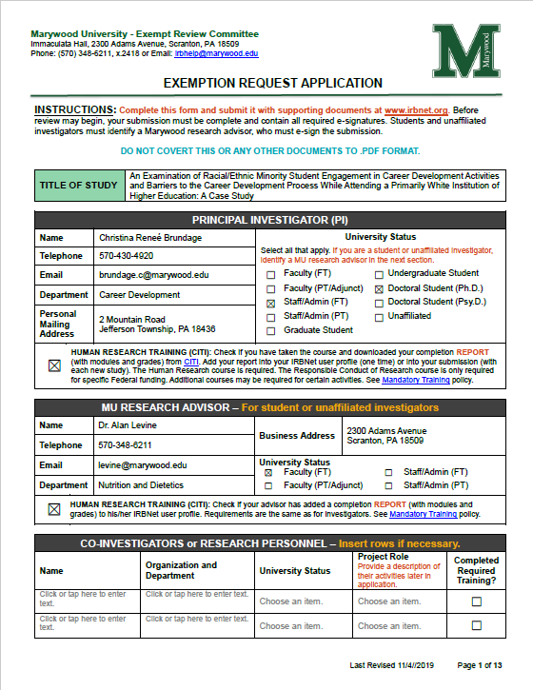
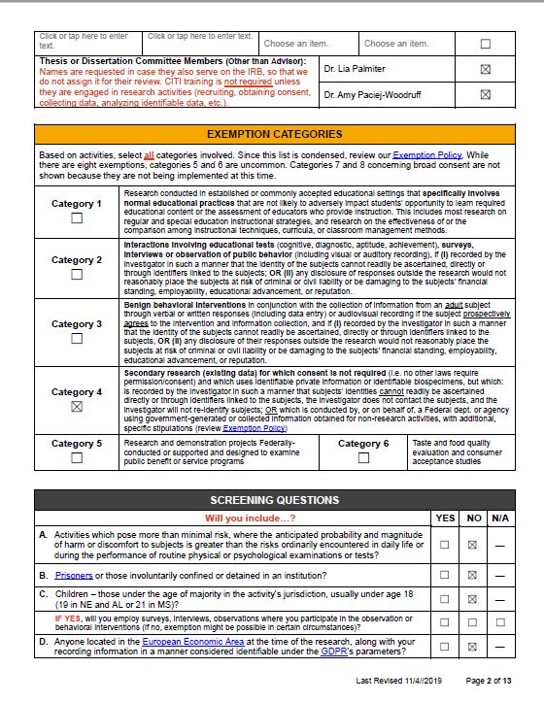
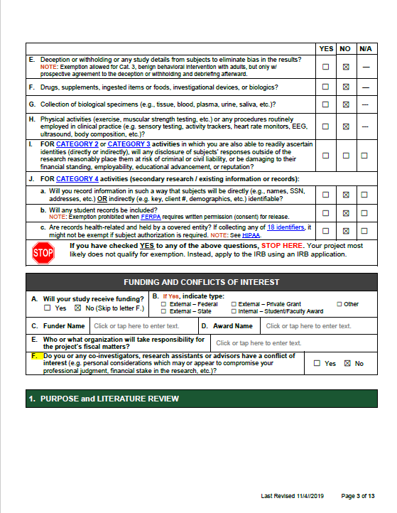
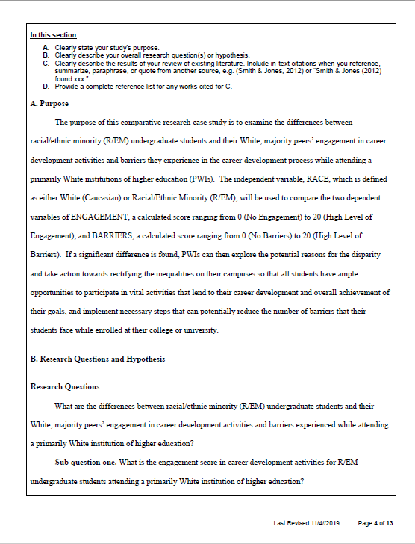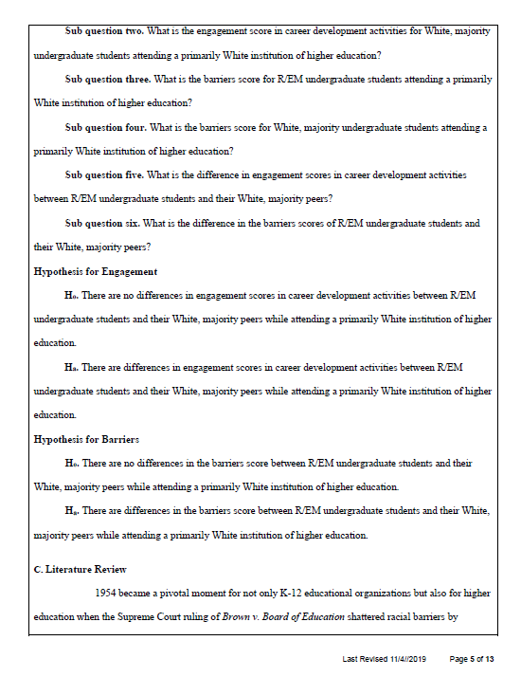
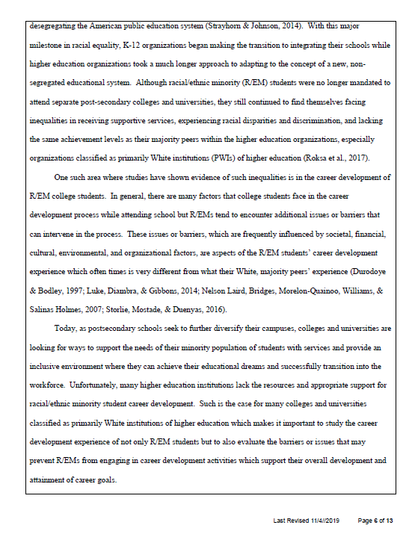
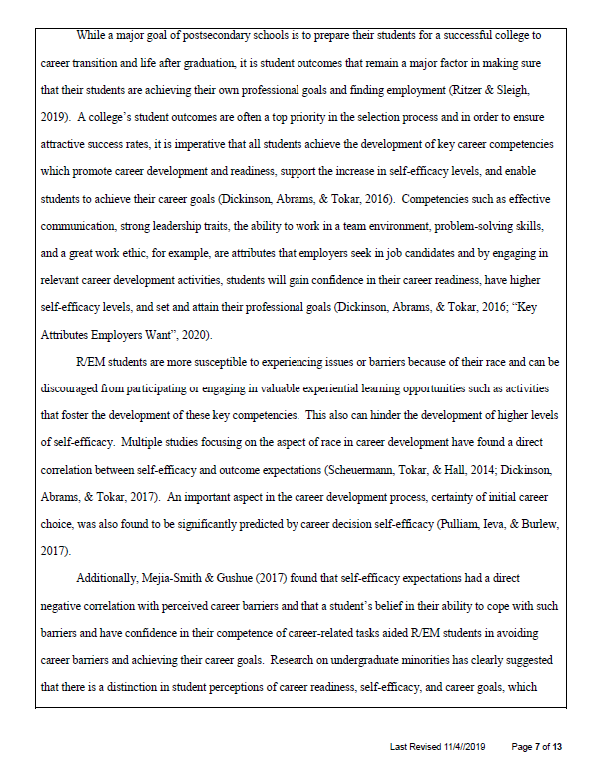
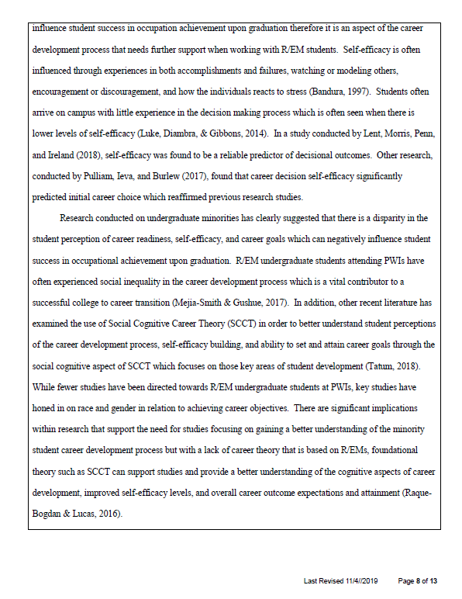
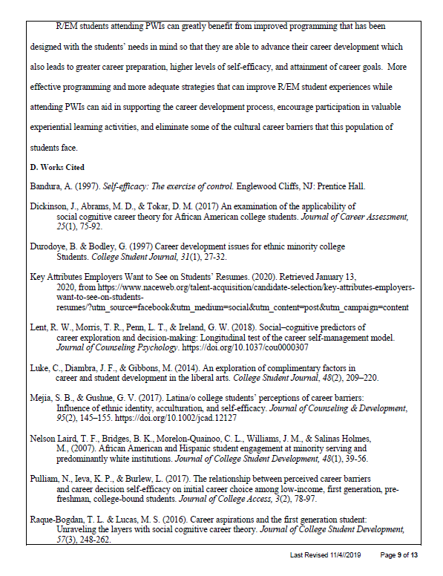
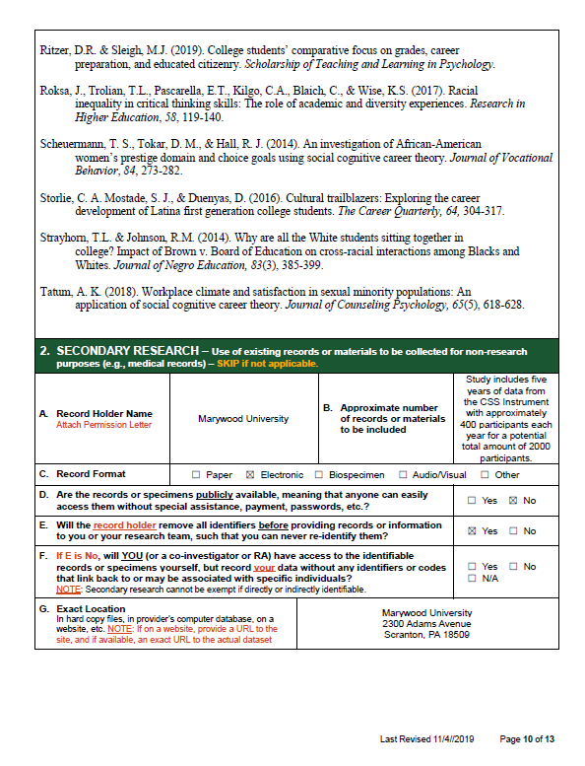
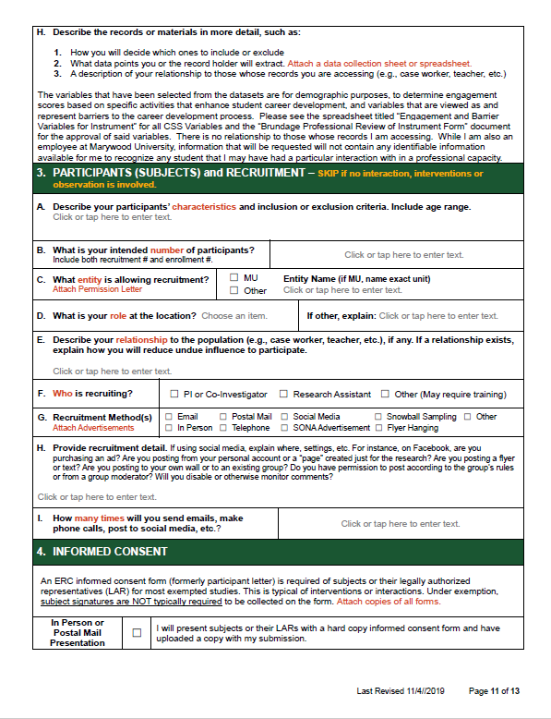
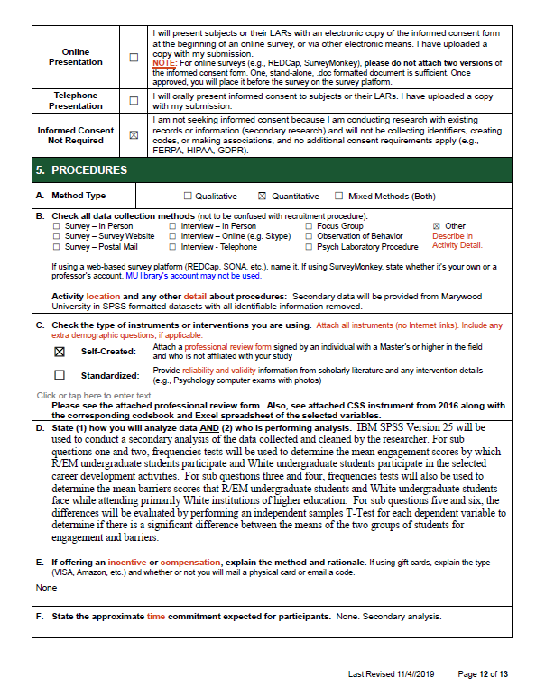
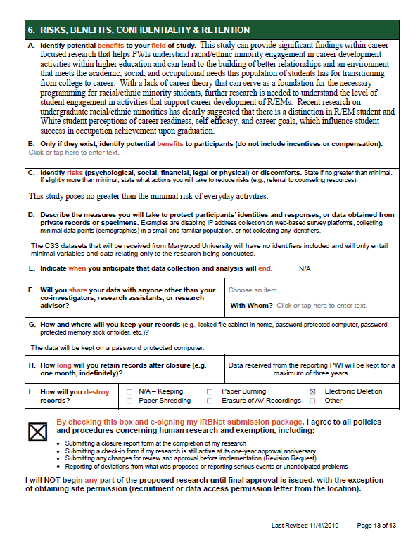

Appendix B

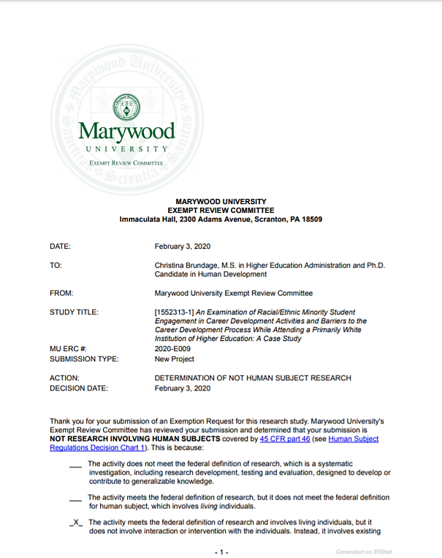
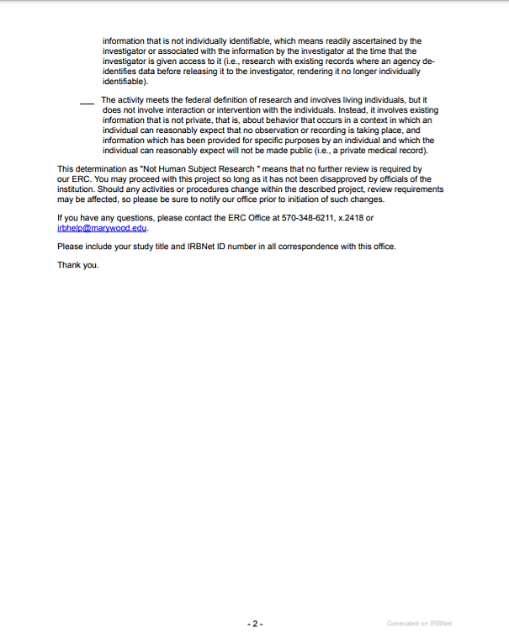

Appendix C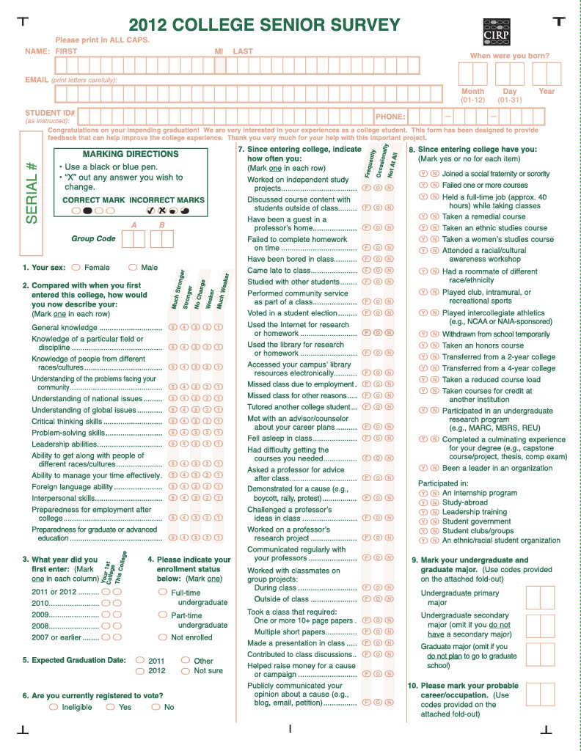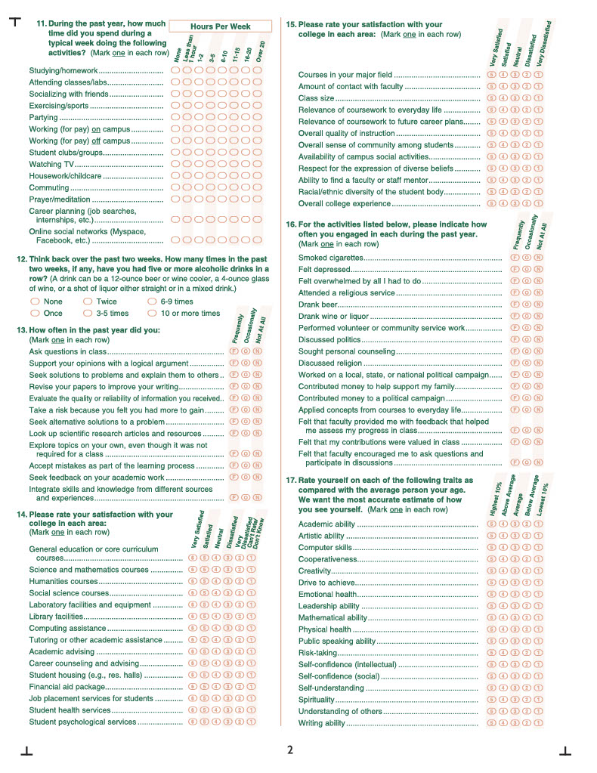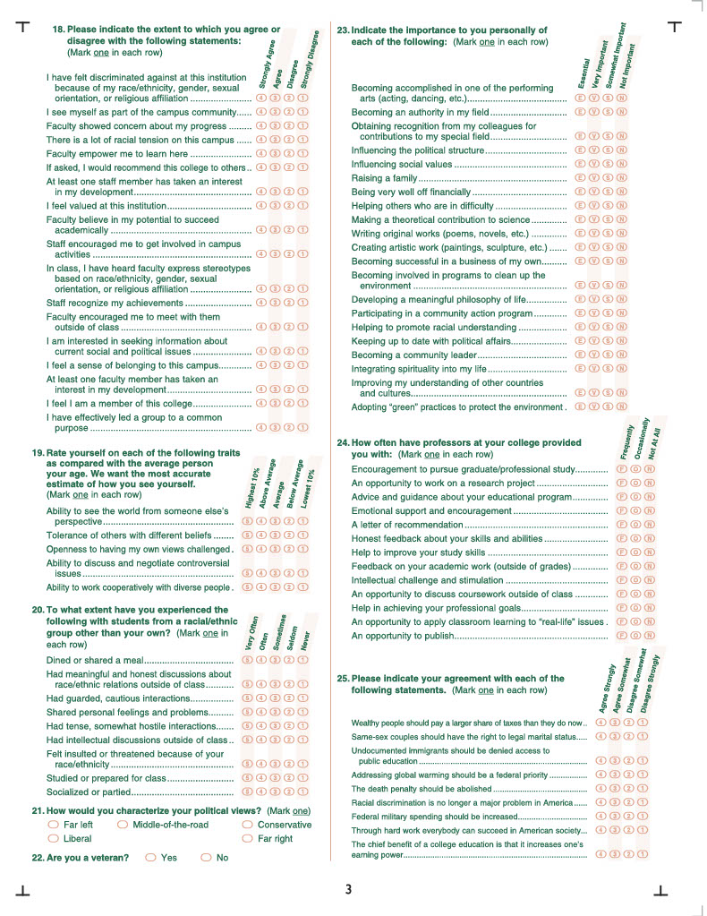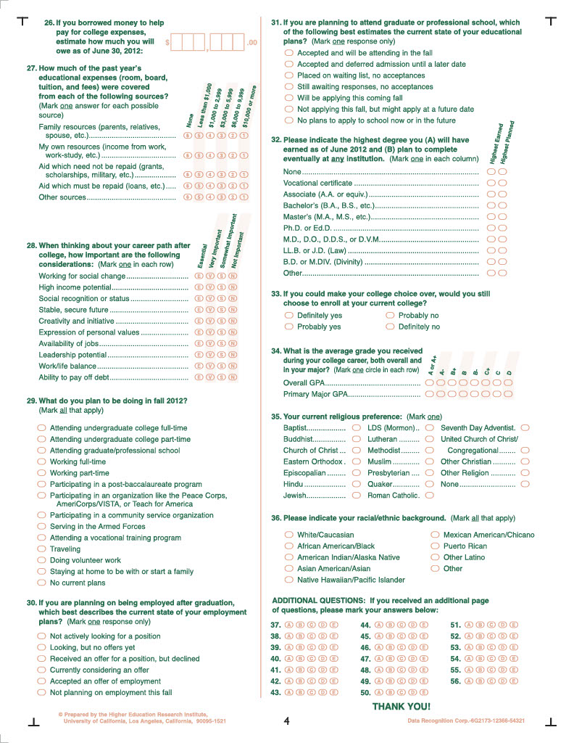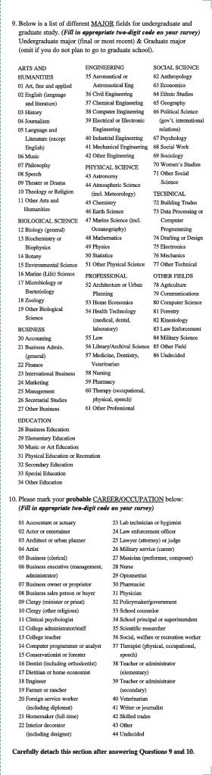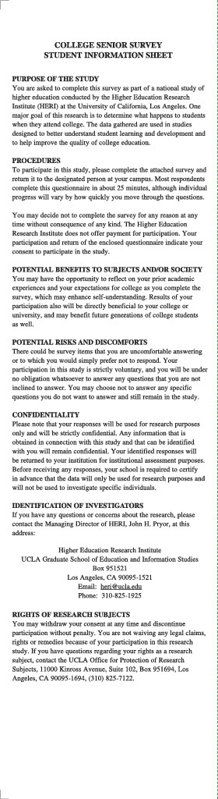
Appendix D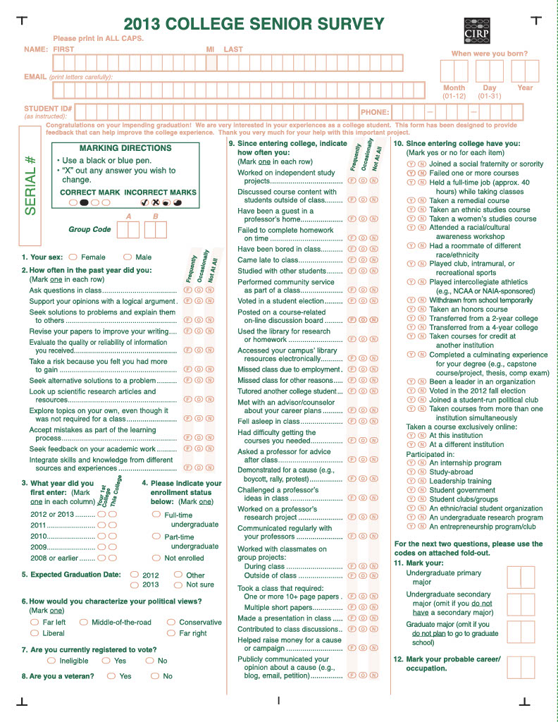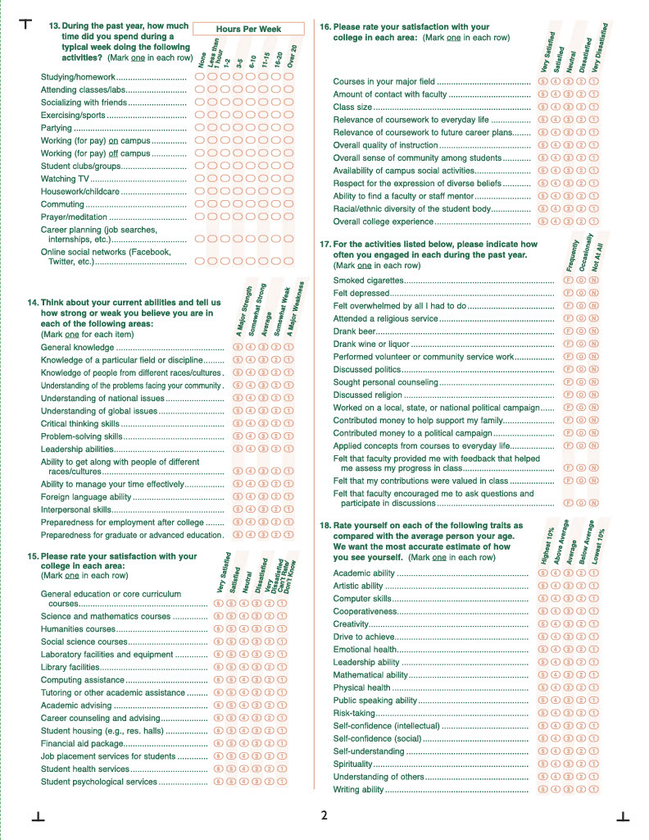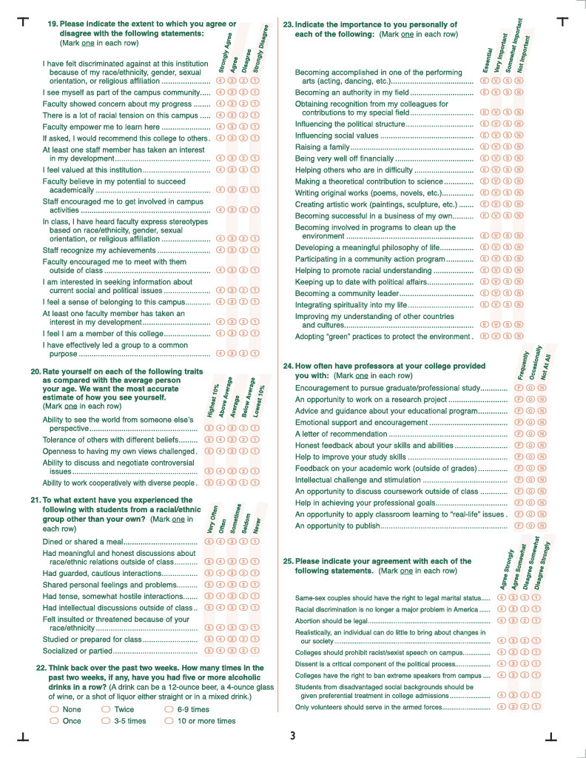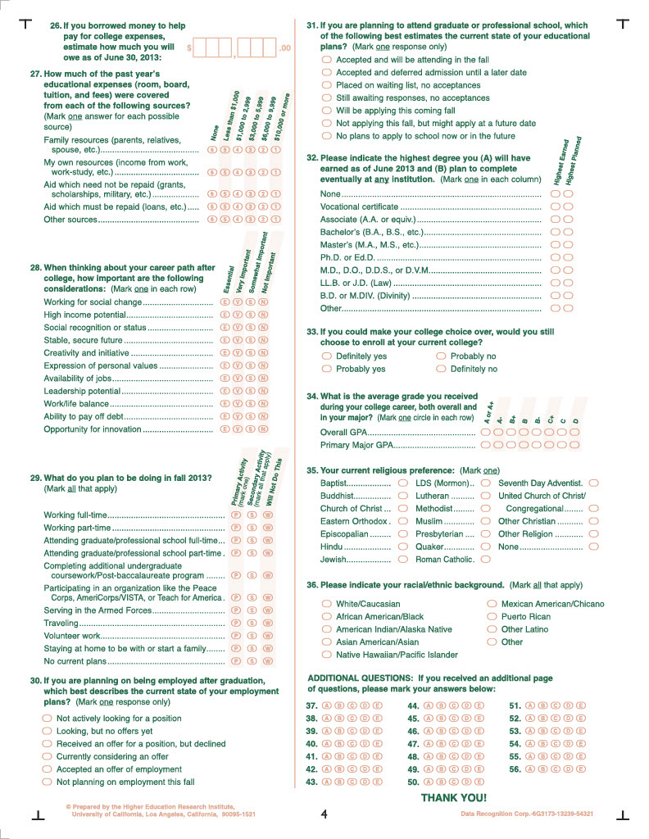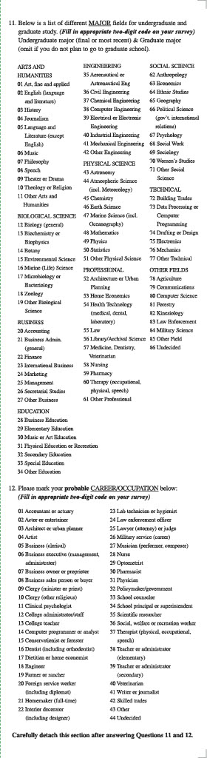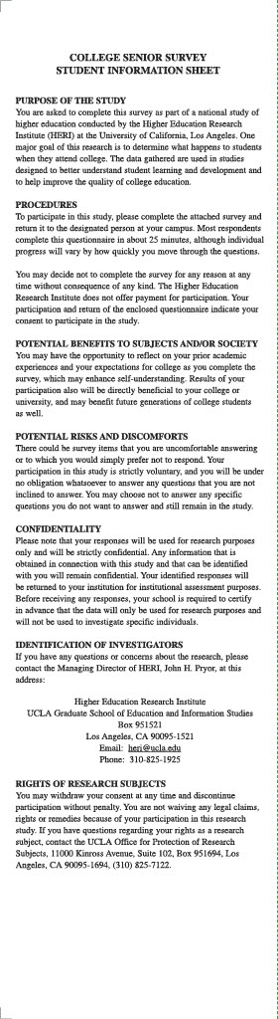
Appendix E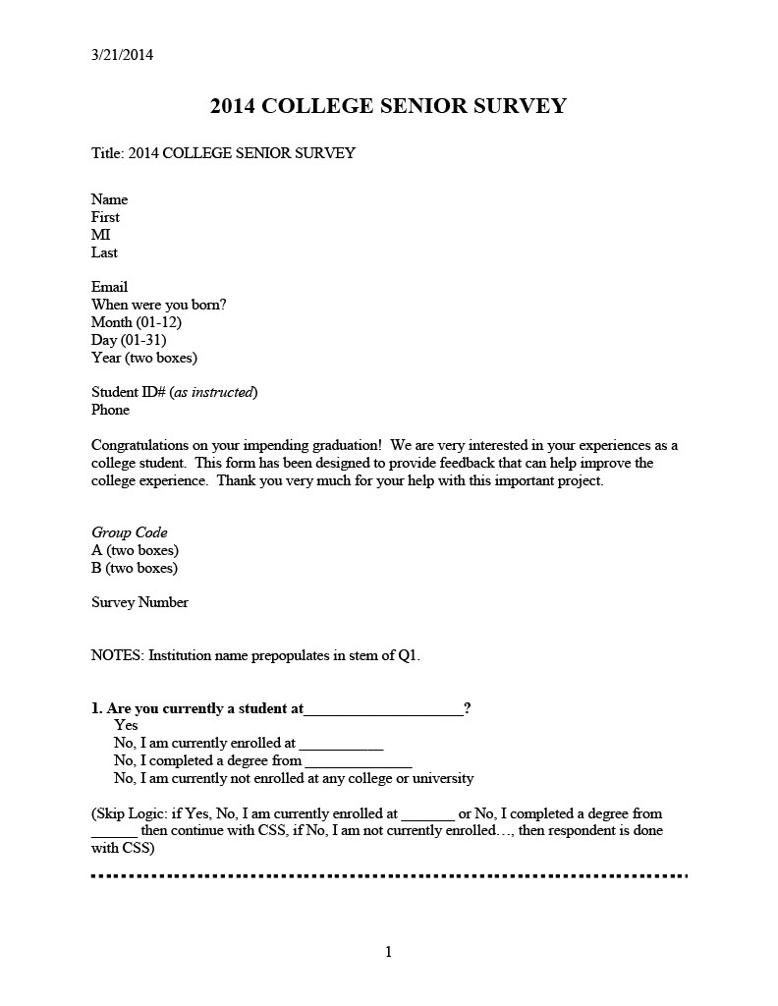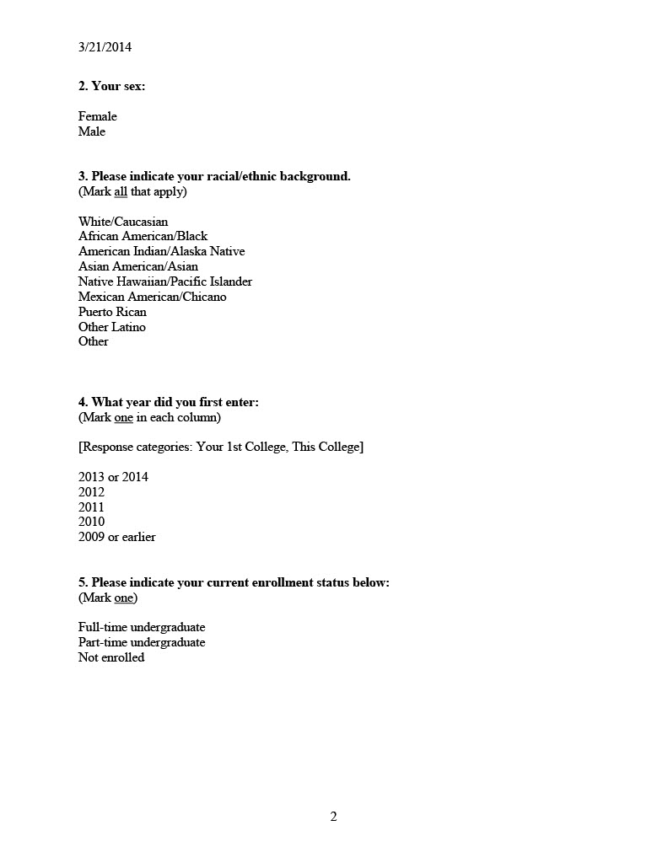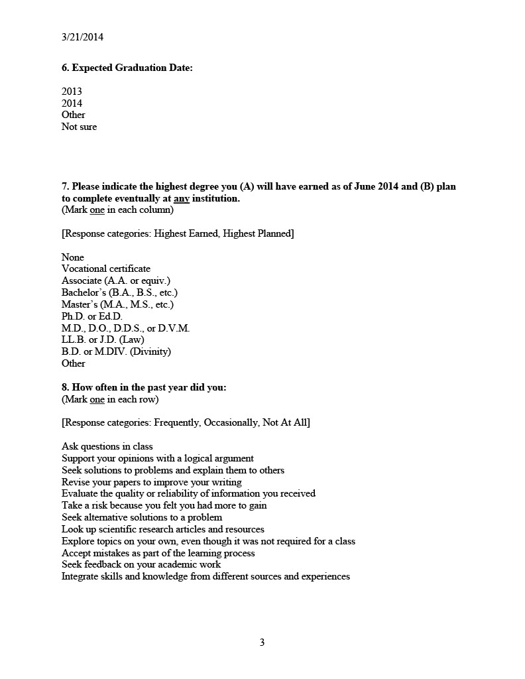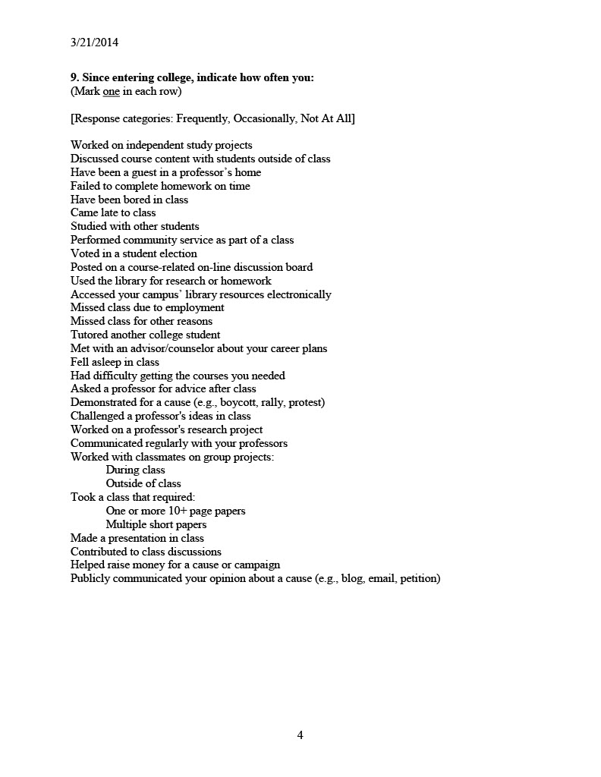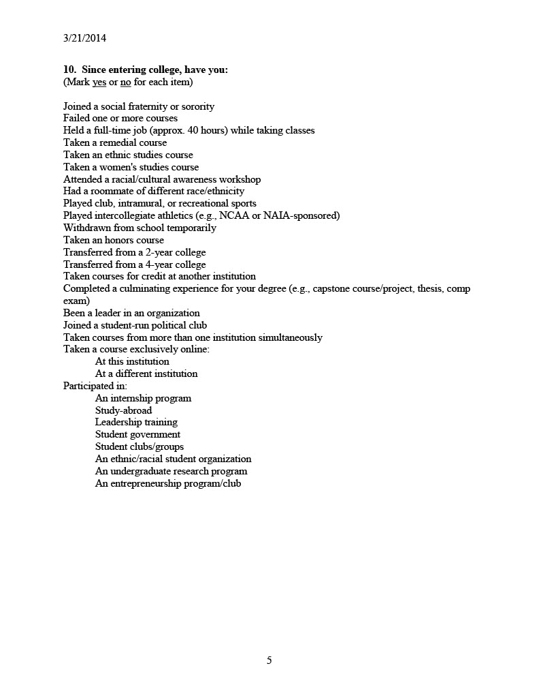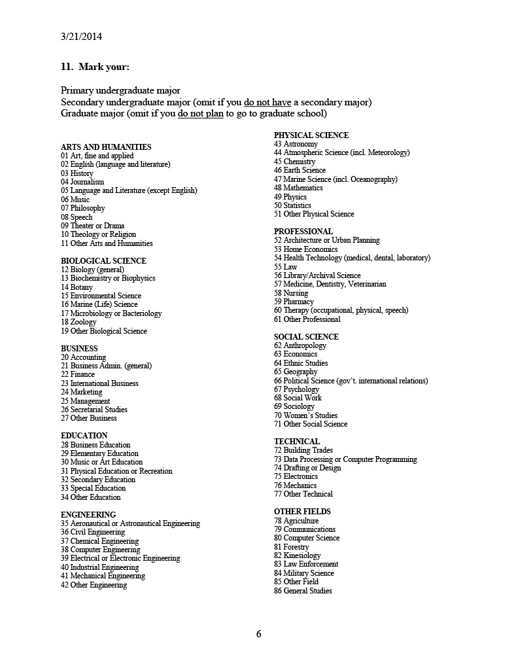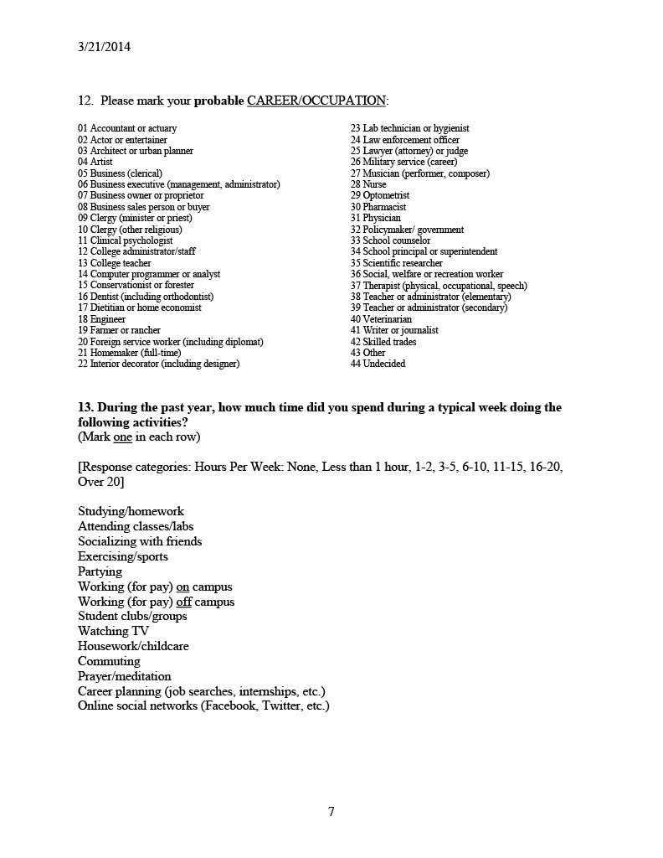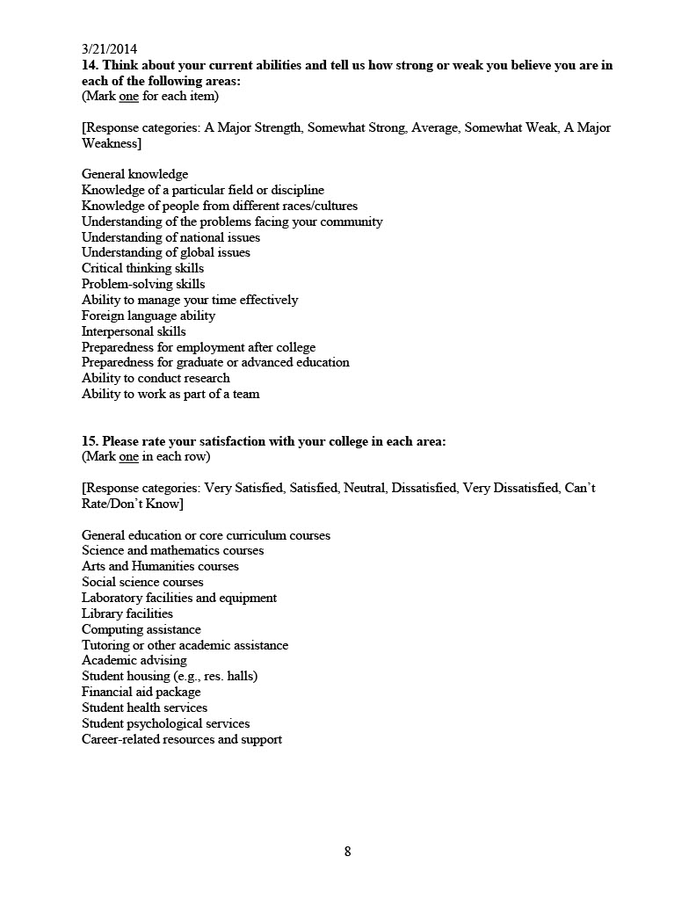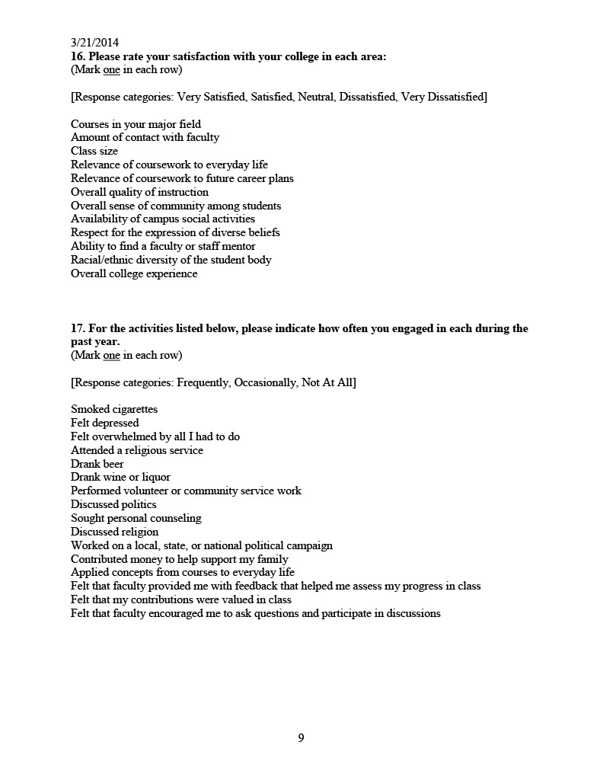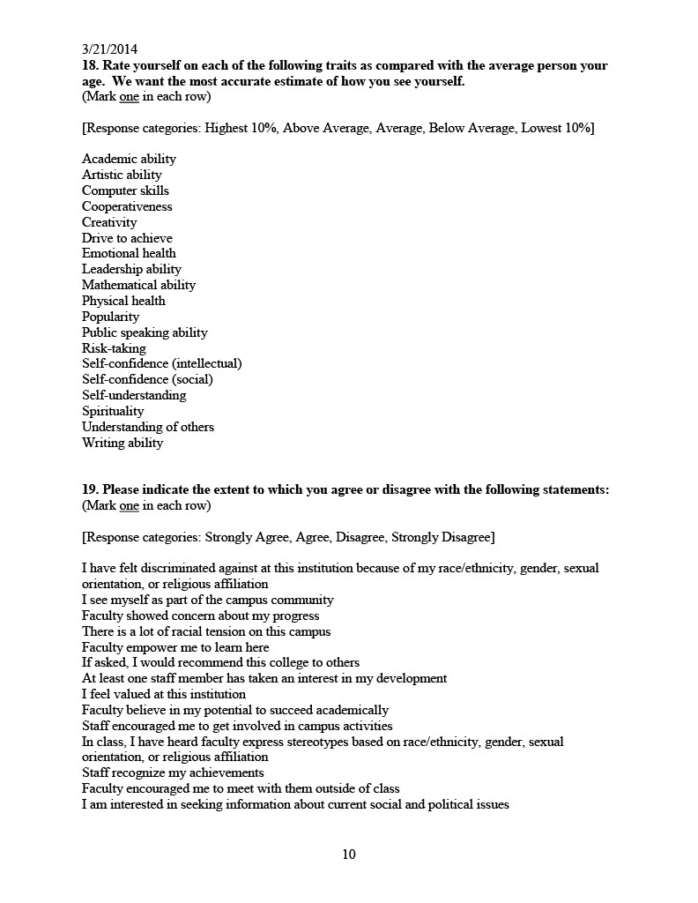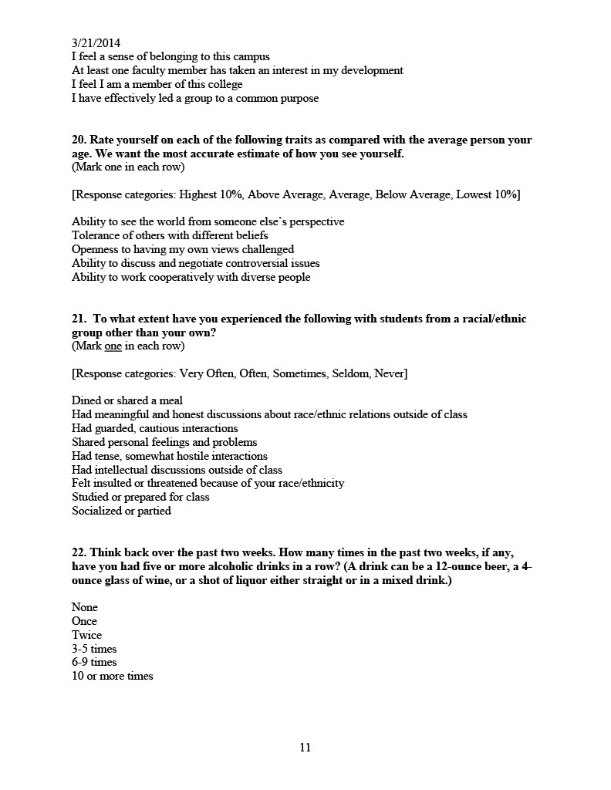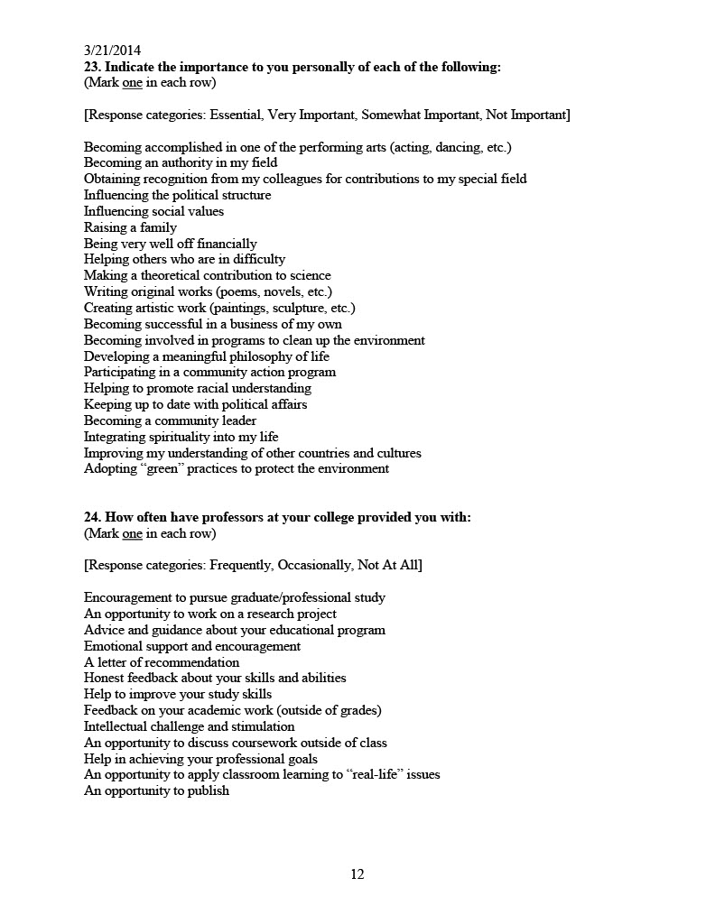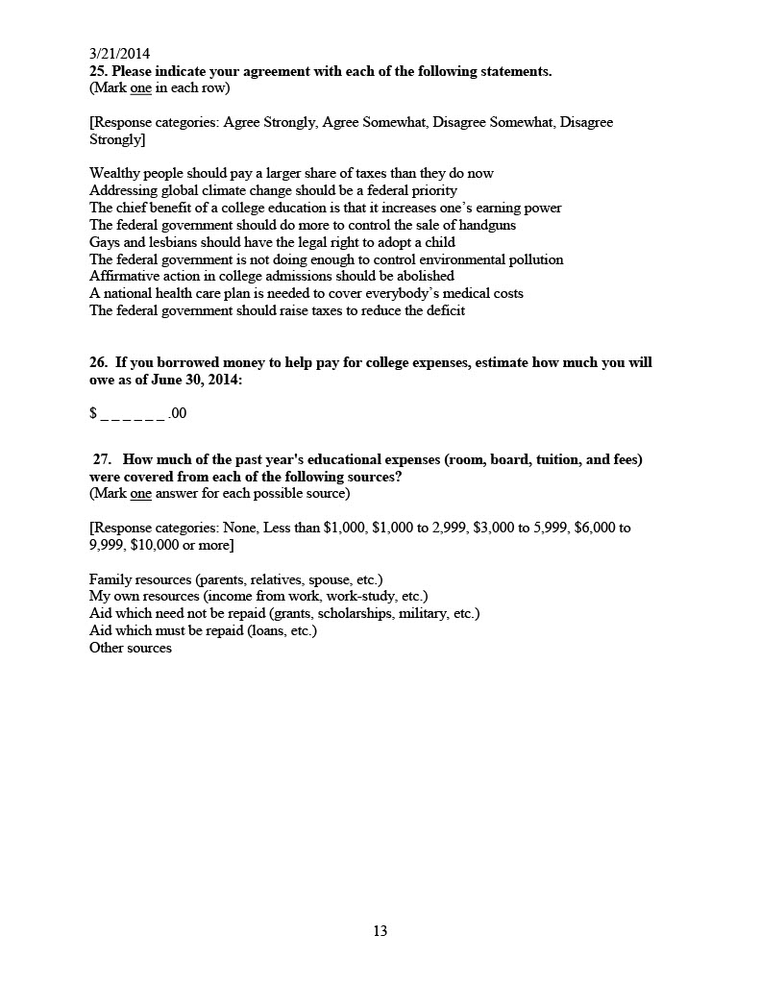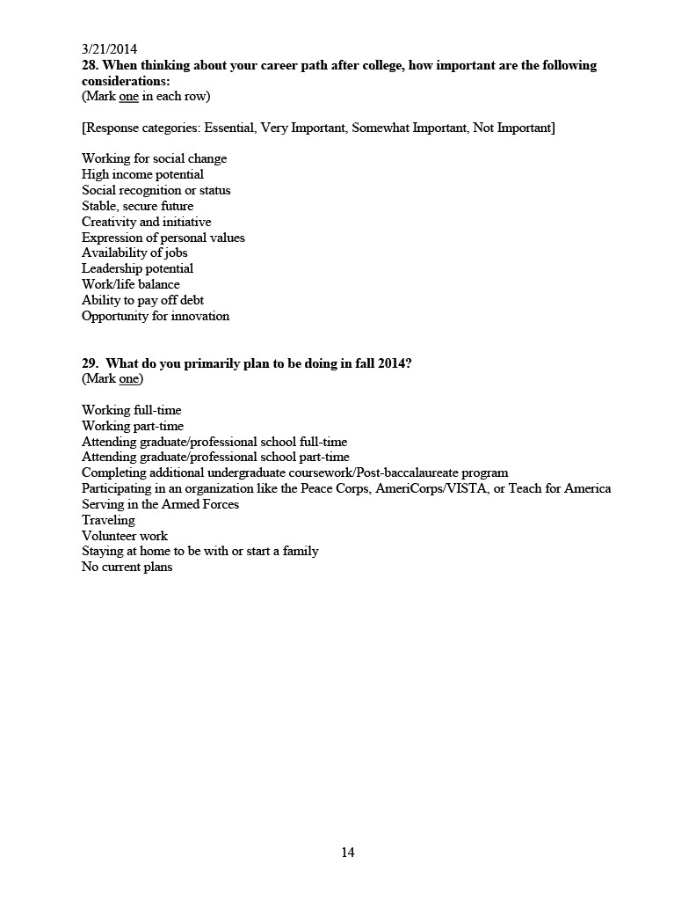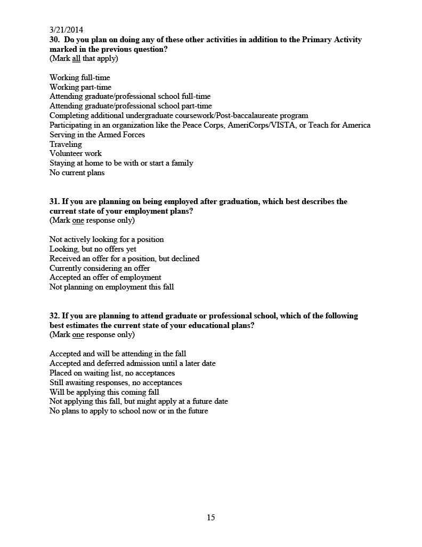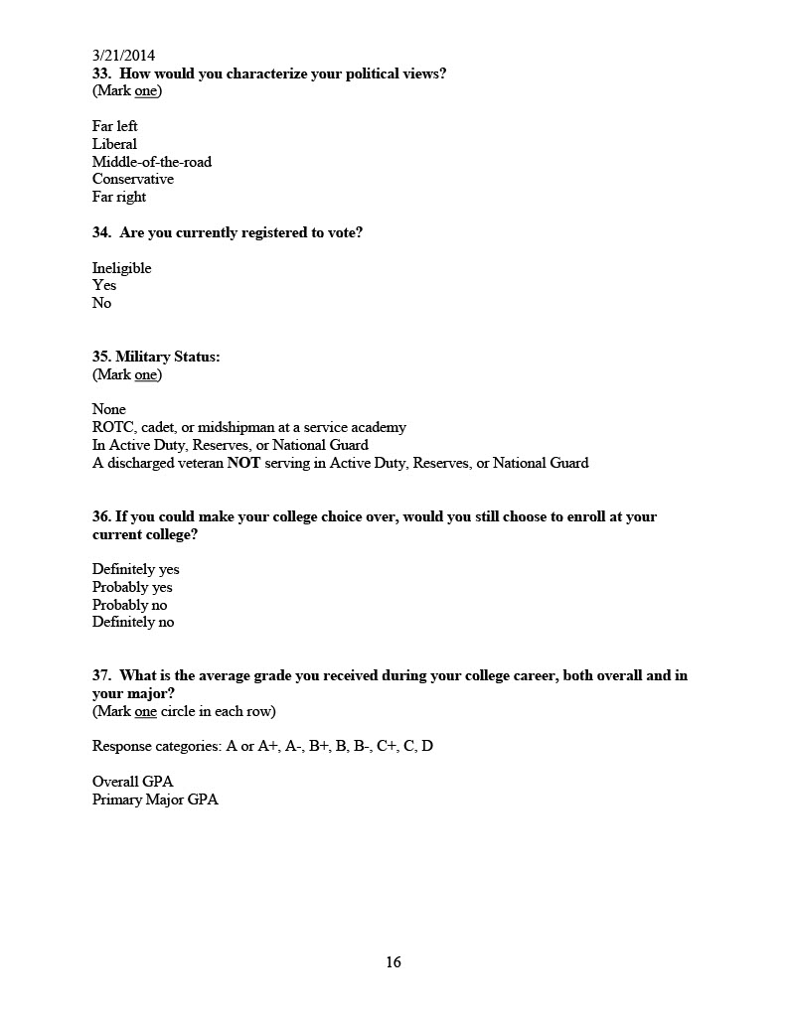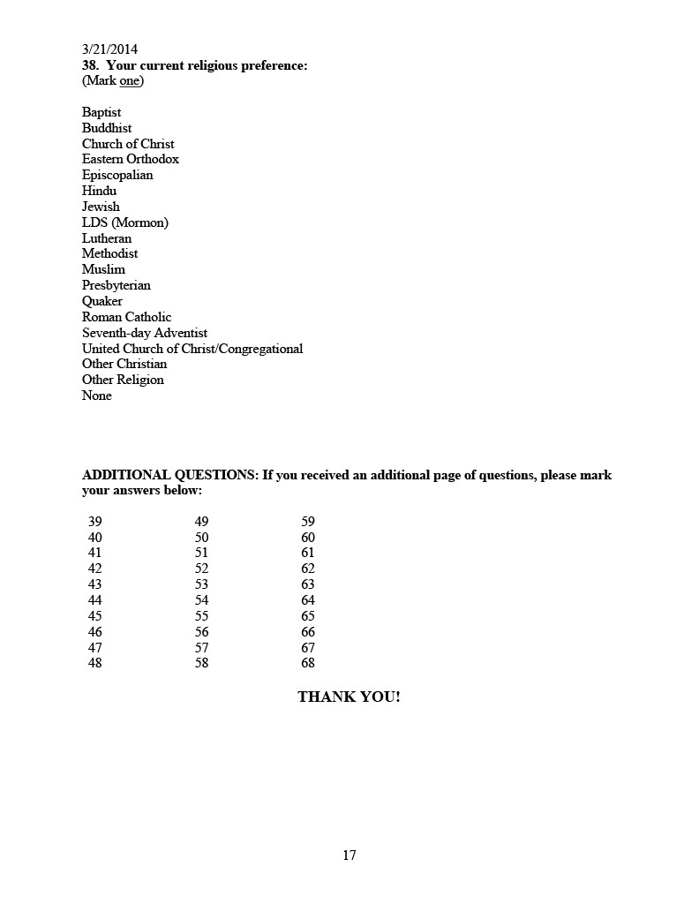

Appendix F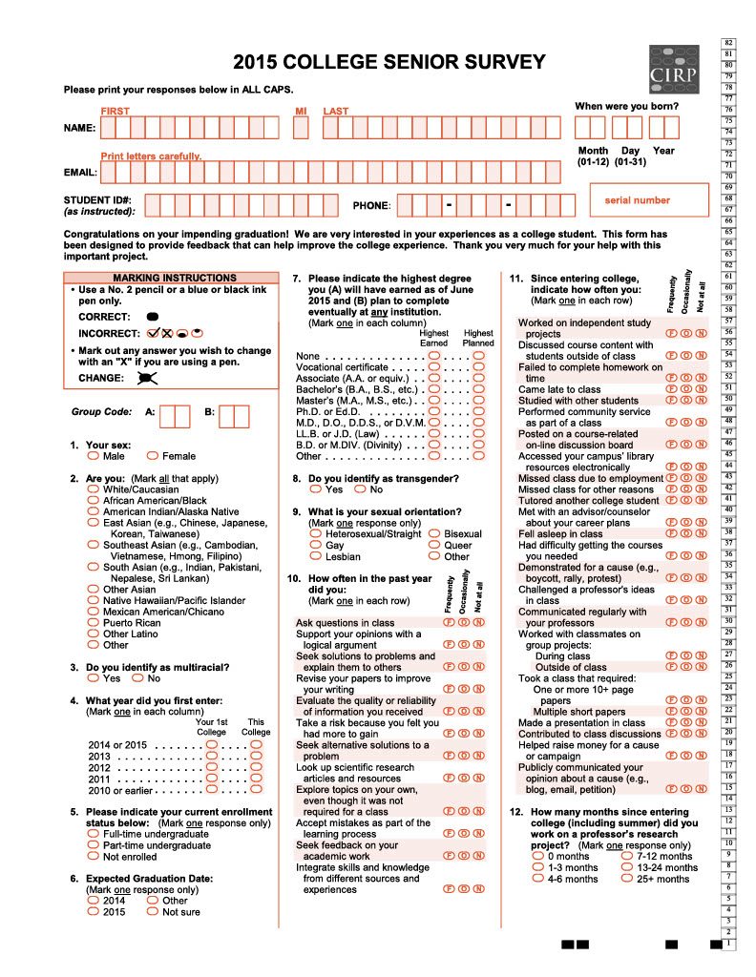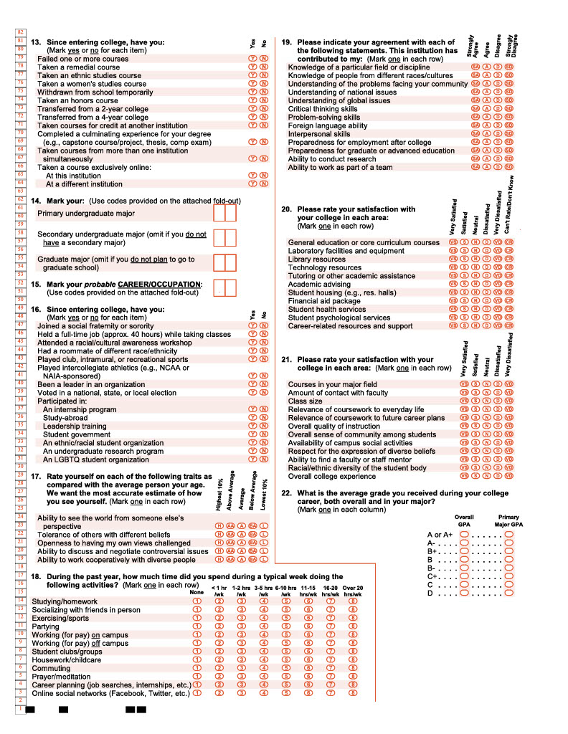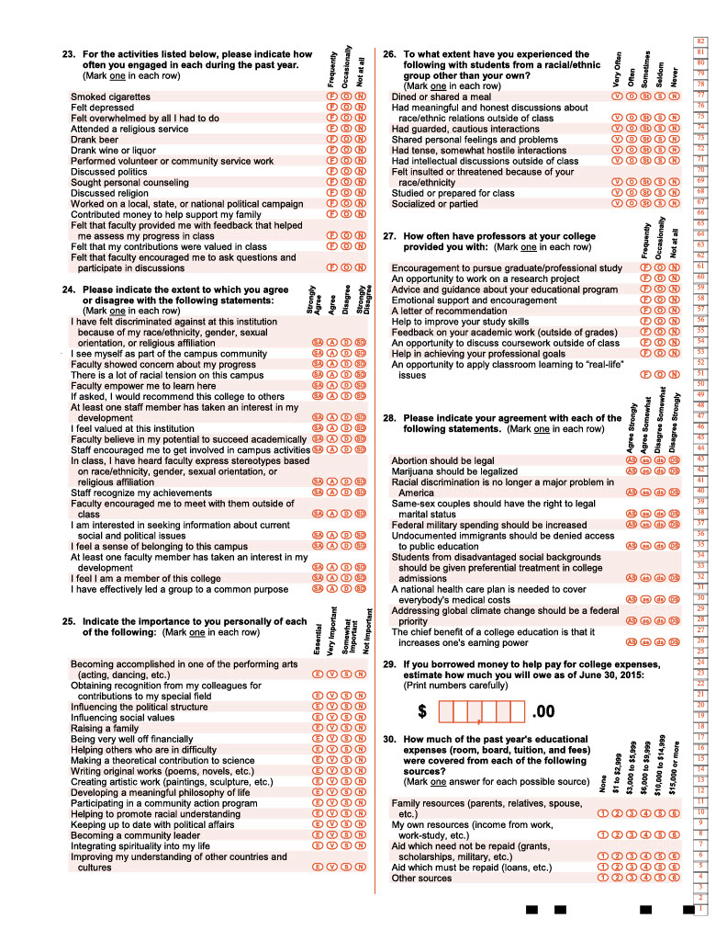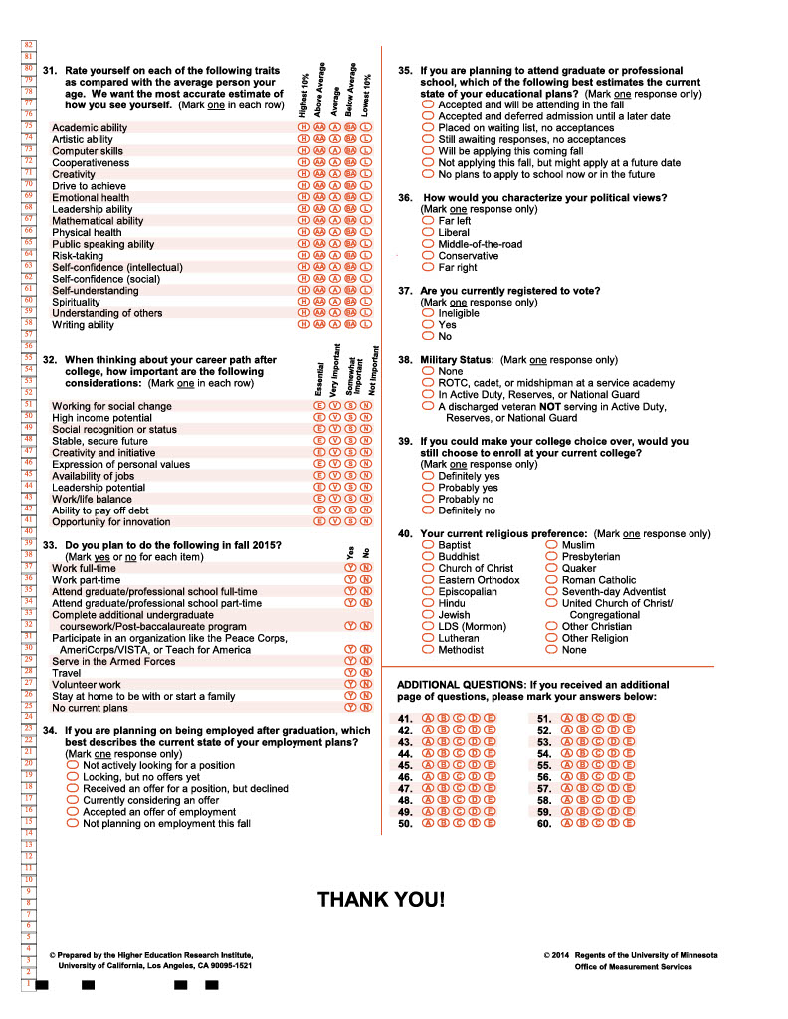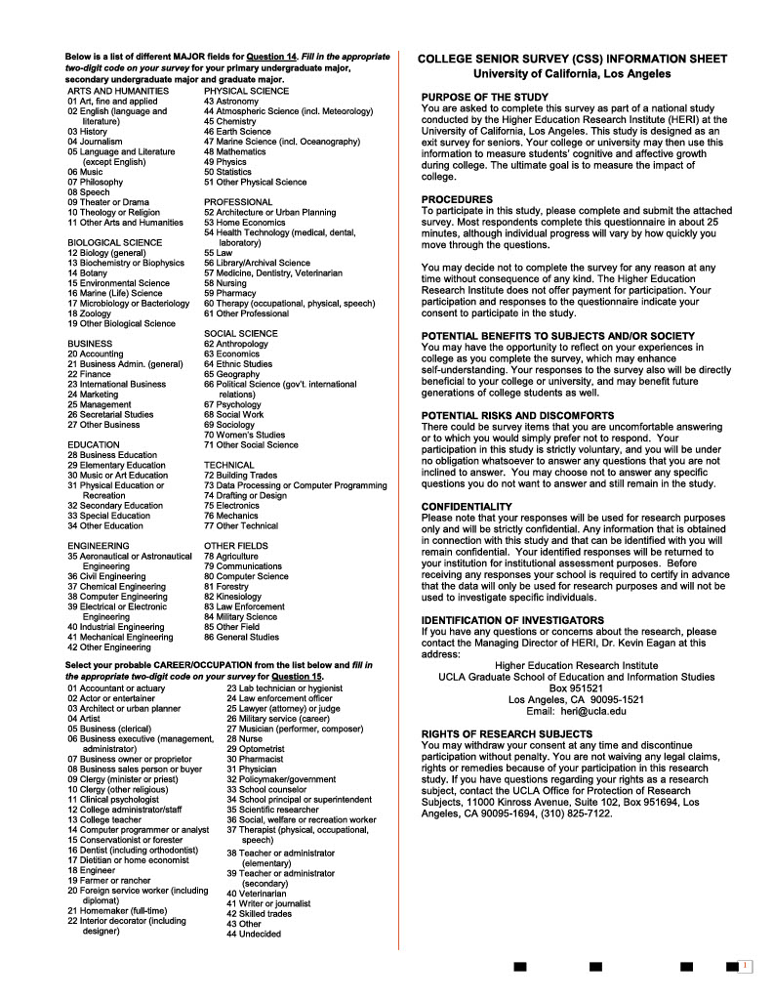

Appendix G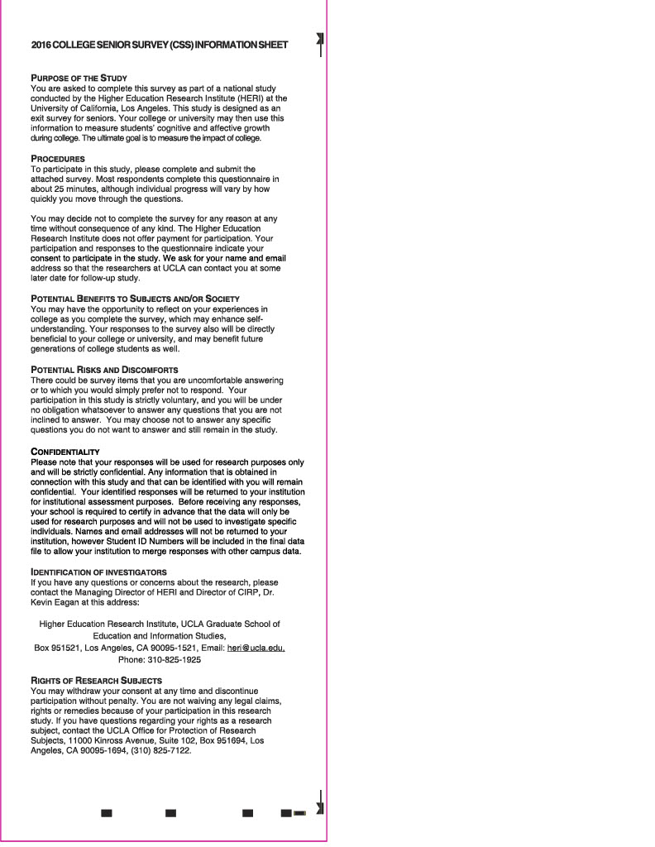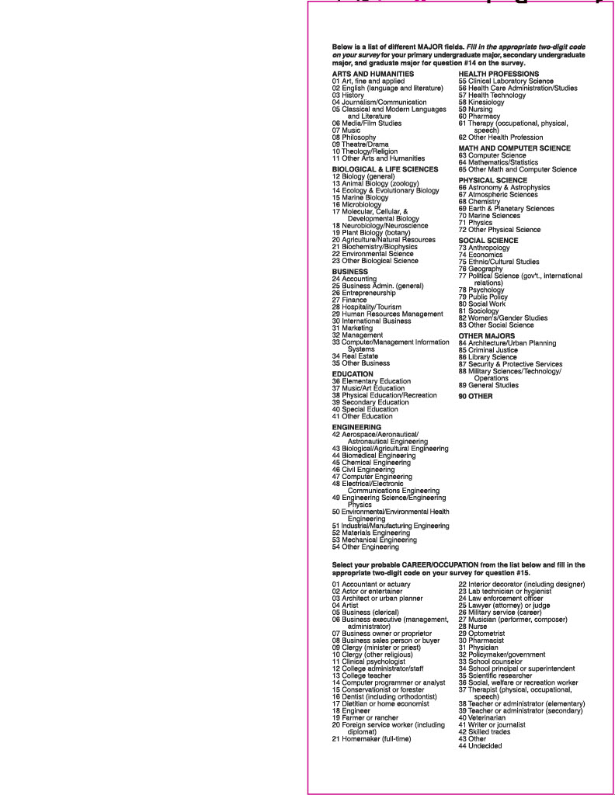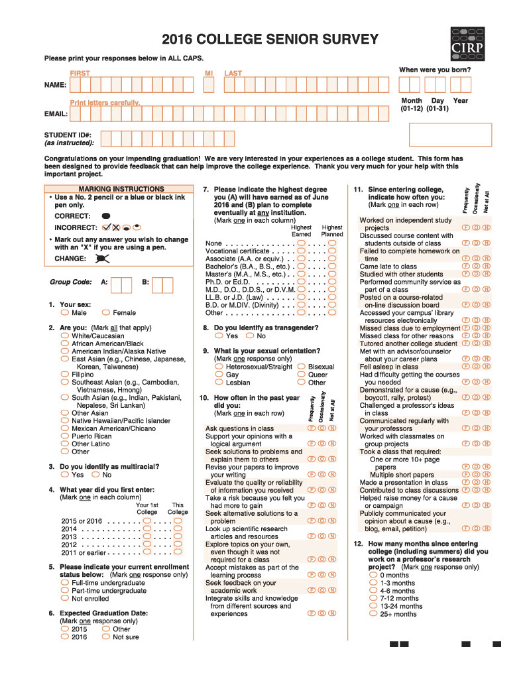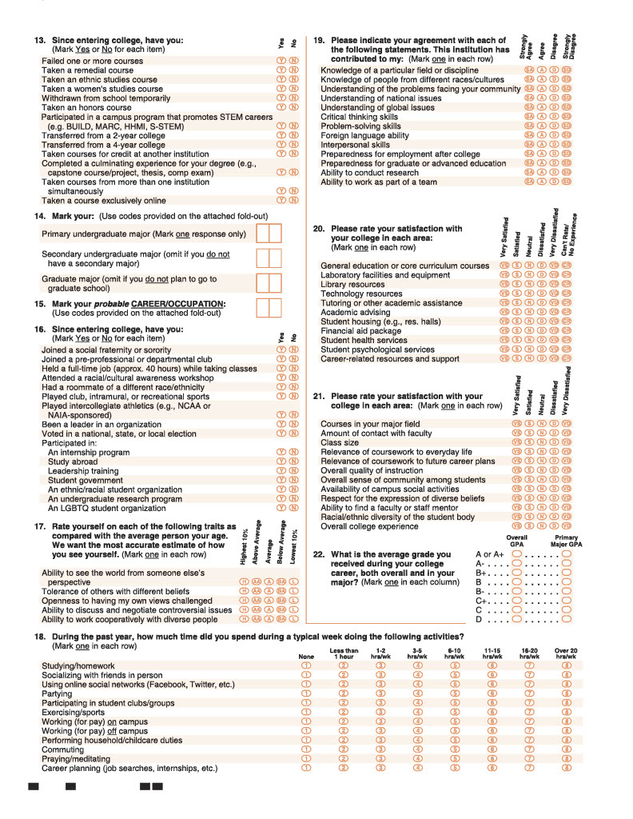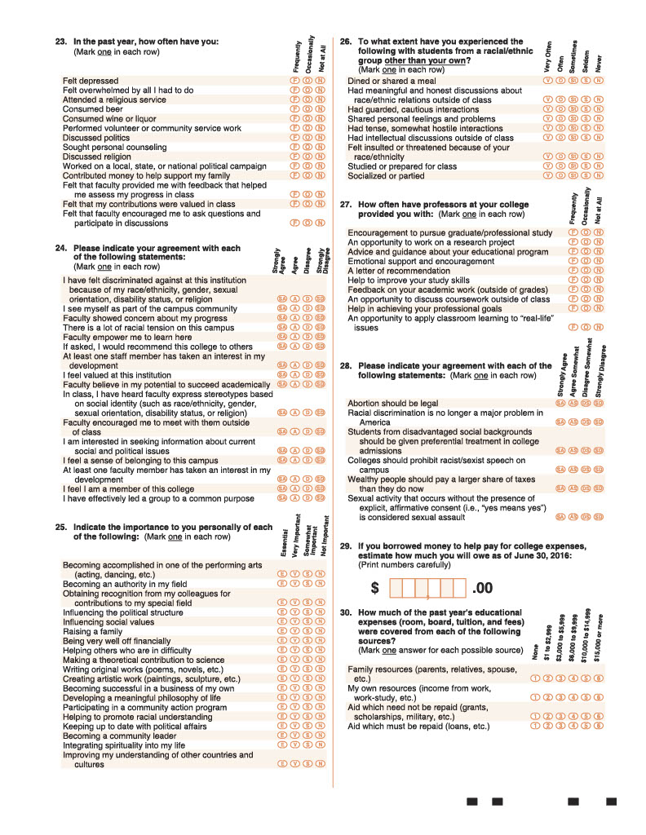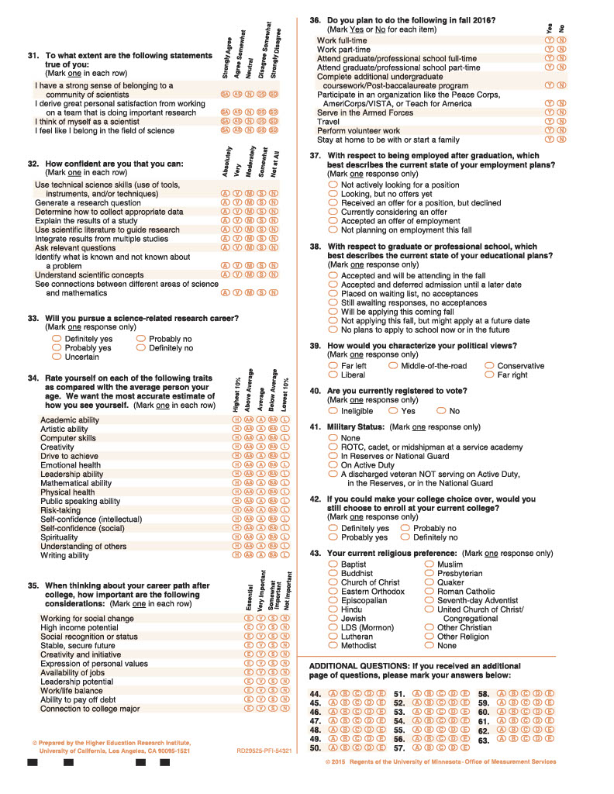

Appendix H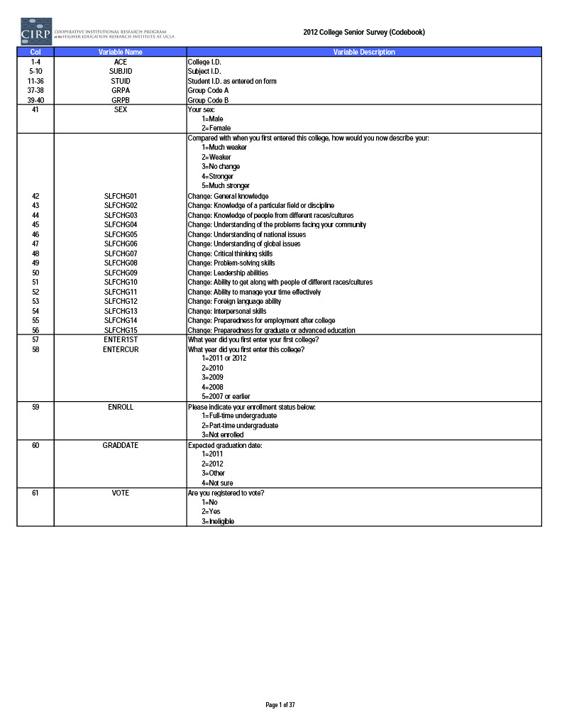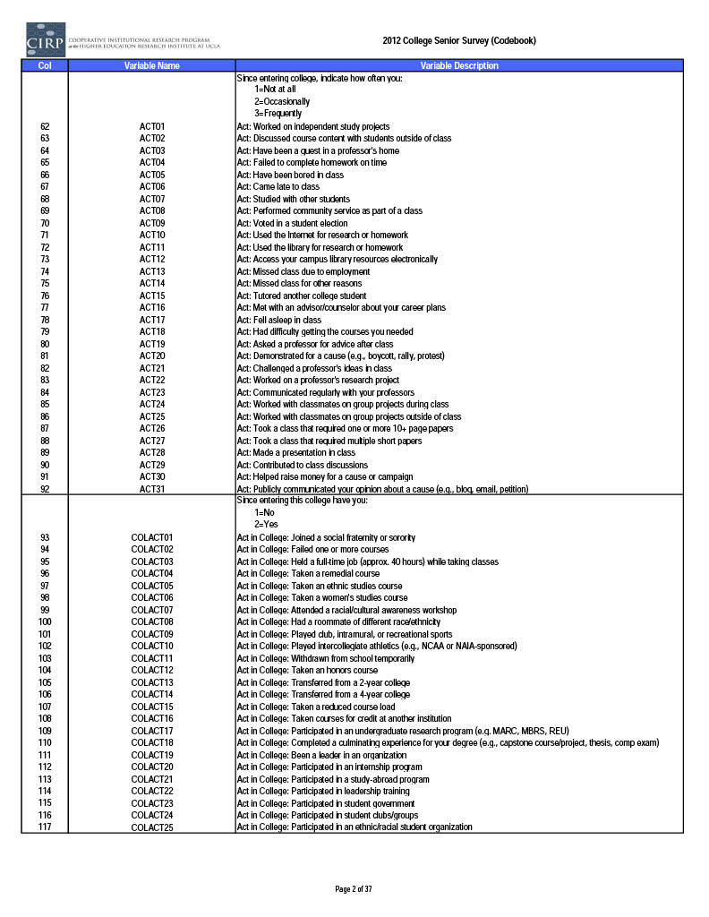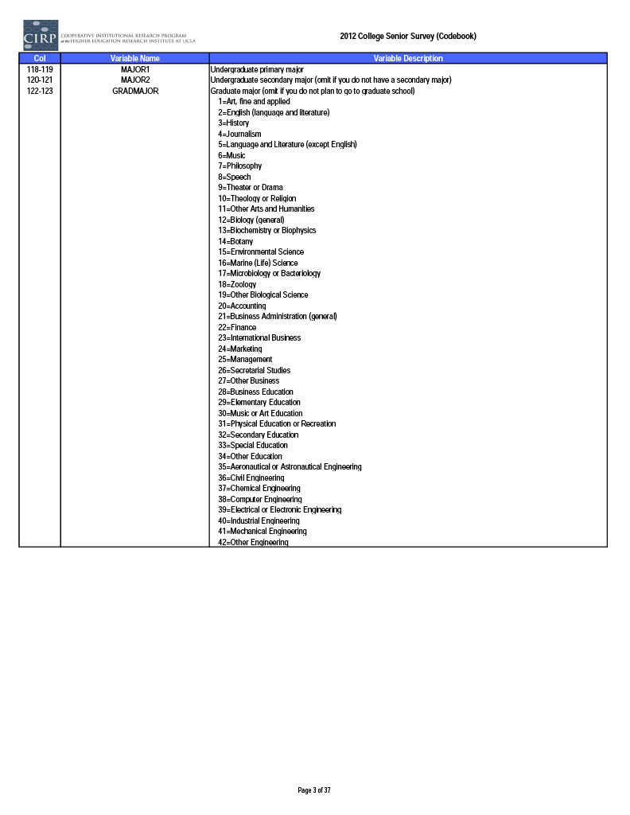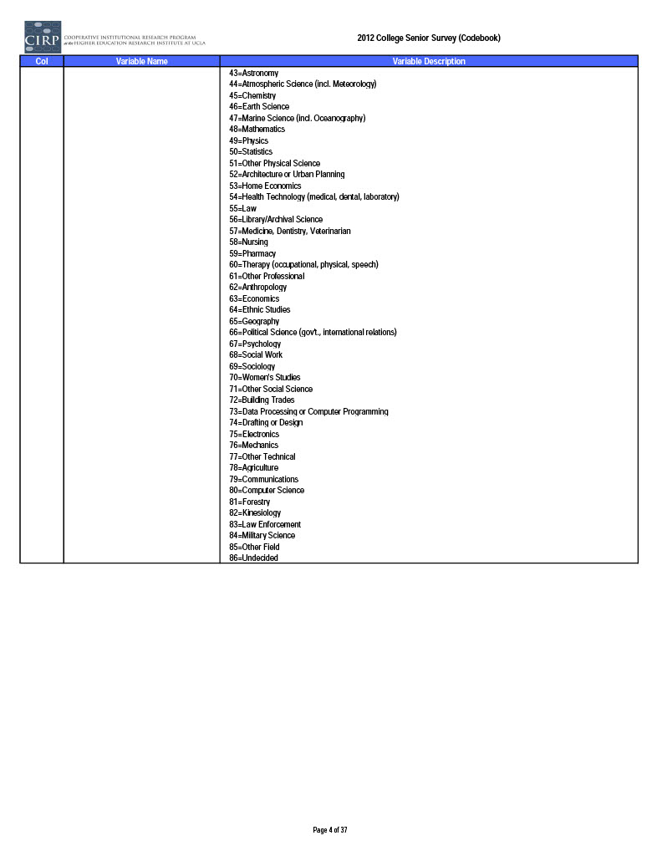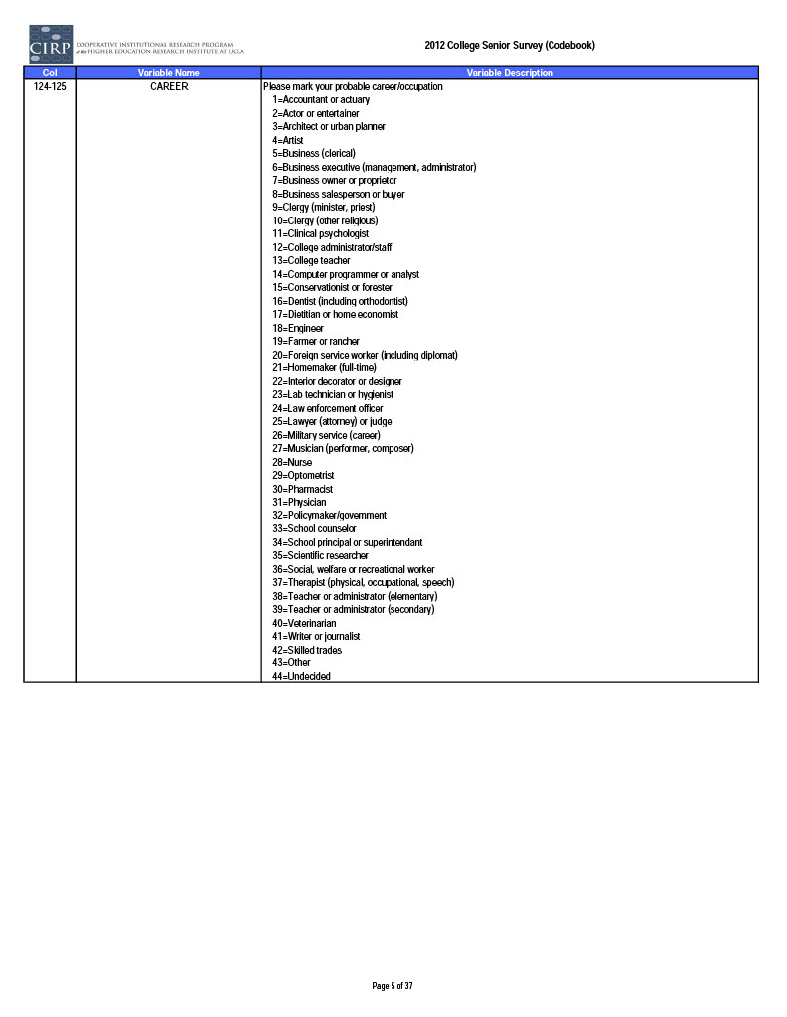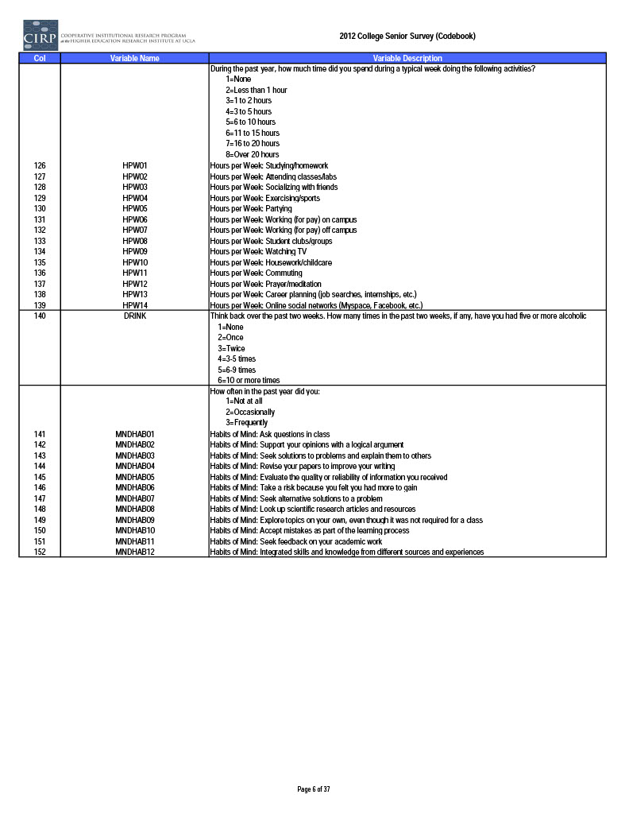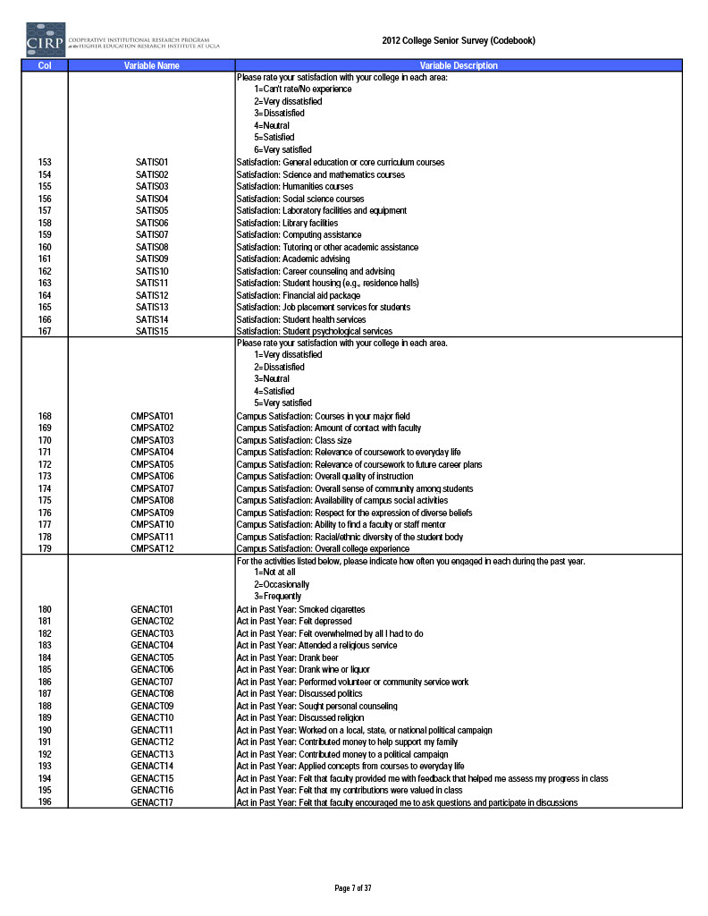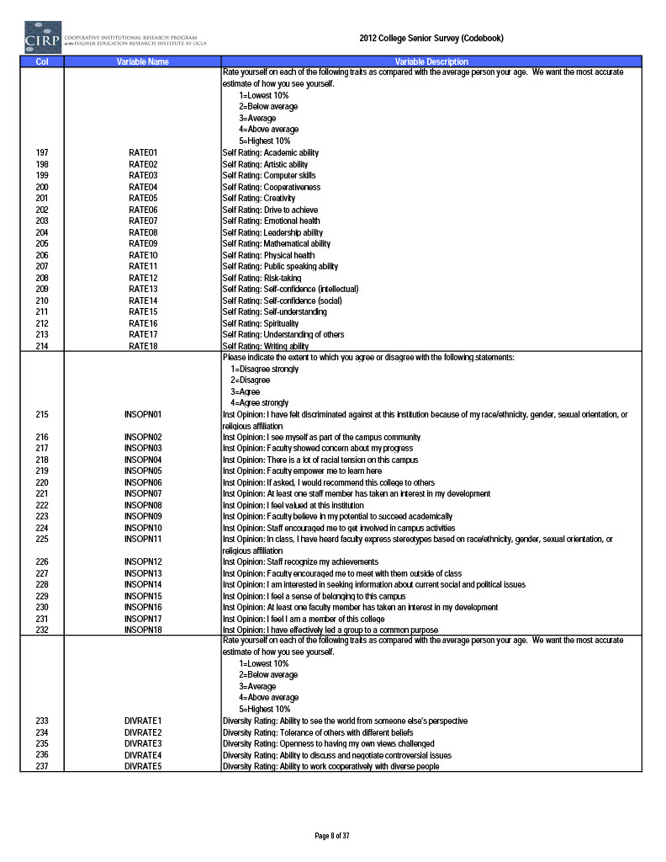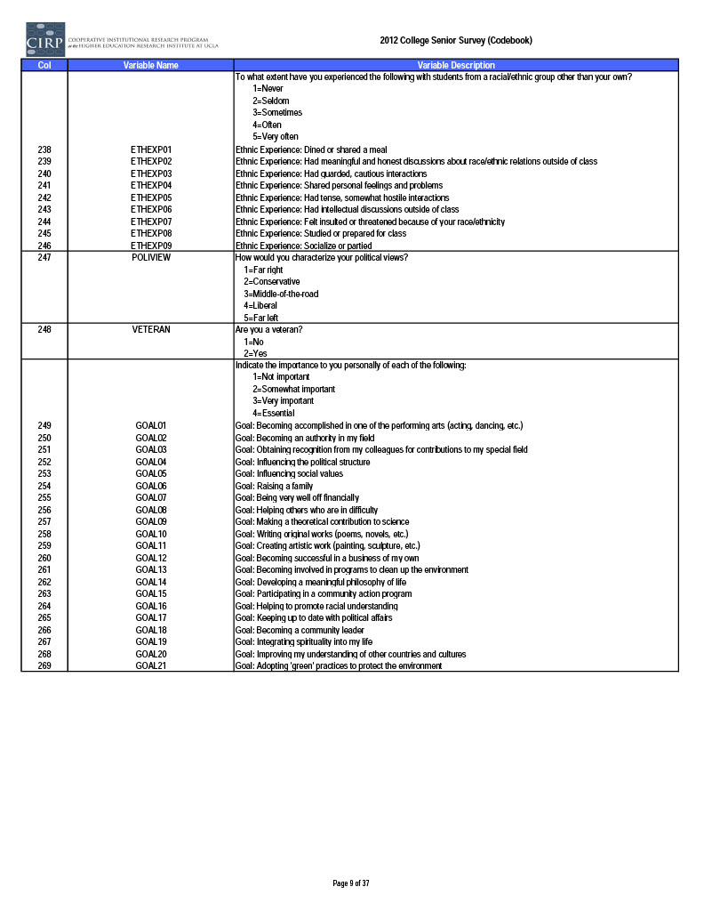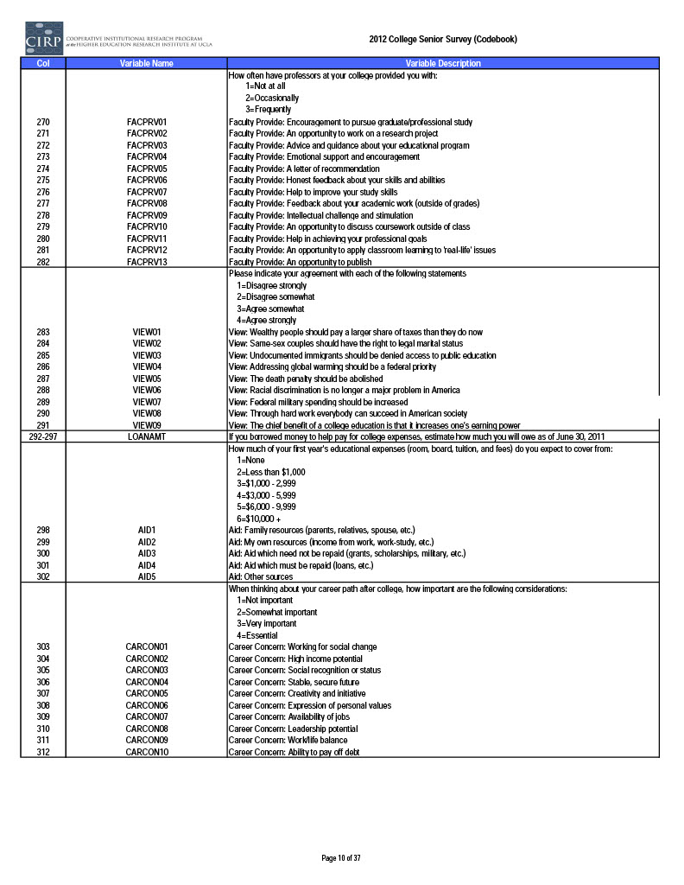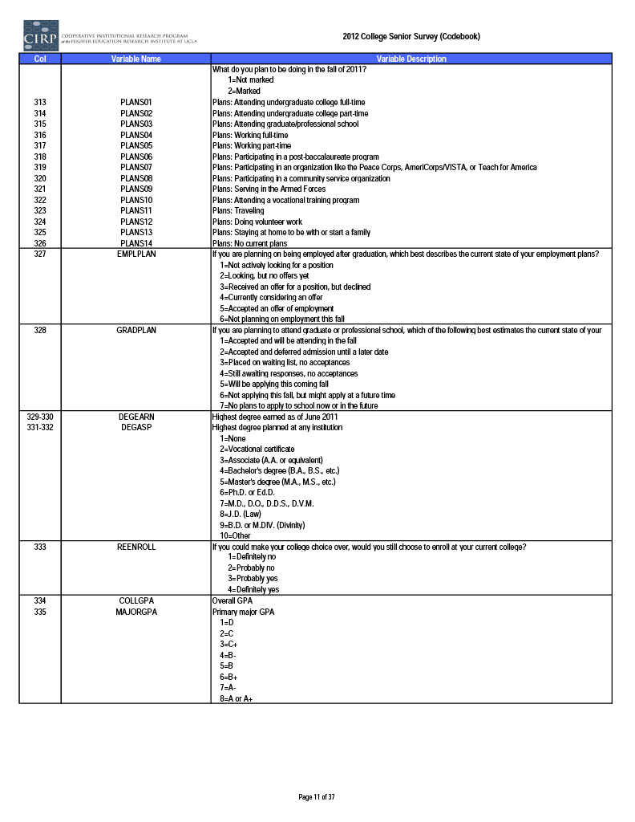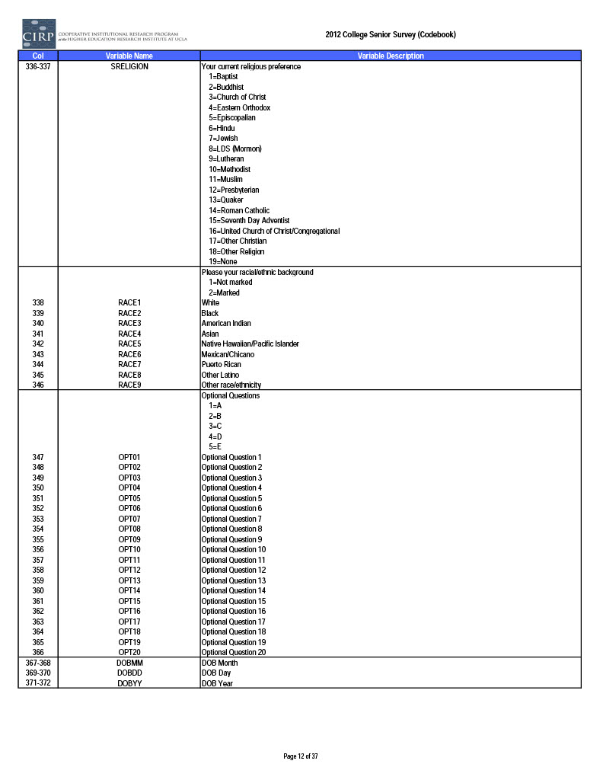

Appendix I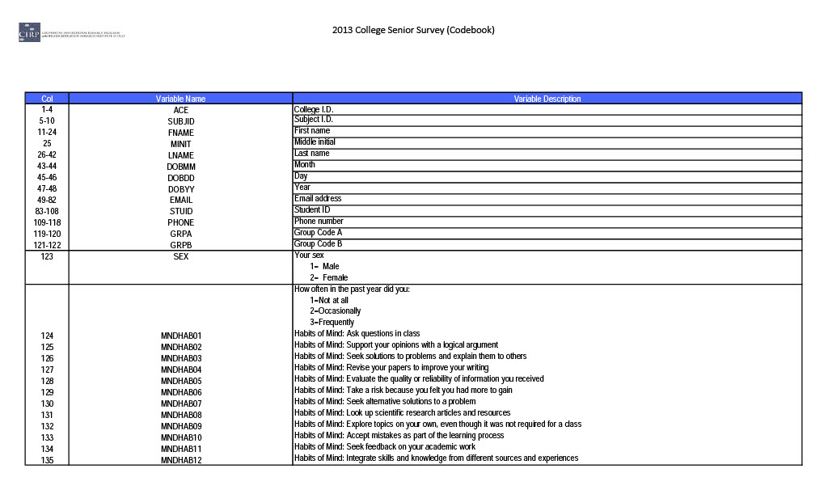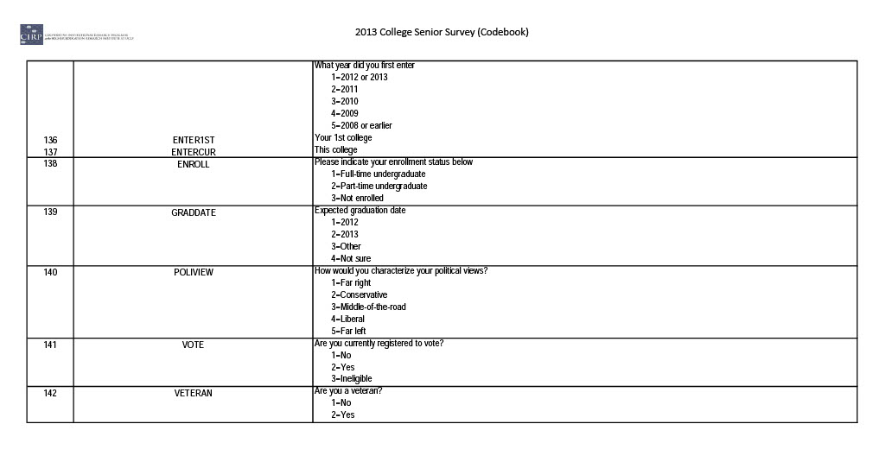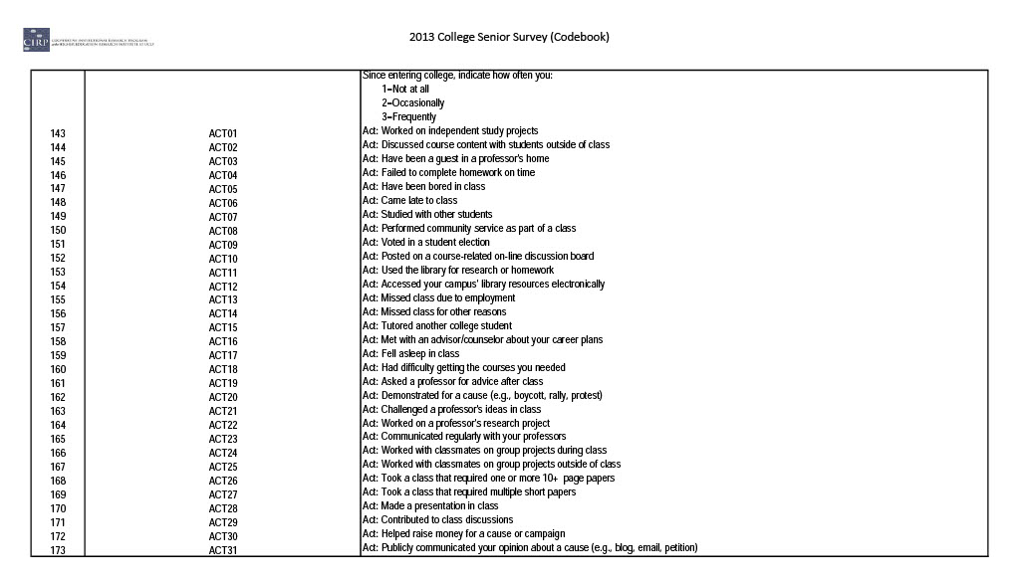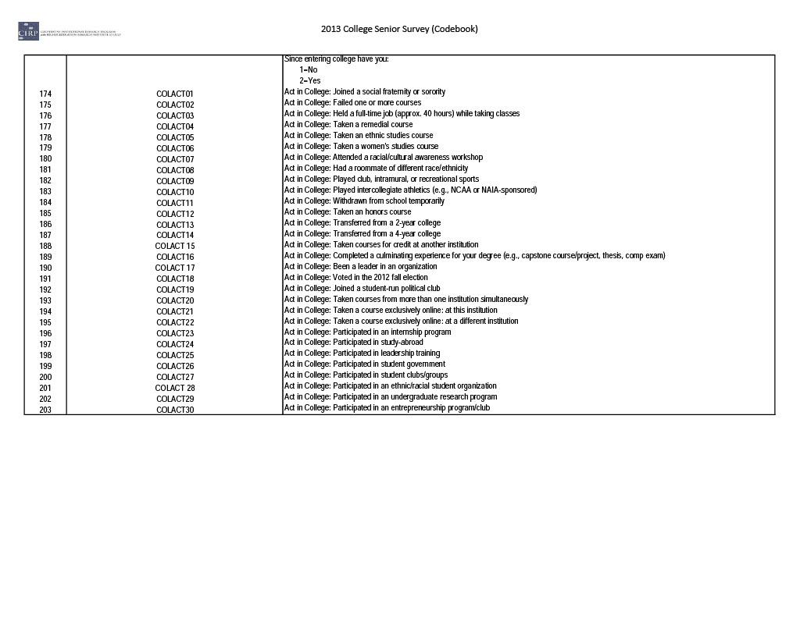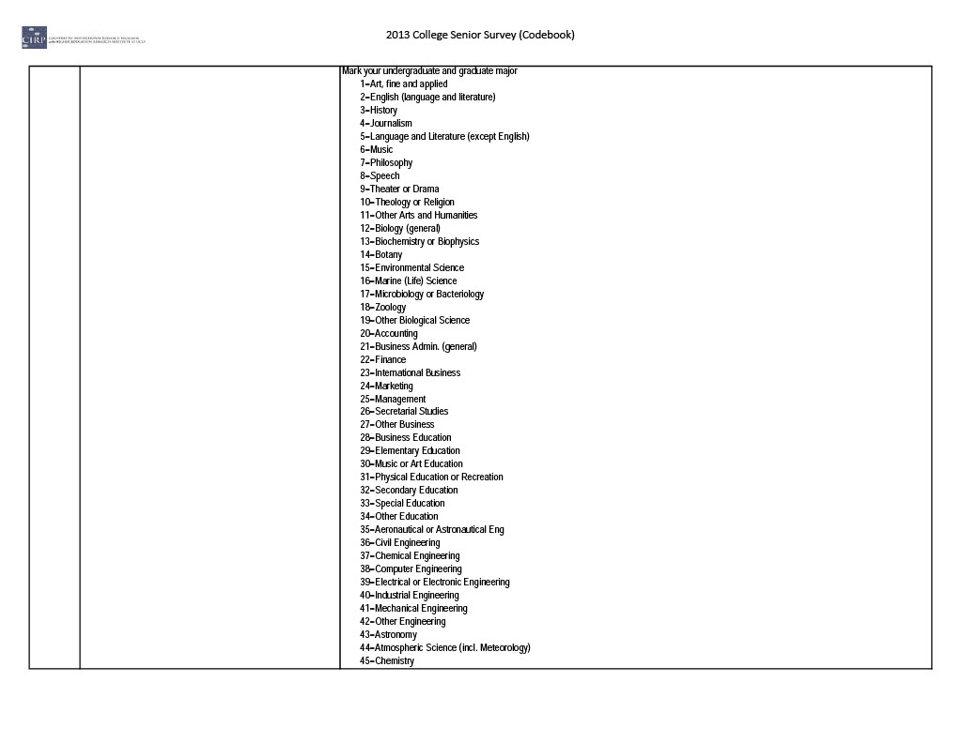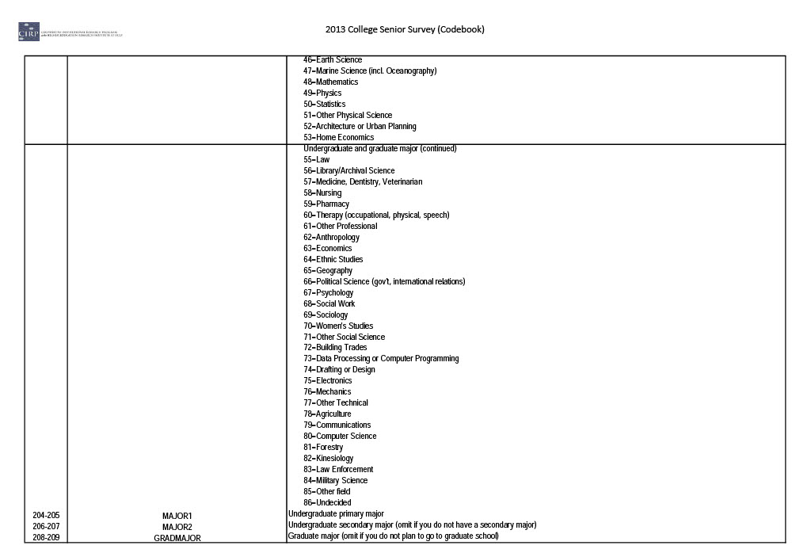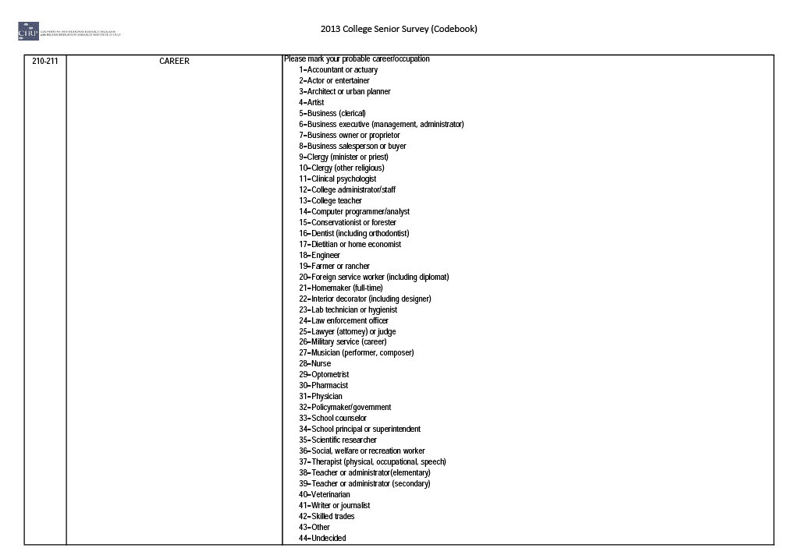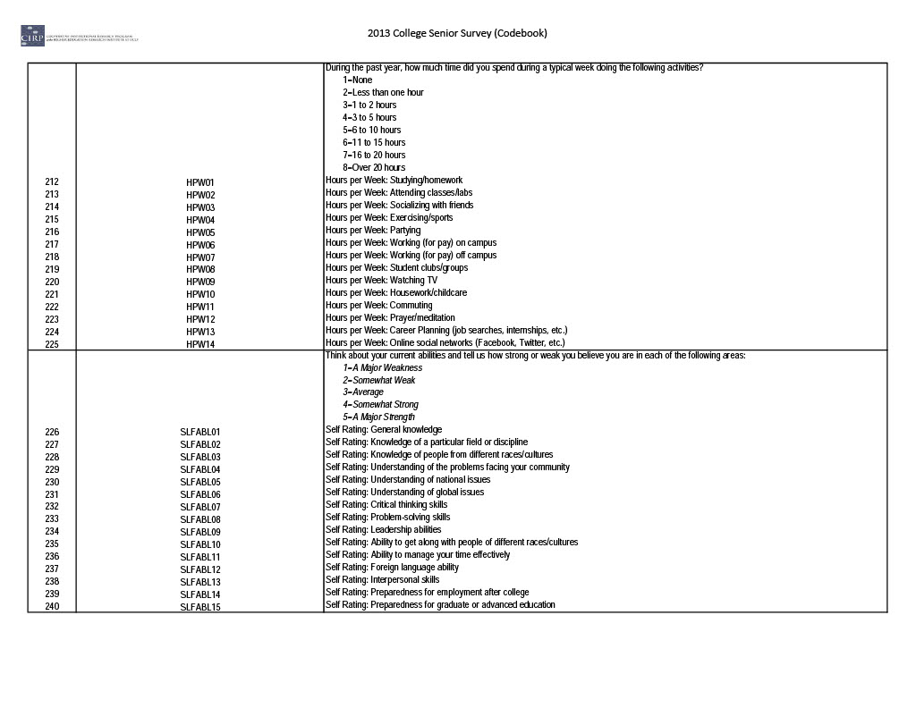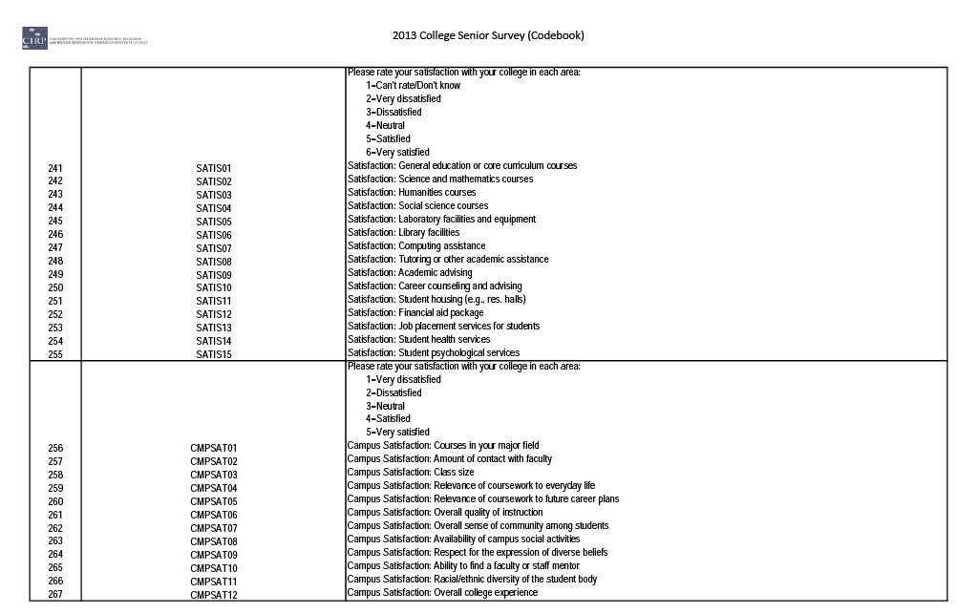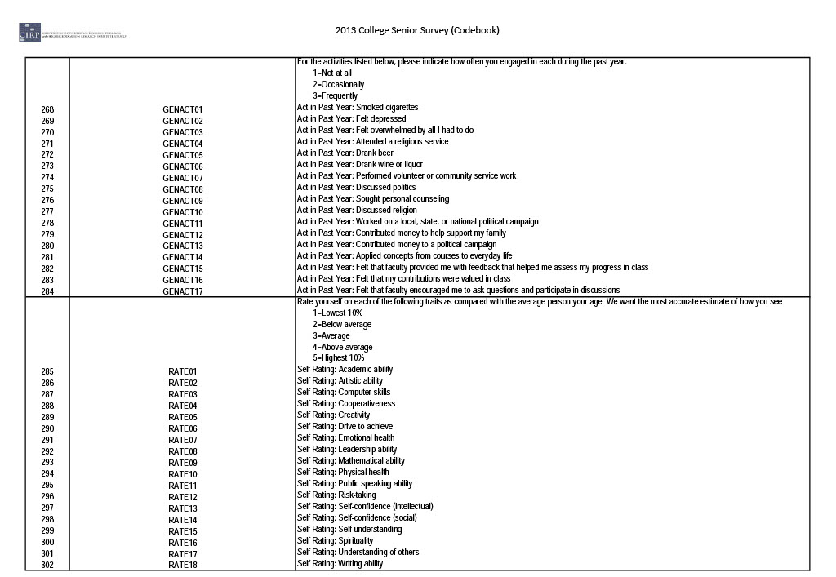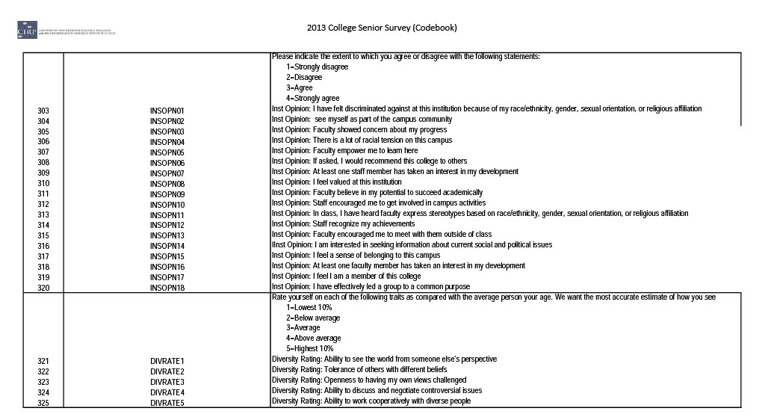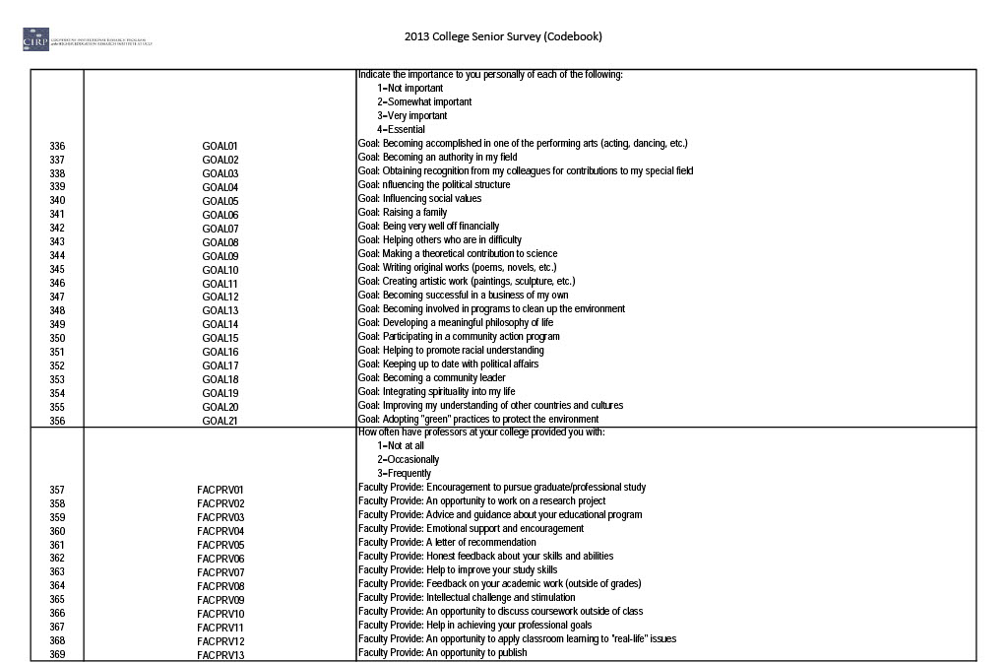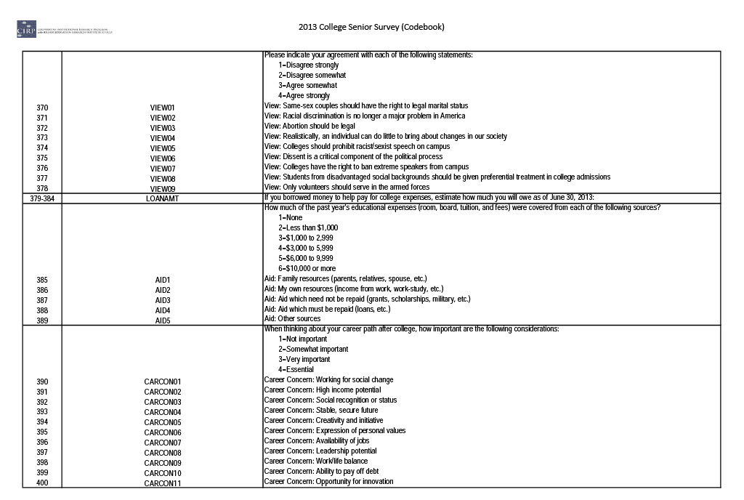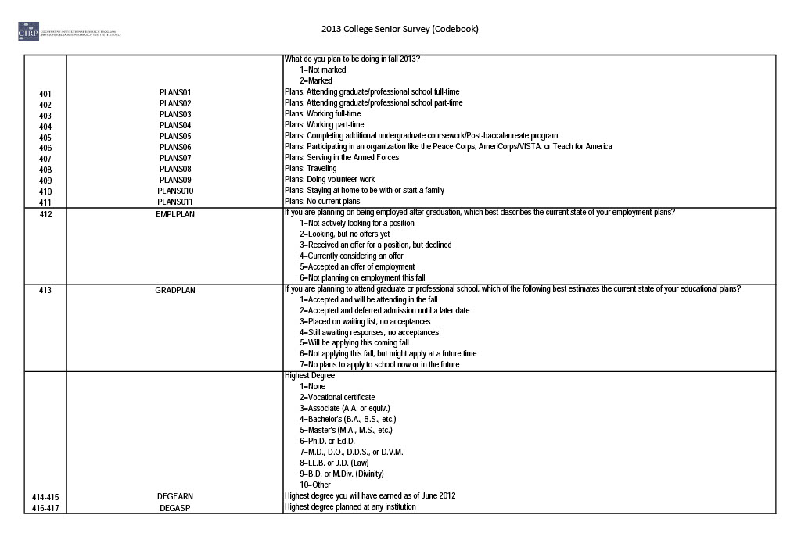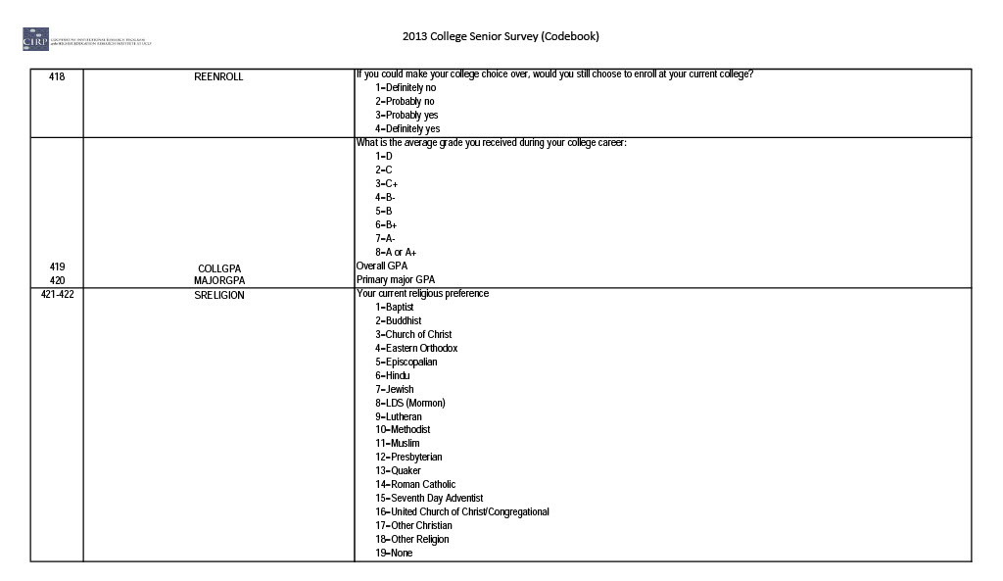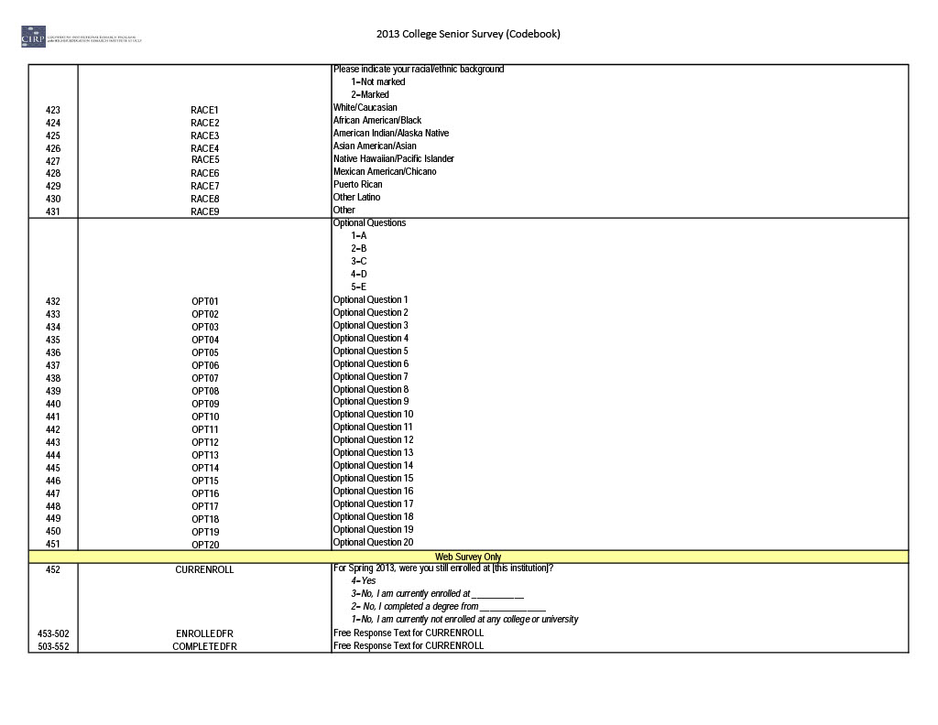

Appendix J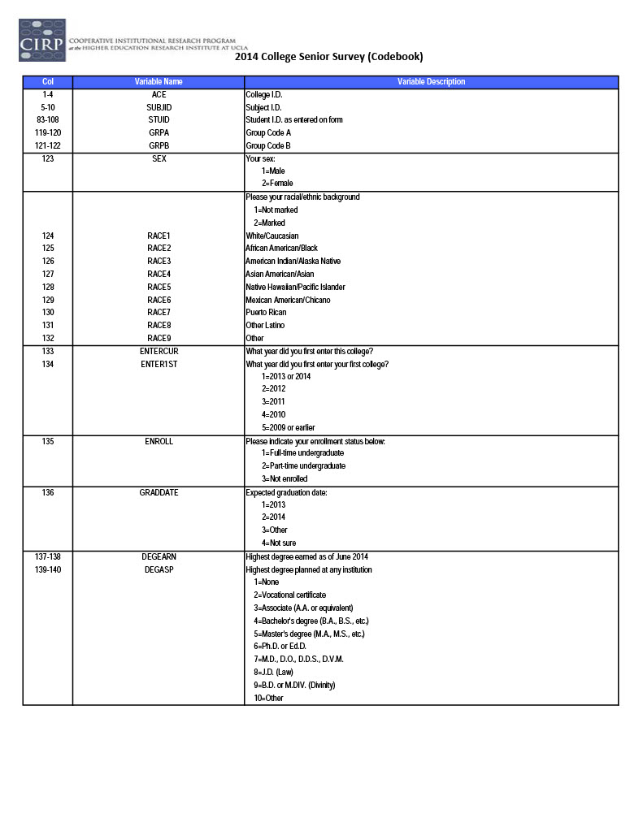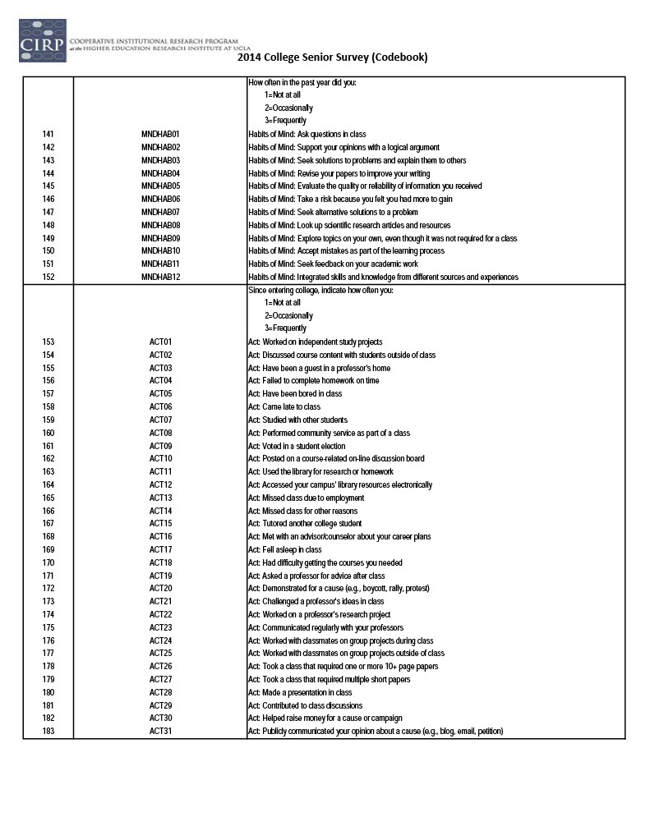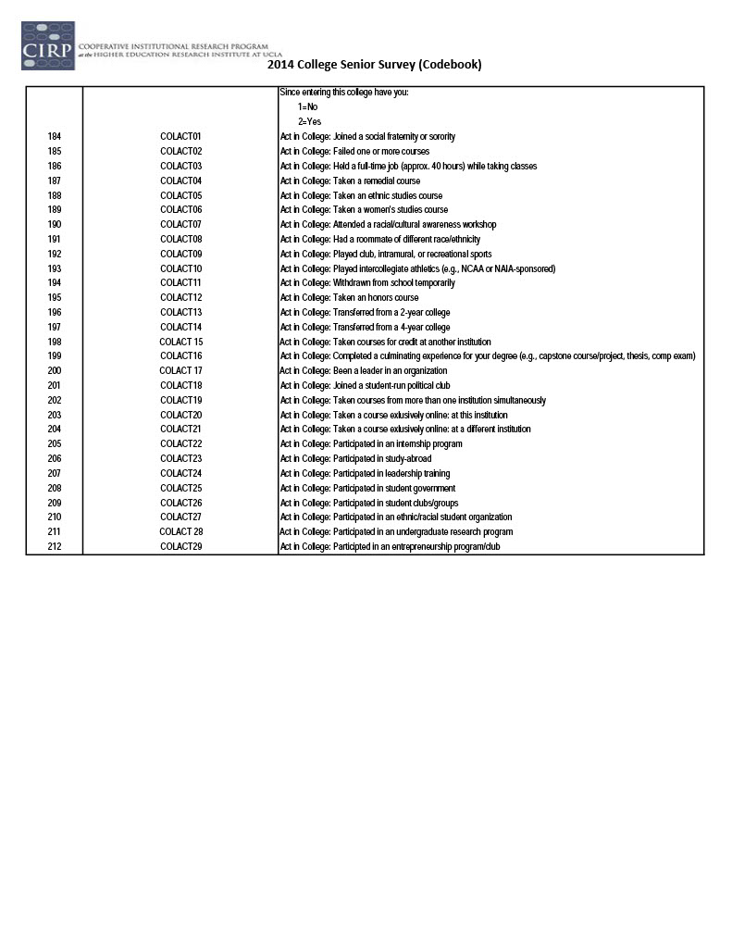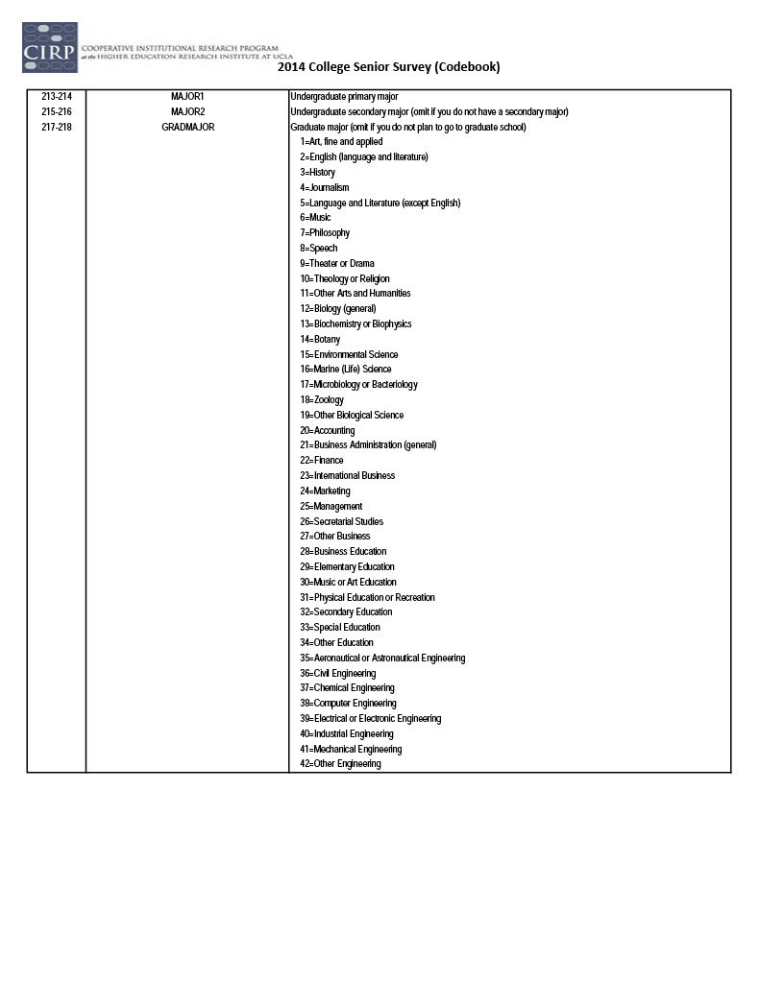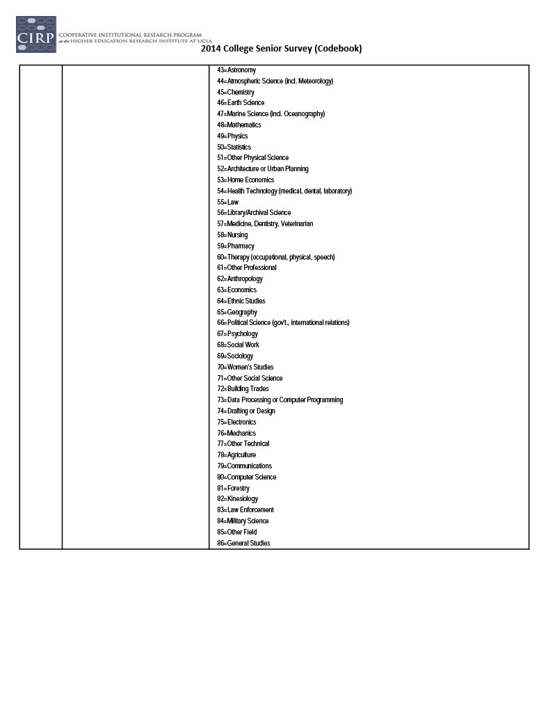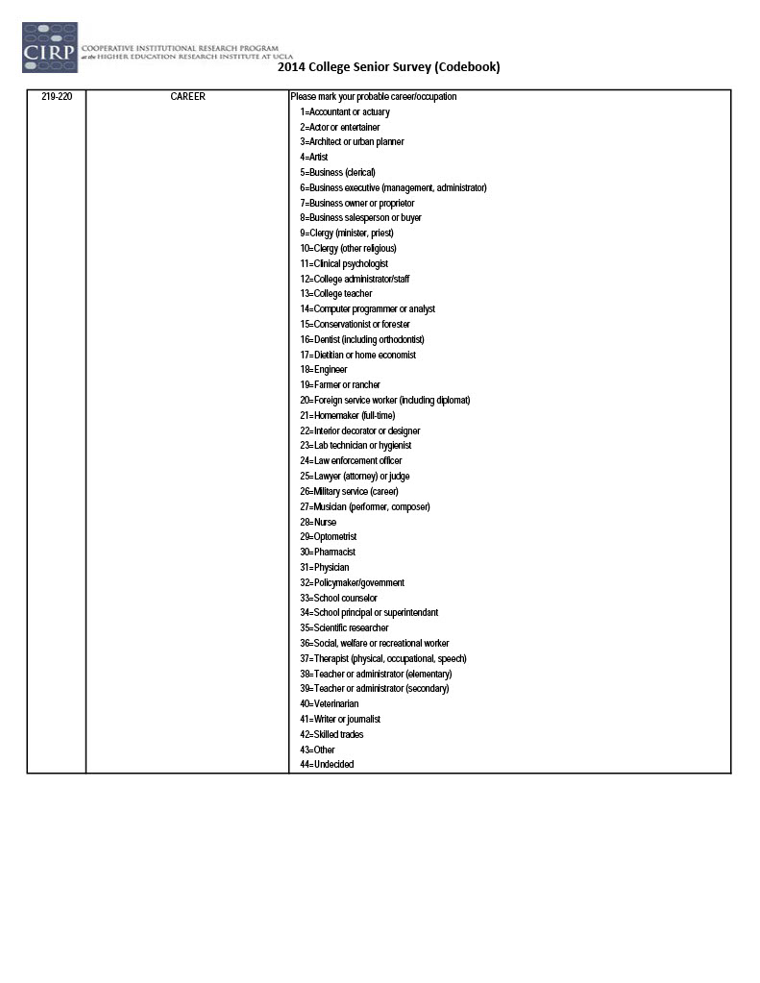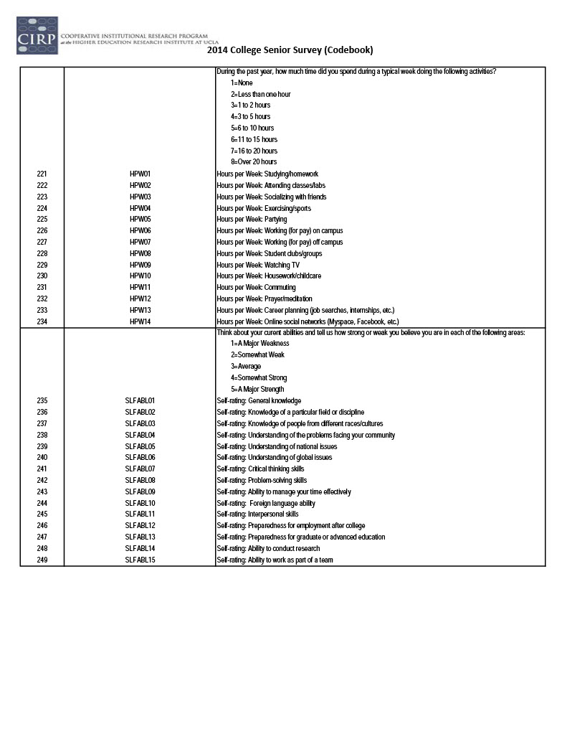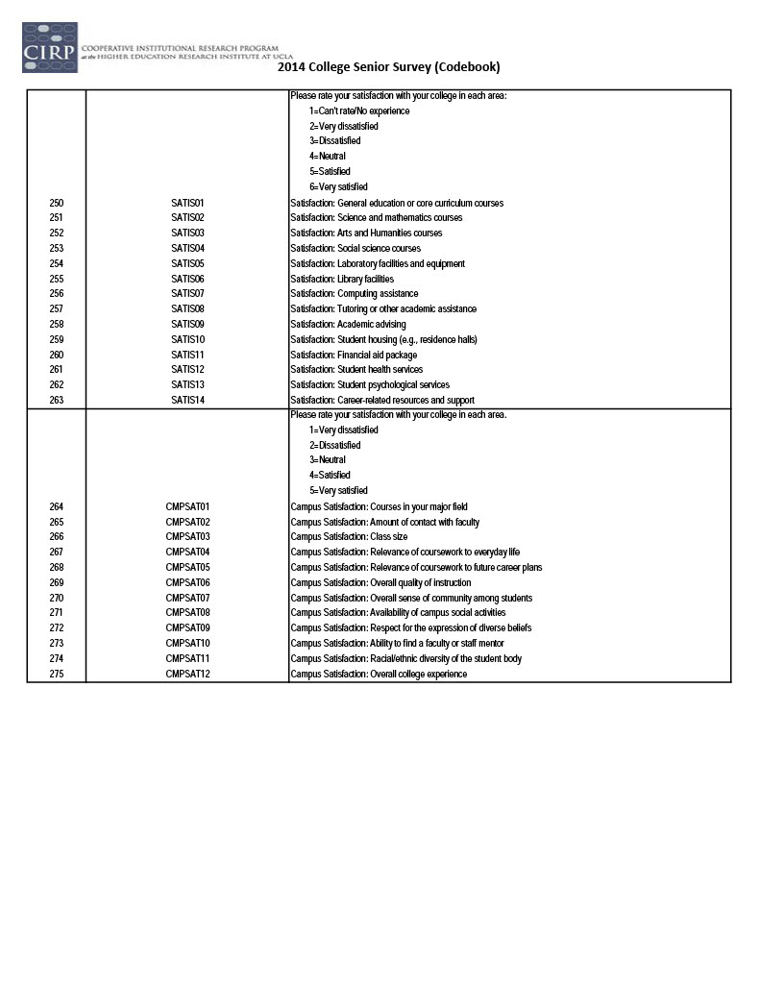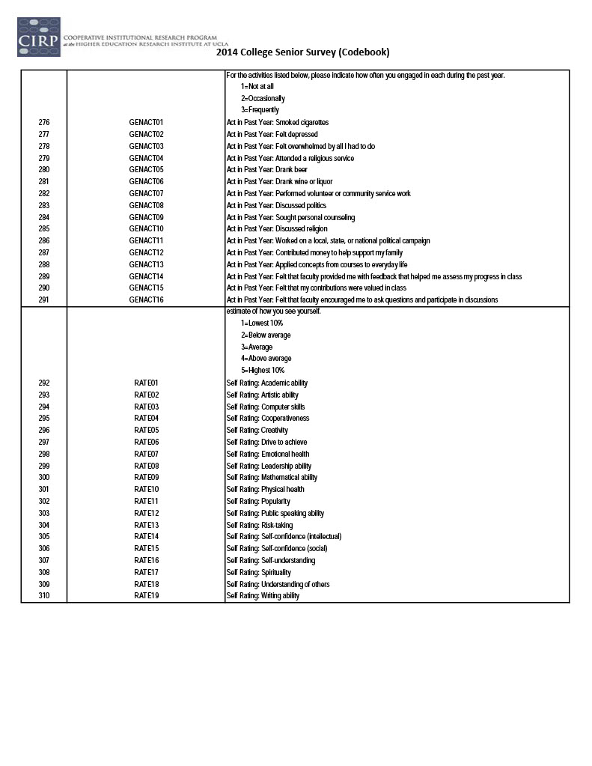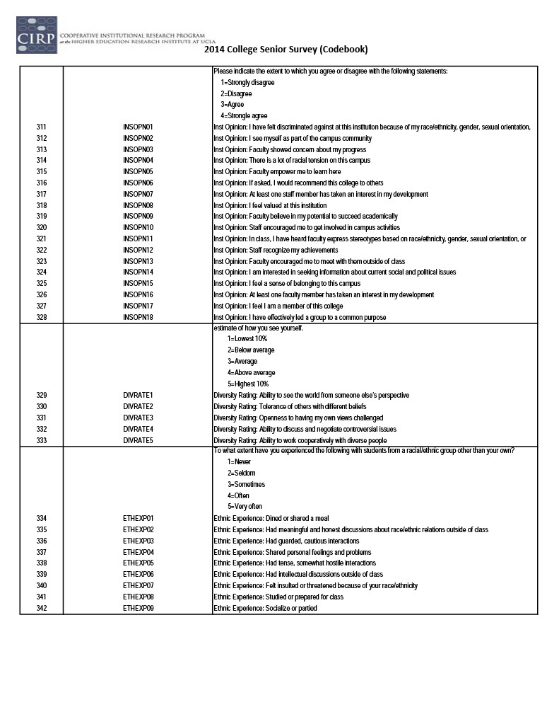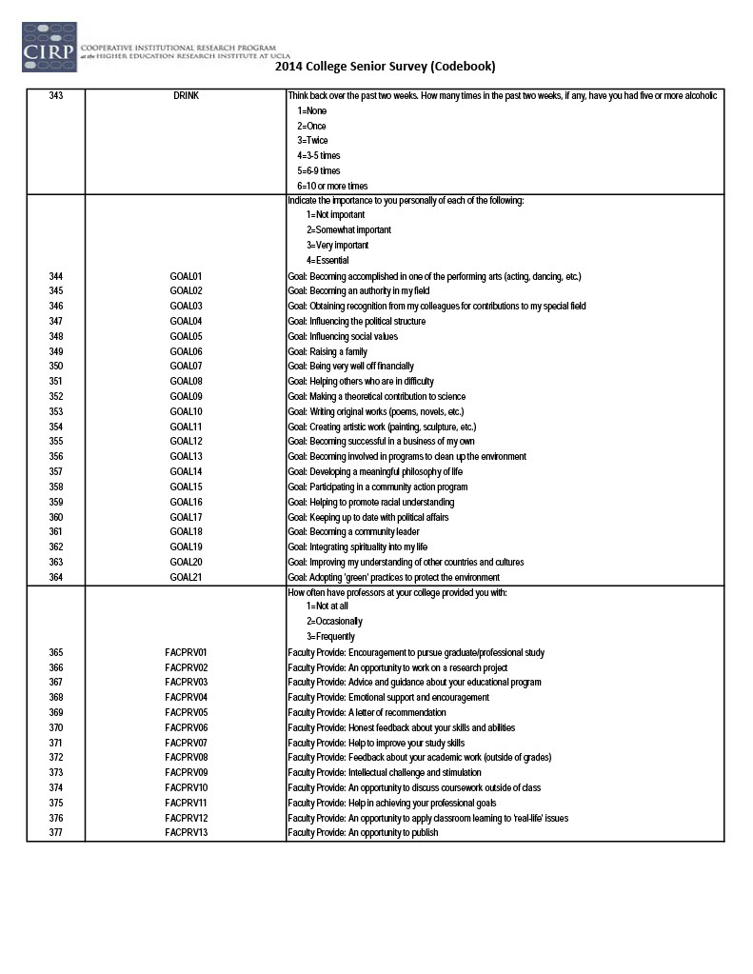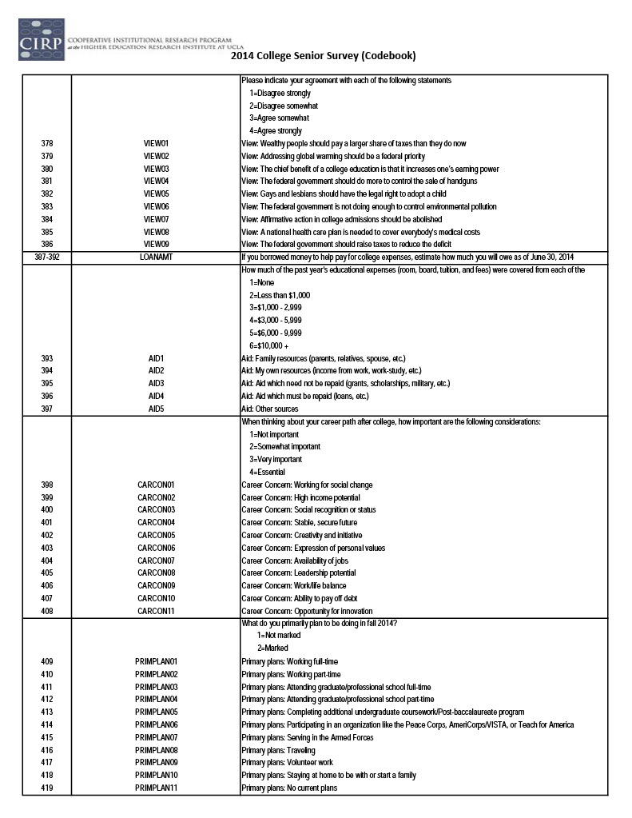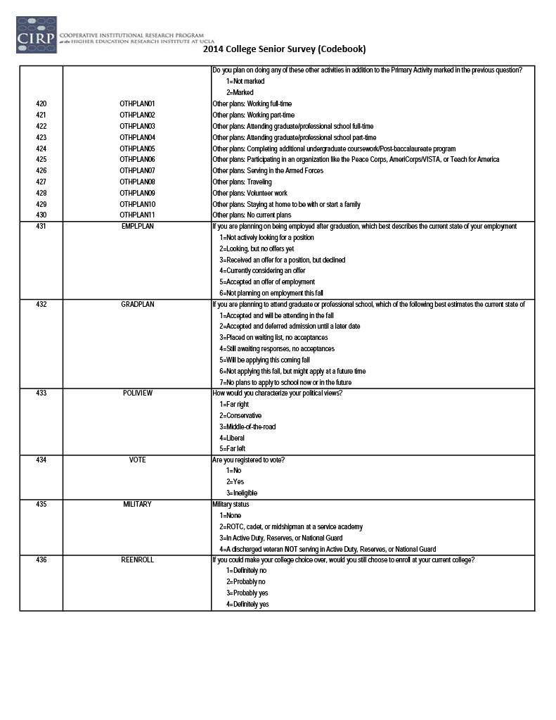

Appendix K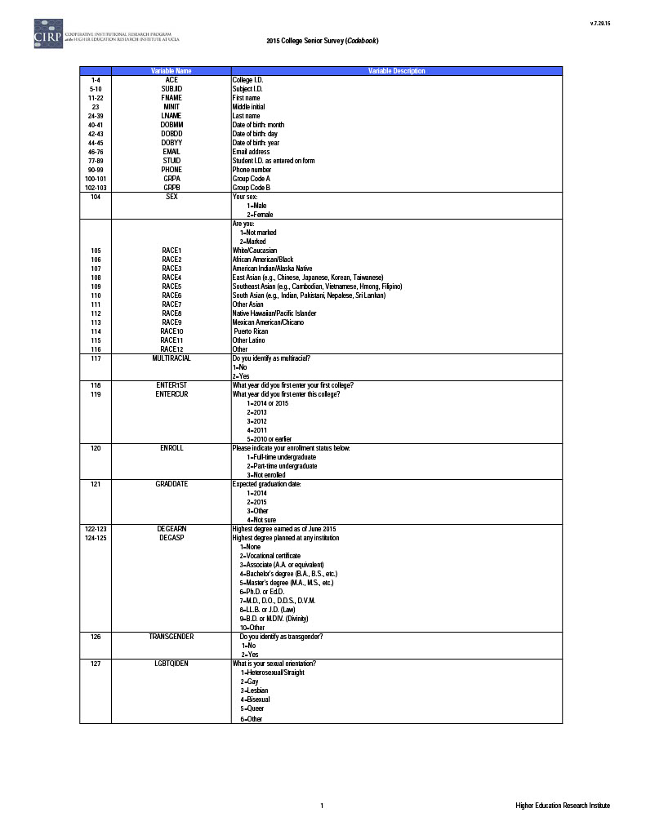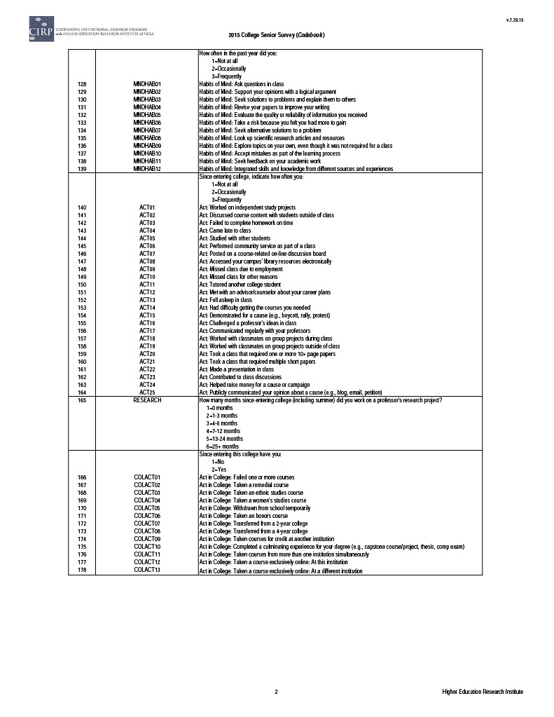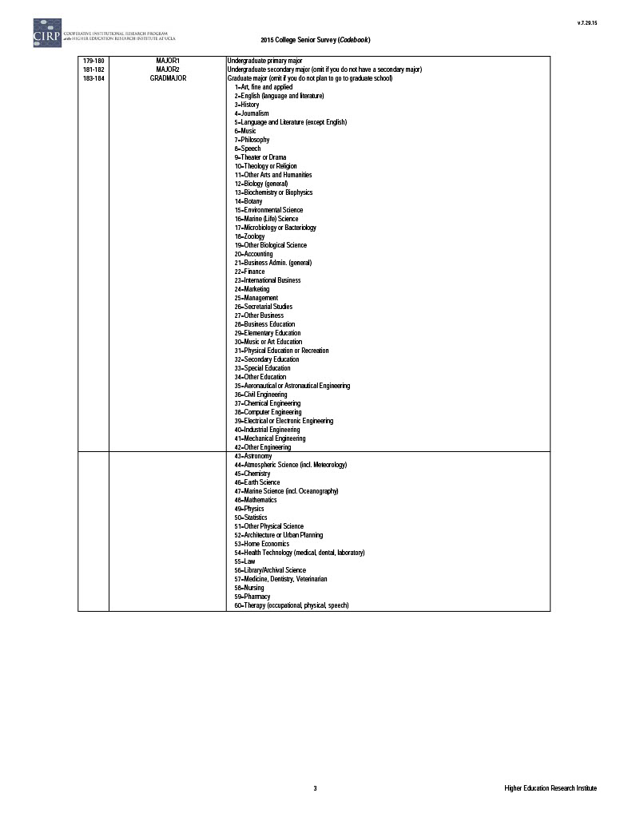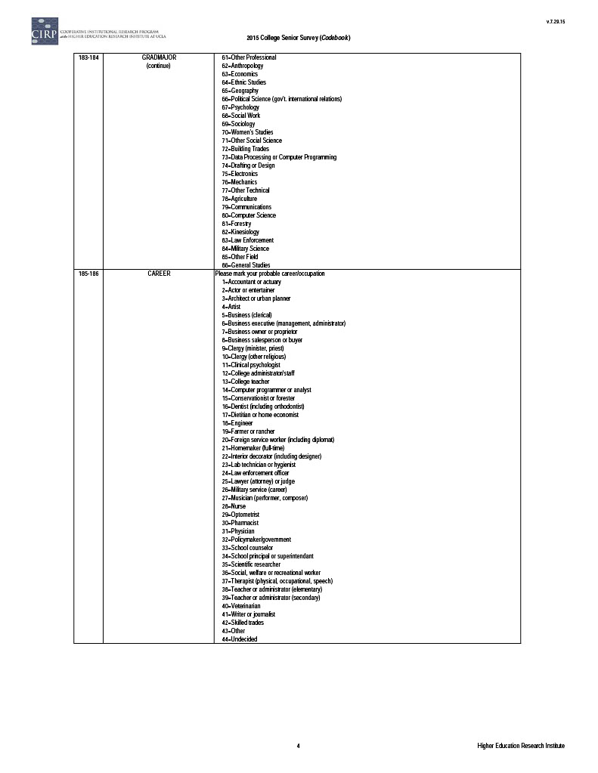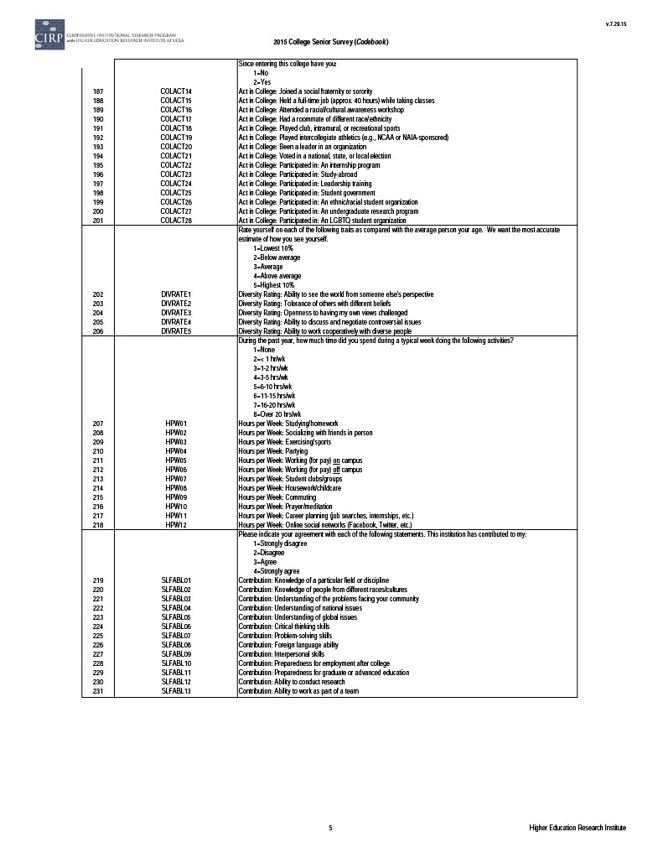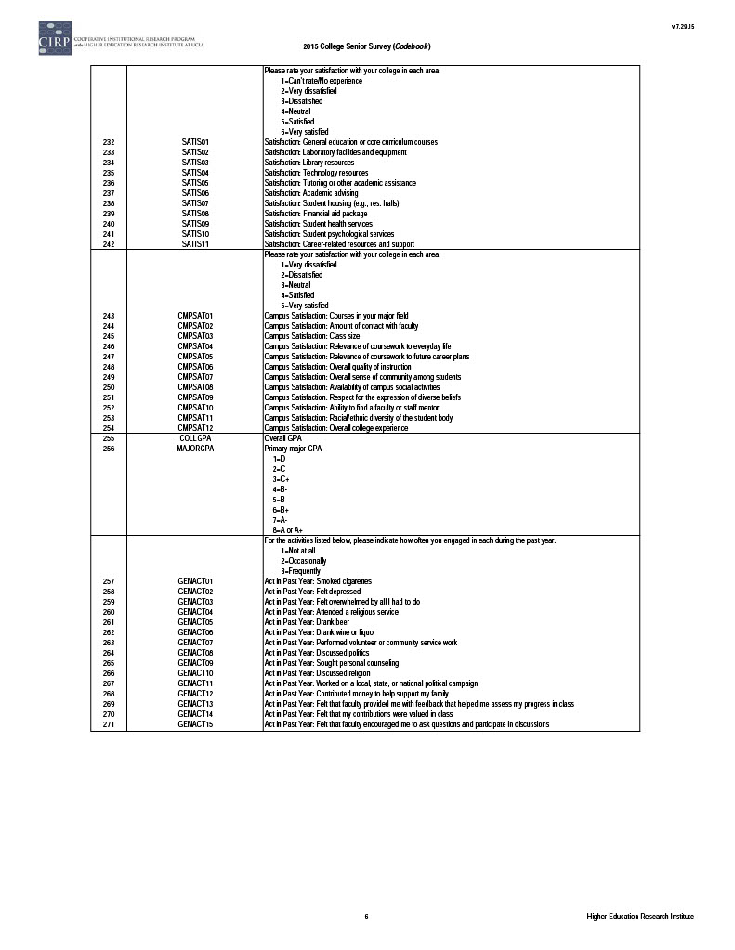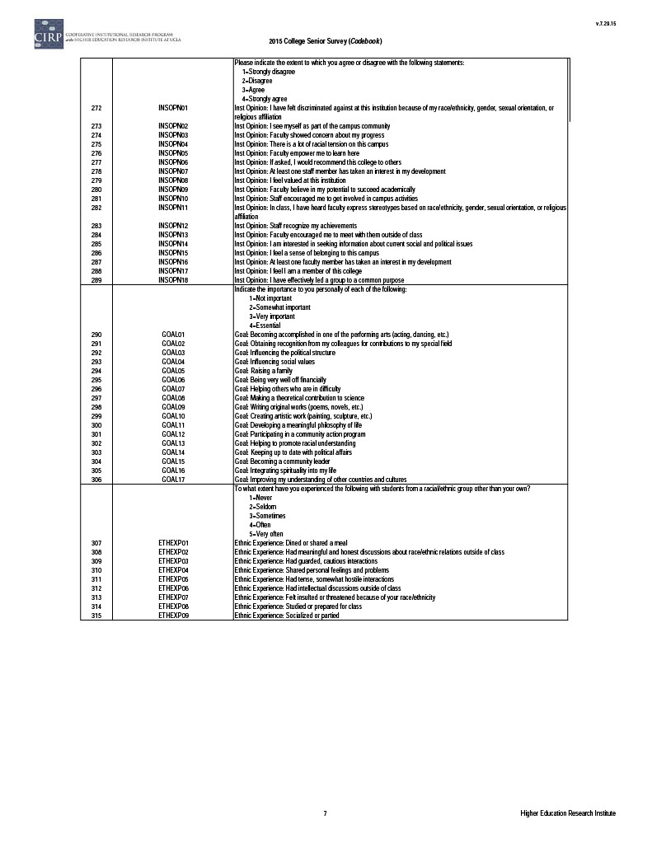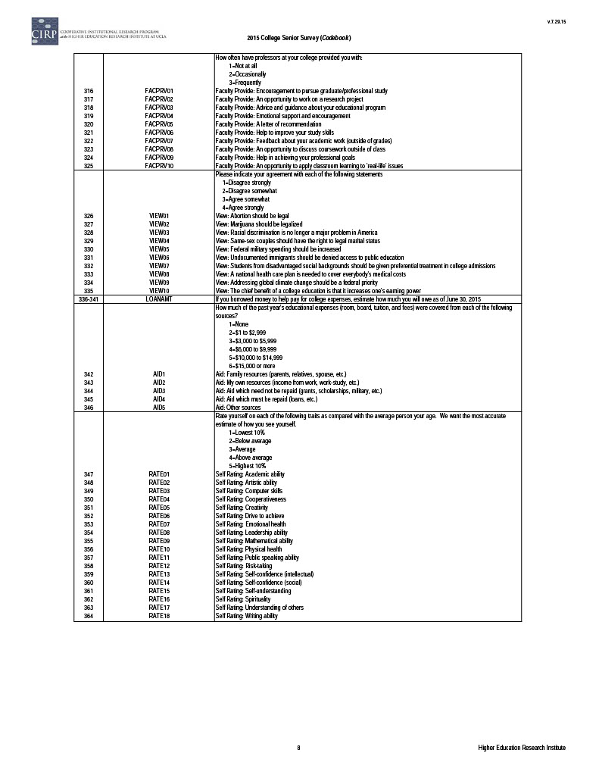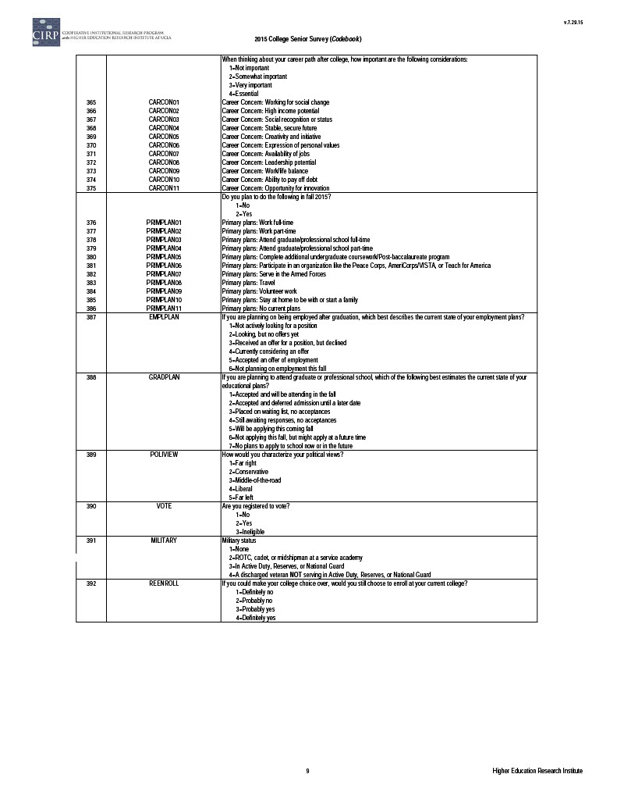

Appendix L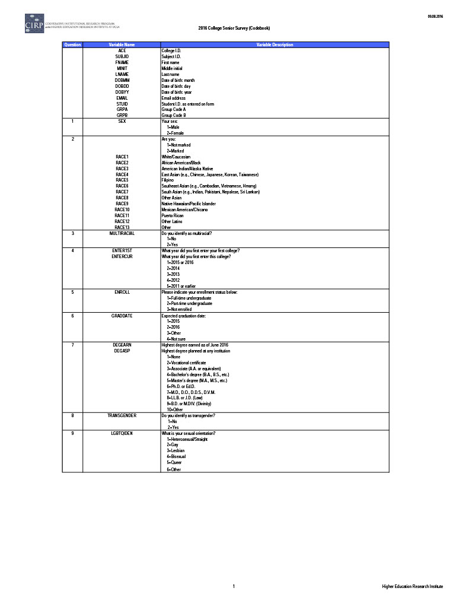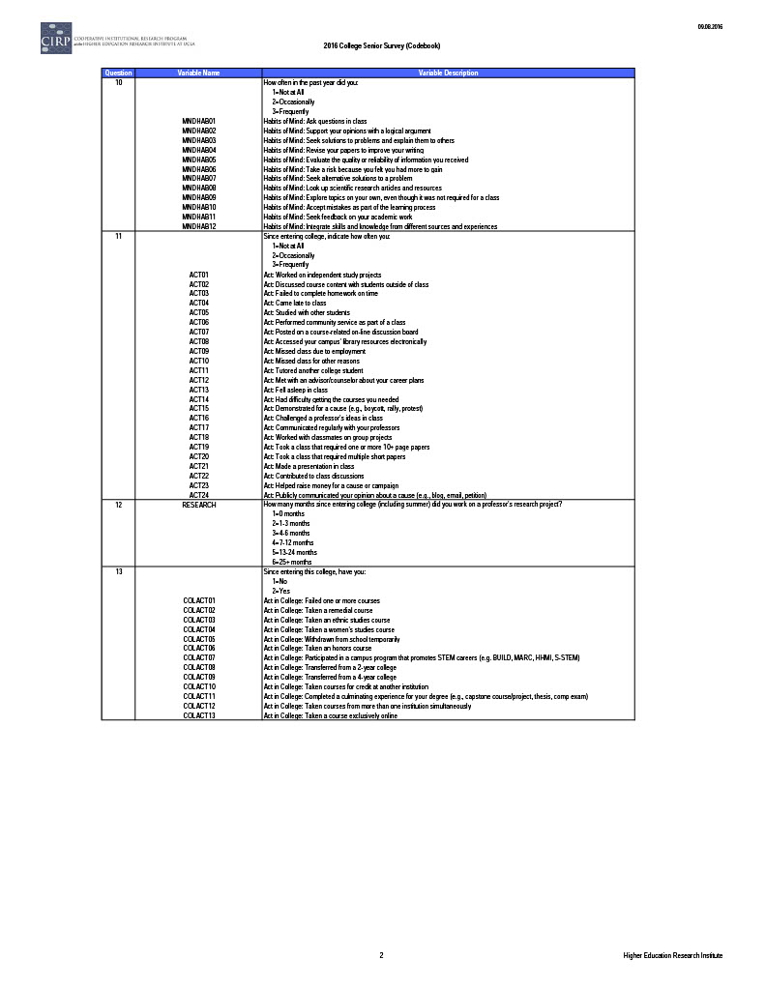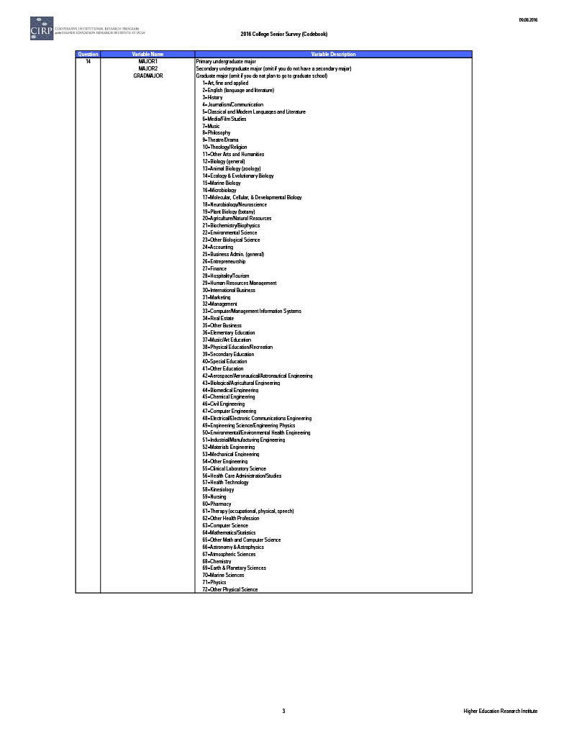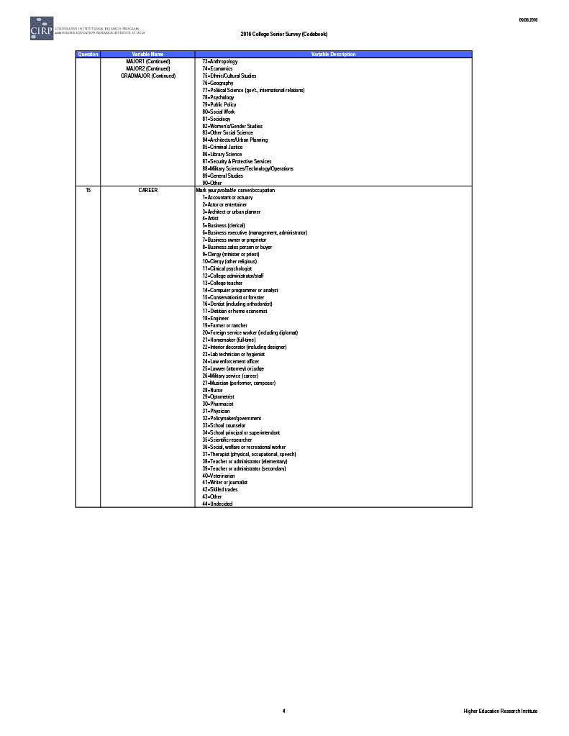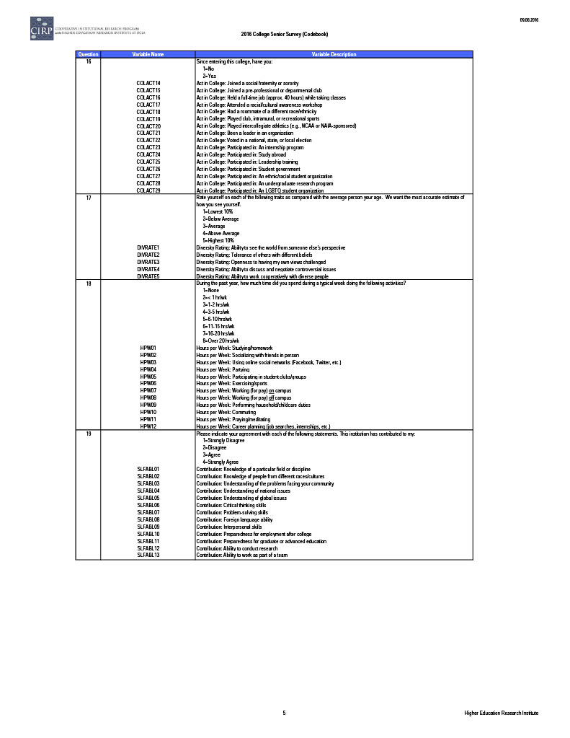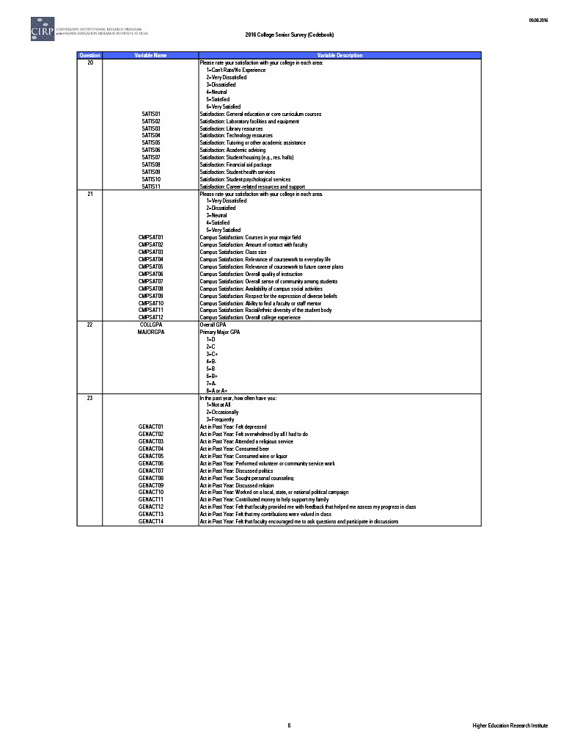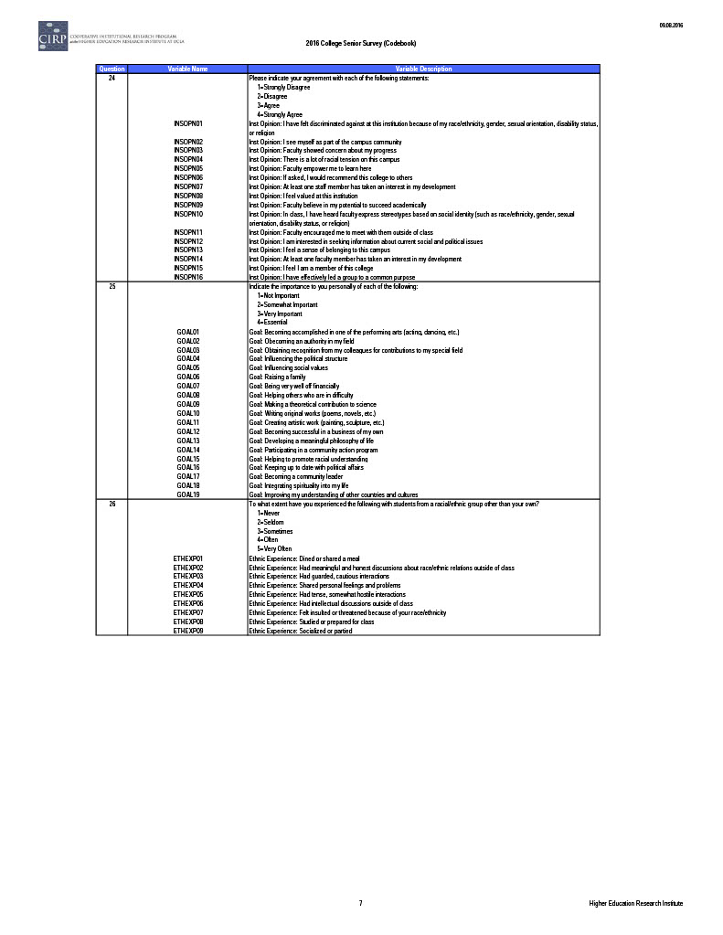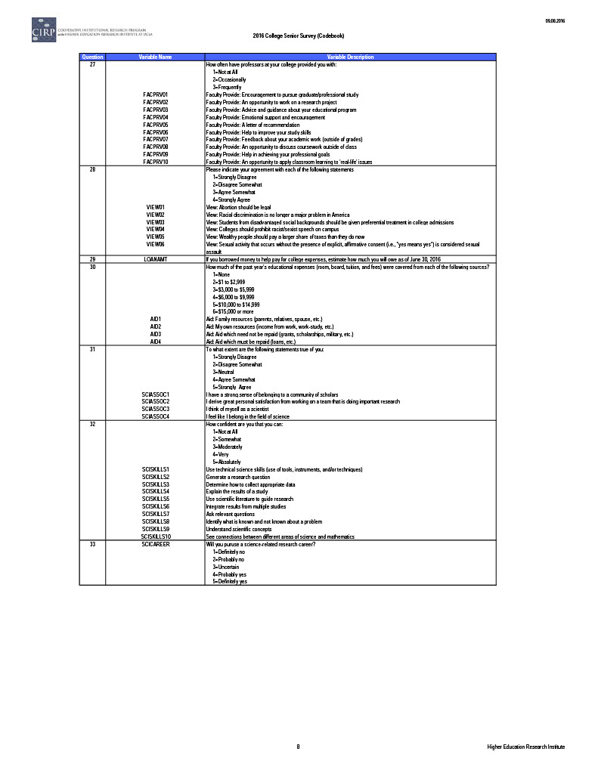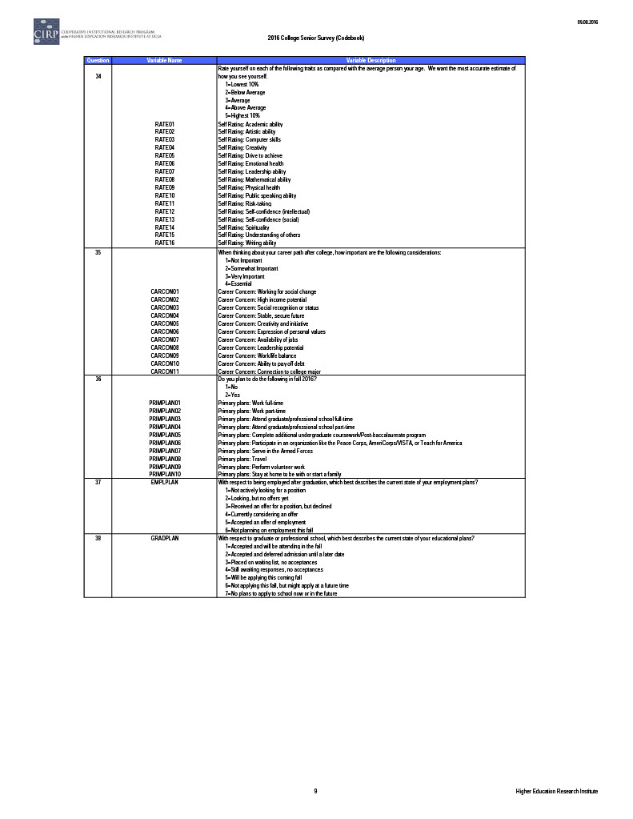

Appendix M

Permission for Data Access Letter
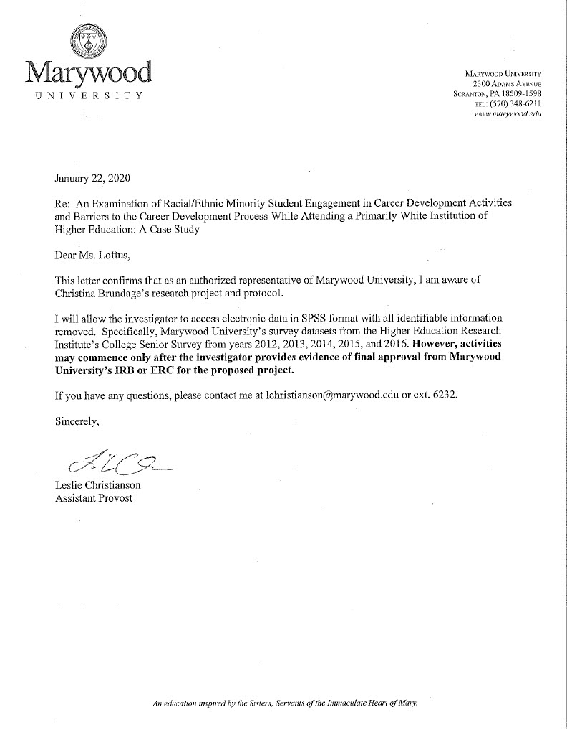
Appendix N

Conversion of Variables to Engagement and Barrier Score

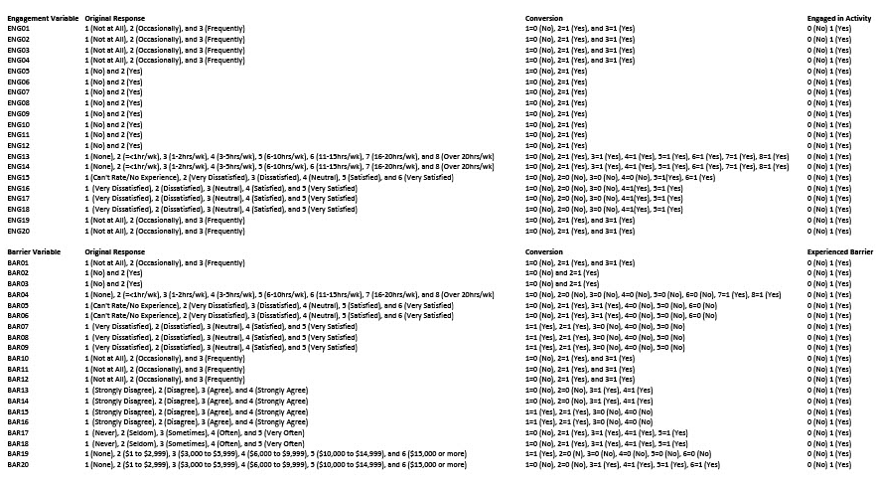

Appendix O

Engagement Score Instrument Questions

Question Response

- Met with an advisor or counselor about your career plans Y N

- Worked with classmates on group projects Y N

- Made a presentation in class Y N

- Publicly communicated your opinion about a cause Y N

- Joined a social fraternity or sorority Y N

- Played club, intramural, or recreational sports Y N

- Played intercollegiate athletics Y N

- Been a leader in an organization Y N

- Participated in an internship program Y N

- Participated in a study abroad program Y N

- Participated in leadership training Y N

- Participated in student government Y N

- Participated in student clubs/organizations Y N

- Performed career-planning Y N

- Received satisfactory career-related resources and support Y N

- Received satisfactory amount of contact with faculty Y N

- Coursework was relevant to future career plans Y N

- Found a faculty or staff mentor Y N

- Performed volunteer or community service work Y N

- Faculty provided an opportunity to apply your classroom learning Y N
to real-life issues
Appendix P
Approval of Instrument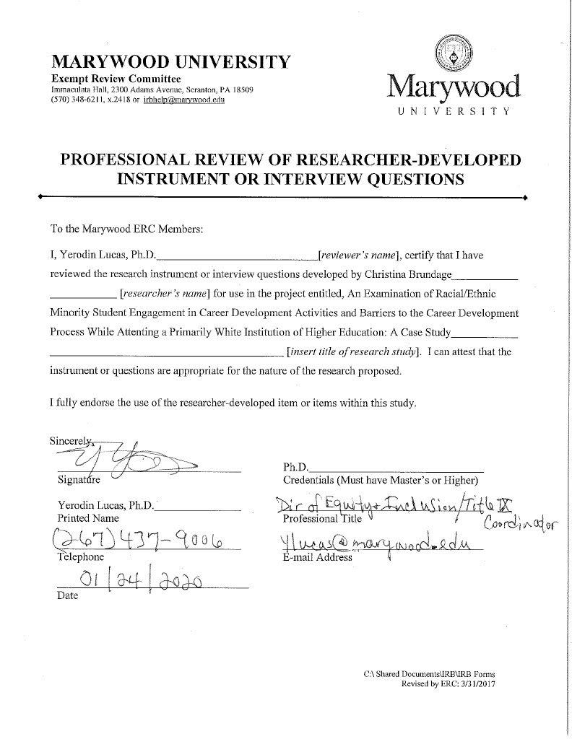
Appendix Q
Barrier Score Instrument Questions

Question Response

- Missed class due to employment Y N

- Withdrawn from school temporarily Y N

- Held a full-time job (aprox. 40hrs) Y N

- Performed household/childcare duties (16 or more hrs/wk) Y N

- Did not receive a satisfactory financial aid package Y N

- Did not receive satisfactory psychological services Y N

- Unhappy with overall sense of community among students Y N

- Felt disrespect for expression of diverse beliefs Y N

- Not satisfied with racial/diversity of the student body Y N

- Felt depressed Y N

- Felt overwhelmed by all I had to do Y N

- Contributed money to help support my family Y N

- Felt discriminated against at this institution Y N

- Have heard faculty express stereotypes Y N

- Do not feel a sense of belonging to this campus Y N

- A faculty member has not taken an interest in my development Y N

- Experienced tense, somewhat hostile interactions Y N

- Felt insulted or threatened because of your race/ethnicity Y N

- Did not receive aid from family resources for educational expenses Y N

- Had to cover my own educational expenses (work, work study, etc.) Y N

Appendix R

Frequency Distribution for Engagement Variables (White/Caucasian, N = 838), (R/EM, N = 62)

Engagement Score | Race | Frequency | Percentile(In Race)
3  4  5  6  7  8  9  10  11  12  13  14  15  16  17  19 | White/Caucasian  R/EM  Total  White/Caucasian  R/EM  Total  White/Caucasian  R/EM  Total  White/Caucasian  R/EM  Total  White/Caucasian  R/EM  Total  White/Caucasian  R/EM  Total  White/Caucasian  R/EM  Total  White/Caucasian  R/EM  Total  White/Caucasian  R/EM  Total  White/Caucasian  R/EM  Total  White/Caucasian  R/EM  Total  White/Caucasian  R/EM  Total  White/Caucasian  R/EM  Total  White/Caucasian  R/EM  Total  White/Caucasian  R/EM  Total  White/Caucasian  R/EM  Total | 3  0  3  3  0  3  12  3  15  16  3  19  25  3  28  46  4  50  83  8  91  99  11  110  99  8  107  134  4  138  100  6  106  94  6  100  72  1  73  30  5  35  21  0  21  1  0  1 | 0.4%  0.0%  0.3%  0.4%  0.0%  0.3%  1.4%  4.8%  1.7%  1.9%  5.8%  2.1%  3.0%  4.8%  3.1%  5.5%  6.5%  5.6%  9.9%  12.9%  10.1%  11.8%  17.7%  12.2%  11.8%  12.9%  11.9%  16%  6.5%  15.3%  11.9%  9.7%  11.8%  11.2%  9.7%  11.1%  8.6%  1.6%  8.1%  3.6%  8.1%  3.9%  2.5%  0.0%  2.3%  0.1%  0.0%  0.1%

Appendix S

Frequency Distribution for Barrier Variables (White/Caucasian, N = 838), (R/EM, N = 62)

Barrier Score | Race | Frequency | Percentile
0  1  2  3  4  5  6  7  8  9  10  11  12  13  14 | White/Caucasian  R/EM  Total  White/Caucasian  R/EM  Total  White/Caucasian  R/EM  Total  White/Caucasian  R/EM  Total  White/Caucasian  R/EM  Total  White/Caucasian  R/EM  Total  White/Caucasian  R/EM  Total  White/Caucasian  R/EM  Total  White/Caucasian  R/EM  Total  White/Caucasian  R/EM  Total  White/Caucasian  R/EM  Total  White/Caucasian  R/EM  Total  White/Caucasian  R/EM  Total  White/Caucasian  R/EM  Total  White/Caucasian  R/EM  Total | 2  1  3  51  3  54  87  4  91  140  8  148  135  10  145  156  10  166  110  5  115  71  9  80  35  5  40  24  4  28  11  0  11  9  0  9  3  1  4  2  2  4  2  0  2 | 0.2%  1.6%  0.3%  6.1%  4.8%  6.0%  10.4%  6.5%  10.1%  16.7%  12.9%  16.4%  16.1%  16.1%  16.1%  18.6%  16.1%  18.4%  13.1%  8.1%  12.8%  8.5%  14.5%  8.9%  4.2%  8.1%  4.4%  2.9%  6.5%  3.1%  1.3%  0.0%  1.2%  1.1%  0.0%  1.0%  0.4%  1.6%  0.4%  0.2%  3.2%  0.4%  0.2%  0.0%  0.2%

