Genetically Modified Organisms in the United States and its Effects
Namuunaa Otgonbaatar
GCH360-002
Professor Snyder
April 29, 2016

"By placing this statement on my webpage, I certify that I have read and understand the GMU Honor Code on http://oai.gmu.edu/the-mason-honor-code-2/ and as stated, I as student member of the George Mason University community pledge not to cheat, plagiarize, steal, or lie in matters related to academic work. In addition, I have received permission from the copyright holder for any copyrighted material that is displayed on my site. This includes quoting extensive amounts of text, any material copied directly from a web page and graphics/pictures that are copyrighted. This project or subject material has not been used in another class by me or any other student. Finally, I certify that this site is not for commercial purposes, which is a violation of the George Mason Responsible Use of Computing (RUC) Policy posted on http://copyright.gmu.edu/?page_id=301 web site."

Introduction
Genetically modified organisms are made with engineered materials with the goal of improving the original form. In United States of America majority of the food that individuals consume is genetically modified and altered. Genetically engineered organisms do not require labeling in the US. These organisms have not been out for a long time to see actual long-term effects on humans or in the environment, yet we have seen some diseases and infection increase after genetically modified organisms were introduced to the human world. Due to that certain countries banned GM food altogether, whereas in United States it has been very trendy.

Background
Genetically modified organisms have been increasing drastically in the past few years in the United States. It became the main source of food throughout the country. Majority of food sold and consumed has some alterations and structural changes in it. GMO food has not been out for too long, human beings don’t know much about it. Its long term affects and negative side effects are not known. GMO labeling requirements were set in most of European countries, Japan, Australia and China. Many places oppose genetically modified organisms. Yet United States is considered to be one of the world’s biggest GMO lovers with no labeling requirements. Looking at both positive and negative sides of genetically engineered organisms, it has brought more damage than wellness to the human world.
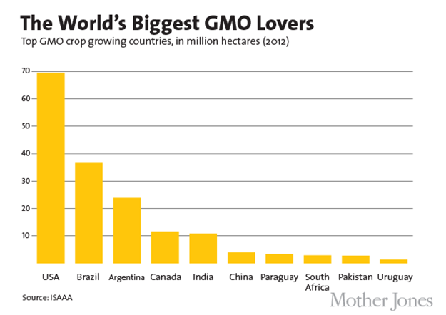
Methodology
To do this research on genetically modified organisms in the United States the best way was to get information from ProQuest scholarly journals and articles. Data and statistics were acquired from NONGMO Project Act website. These websites are accurate and efficient due to its recent publication. The World According To Monsanto by Robin gave a whole new perspective on genetically modified organisms, and the book looks from the inside of everything what it has caused and damaged. Researching and looking at both sides of a certain thing is always a great way to do a research especially from scholarly articles and studies that were done. Data is crucial in research papers; it makes one’s paper more provable and gives specific points.
GMO Labeling in the United States
United States doesn’t have any labeling requirements regarding to genetically modified organisms. Yet consumers do have the right to know what they are paying for and what they are about to consume. People starting to understand more about GMO food and became more aware of its effects, and want to know what’s on their plate nowadays. In America, 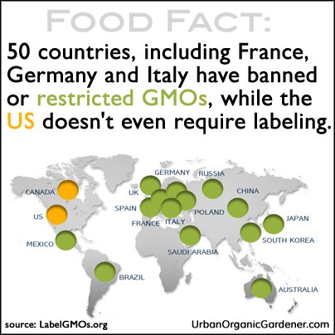GMOs health and environmental risks are mostly neglected and ignored. The World According to Monsanto by Robin (2010), states a lot of workers and main people of Monsanto got into the government and to US Food and Drug Administration. Monsanto is the biggest GM producing company throughout the world. Their connection within the government allows them to pass on genetically modified organisms with no specific requirement or law. According to Leahy (2016), the Biotechnology Food Labeling and Uniformity Act would allow American consumers to see whether a food has been prepared with GM ingredients, while offering food manufacturers several options for including this information on or near the ingredients list. It would be a great beginning to start on labeling, individuals who are purchasing the labeled products would know what they are investing in. “This framework meets the needs of consumers, the vast majority of whom support labeling according to polls, and producers, who worry that a patchwork of state labeling laws would be costly and difficult to comply with and confusing for consumers” (Leahy, 2016). From producers and consumers point of view, it would be very efficient. People who choose to buy such food would know what they are paying for, whereas now majority the produce, whether they are organic or non-GMO or genetically modified are not labeled and sold almost on the same shelf. Starting to label would be very helpful for those who want to invest in their health and purchase only natural or organic food.
Pros and Cons
There are two sides to everything. Genetically modifying organisms results in production of more food and can help the hungry and those in need. Modified entities “may be more resistant to weeds, pests, disease and drought” Erdosh(2014). Helping to reduce world hunger and starvation through producing more food at a faster rate is notable. Also sufficient yield of produce that has a better sustainability will result in improved financial gains of a certain country. Some say the food quality may be improved and have more nutritional value through modifications. These are all delightful sides of the GM organisms.
Despite all those benefits, there are a lot of issues with genetically modified food. Downside to GM technology is that it causes a lot of allergies in some individuals. To modify an organism a gene of a different organism is inserted to the host. To genetically engineer organisms genes are mutated, changed, inserted or deleted by using different techniques or biotechnology. That makes the food very questionable; individuals won’t know what they are consuming specifically due to DNA alterations in the organisms. Margaret Wittenberg stated “ we need to have more answers before we move forward on having it commercially available at this point in time” speaking to WebMd. Even when people get sick, a lot of doctors prescribe non-GMO diets and recommend organic produce. The American Academy of Environmental Medicine cite “how genetically modified food can leave material behind us possibly causing long-term problems,” said Smith. Everything that is natural with no chemicals involved is healthier. It is better to consume all natural and organic produce because it is safe.
GMO leading to Cancer and Obesity in United States
Did GMO lead to more diseases in the United States? GM plants have not been out for too long, yet the process of creating GM organism can result in “massive collateral damage that produces new toxins, allergens, carcinogens and nutritional deficiencies” (Smith, 2011). As noted earlier in the paper, FDA doesn’t require a safety study for GM foods and doesn’t mandate a labeling on them. According to Smith (2011) the percentage of Americans with three or more chronic illnesses jumped from 7 to 13 percent in just nine years, right after genetically modified organisms were introduced in 1996. It caused more food allergies, disorders such as autism, reproductive and digestive problems and many others. It is not natural to add genes and living things such as bacteria to DNAs of completely different living thing and produce an organism for consumption. Avoiding antibiotics, growth hormones, synthetic chemical fertilizers and pesticides is a great way to protect one’s health. Yet these are the most common ingredients that are added to daily food of American consumers. These ingredients have been linked to health problems, including neurological and endocrine system disorders and cancer (Smith, 2014). Through diet people get their nutritional benefits, if there are such unnatural and unhealthy things are added the body will respond negatively. It is important to think about society’s health above all and not add such things into their diet.
Analysis
Looking at all different sides and effects of genetically modified organisms since it has been introduced to the human world, it seems it is better to consume natural and organic produce. It was given by the nature and that is the best way things should stay, anything that is modified and altered by humans for consumption may not be the best solution. Due to all the modifications in the diet and consumption, people’s body and health are changed. It may be the leading cause of obesity and diabetes in United States. If one thinks about his or her health and future, it is better to consume all natural and organic produce.
Conclusion
Through this research, it was made clear that Non-GMO and organic food source is definitely better than genetically altered organisms. For now there are no specific food requirements and laws are made to control the safety of GM engineered produce in the United States. Many other places have banned genetically changed food from their food chain for the safety of its citizens. United States is not there yet, for now just starting to label GMO food and separate them from natural produce would be a step forward. Because it has not been long enough, there are not enough research and knowledge on its negative side effects and trouble it may bring for the health. It is better for people to chose organic produce and restrict genetically modified food from the diet, to stay on the safe side and think about one’s future health.

References
Erdosh, G., & Lusted, M. A. (2014, 02). To GMO or NOT to GMO? Odyssey, 23, 15-19. Retrieved from http://search.proquest.com.mutex.gmu.edu/docview/1502614395?accountid=14541

Goldbas, A.,M.S.Ed J.D. (2014, 07). GMOs: What are they? International Journal of Childbirth Education, 29, 20-24. Retrieved from http://search.proquest.com.mutex.gmu.edu/docview/1545045515?accountid=14541

Merkley, leahy, tester, feinstein introduce GMO food labeling legislation. (2016). (). Lanham: Federal Information & News Dispatch, Inc. Retrieved from http://search.proquest.com/docview/1770072631?accountid=14541

Robin, M. (2010). The world according to Monsanto: Pollution, corruption, and the control of the world's food supply. New York: New Press.

Smith, J. (2011, August 25). 10 Reasons to Avoid GMOs. Retrieved April 23, 2016, from http://responsibletechnology.org/10-reasons-to-avoid-gmos/

Smith, M. D. (2014). Non-GMO vs. organic. Better Nutrition, 76(3), 70-70,72. Retrieved from http://search.proquest.com.mutex.gmu.edu/docview/1511427311?accountid=14541

