Newsletter - Luau 2018 MaryJoBrown.org

Kindness Campaign Finalists

We Broke Records…
Mahalo! Mahalo is how we say “thank you” in Hawaiian and we are ever so thankful to all of our supporters that helped us to have a record-breaking flagship fundraiser for our 7th Annual Indoor Luau.
The hall at the Saugus Elks was set up in record time with the help of Tommy’s cousin, Ken DeCristoforo, Ken’s lovely fiancé, Bonnie Douglas, and Steve Young. Guests were greeted at the door with the help of volunteers Sue Grant and Kim and Kelly Vernorelli.
The buffet dinner, fully donated by Tommy Brown, ran like a well-oiled machine under the watch of Mary Jo’s cousin, Sharon Cora and her team comprised of son DJ Cora, Mary Jo’s cousin Bob O’Brien, Carlos Mora, and long-time Brown-family friend, John Lynch.
The amazingly generous, DJ Deja Denise LaCarubba Wendt, Christina’s dear friend who has kindly donated her time since our first year, acted as emcee.
We raised more money than we have in any of our previous years.
The Silent Auction was a big success with many people heading home with fantastic items provided by individual sponsors and local businesses https://www.maryjobrown.org/sponsors, and the “50/50 and More” raffle brought in the most it ever has at any other event. Kevin did an incredible job of parting people with their money. The winner of the cash prize was awarded a pot of more than $1100 and generously donated half of these winnings back to the Mary Jo Brown Foundation (THANK YOU to long-time supporter, Dan Corcoran!!!)!
There was a fantastic turnout of family, and old and new friends in attendance to see, what was the highlight of the day, the introduction of our 2018 Kindness Campaign finalists. On hand to help us with the Kindness Campaign presentation were our very first Spreading Smiles Award winner, Noelle Gregoire, and our most recent Spreading Smiles Award winner, Kailey Moras.
The stories of four exceptional, young ladies were shared, and each finalist; 14-year old Meredith Casey of North Reading, 10-year old Julia Degnan of Dracut, 16-year old Hannah Finn of Andover, and 14-year old Sarah Podradchik of Melrose, received a framed certificate, a personalized book (courtesy of our friends at “I See Me”) and a $250 TD Bank gift card.
Then, the moment everyone was waiting for…Who would walk away with the Mary Jo Brown Foundation 2018 Spreading Smiles Award and a trip for four to Disney World in Florida?!?
The winner would be…
Hannah Finn!
It needs to be noted that this year’s decision was our most difficult yet. Every one of these young ladies was extraordinary…of the highest caliber…
Christina asked her fellow board members, “What would Mom do?”…What WOULD Mary Jo do???
After celebrating Hannah’s big win, there was one announcement left to make. For just one day…we got to play “Oprah”…and were able to say,
“Julia, you’re going to Disney World!”
“Meredith, you’re going to Disney World!”
“Sarah, you’re going to Disney World!”
Talk about spreading smiles…Our 7th year was our best and most successful yet…And we could not do this without your help, love, and support…so thank you to each and every one of you…Mahalo!
We broke records…

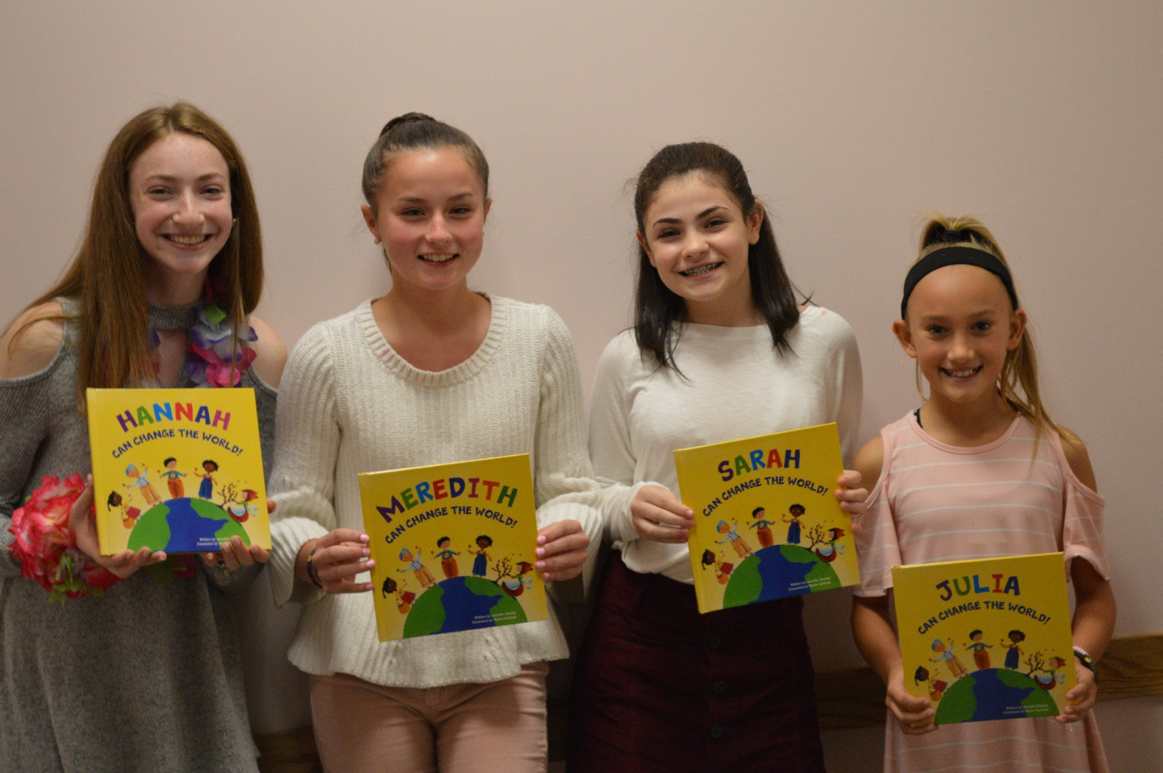
HIGHLIGHT OF THE DAY-OUR 2018 KINDNESS CAMPAIGN FINALISTS
Hannah Finn, Meredith Casey, Sarah Podradchik and Julia Degnan

These girls and their stories deserve to be shared—following are the presentations of President Christina Brown and Secretary Sharon Macone

Julia Degnan is a 10-year old 5th grade student at the Englesby Elementary School in Dracut.
At a young age, Julia particularly shined when it came to being sensitive to the needs of others. Her parents taught her to always be willing to give before receiving.
In early 2016, Julia was diagnosed with atrial septal defect, which would require surgery. Julia was frightened and anxious, but continued to stay positive. She had surgery at Tufts Floating Hospital in March 2017, which went great, but one-week post-op, Julia developed a blood clot on her atrium. Because the regular pediatric floor was fully occupied, she was admitted to the Cam Neely Bone Marrow unit to await diagnosis.
During Julia’s stay, she began to focus on the needs of the other patients. There is a playroom at the Floating, but because the children in the unit have weakened immune systems, they are not able to leave the floor. They instead have a small supply closet. Julia wanted to provide these other children with more toys to play with throughout their stay to brighten their spirits, and came up with the idea to raise money for toys.
At Christmastime, she made homemade candy and sold it to relatives to start raising money for toys.
After that, she hosted a lemonade stand. She raised $1200 at her first stand and used this money to purchase Kindles for every room on the Cam Neely Floor, made cash donations to the hospital, $200 to the Lucy’s Love Bus Music program that visits Tufts, and numerous toy donations.
Julia also made a cash donation to the Adam Keenan Foundation. Adam was a young, family-friend that died of heart disease while playing baseball.
Adam’s Mom, Audrey, states that AEDs were purchased with help from the money Julia raised. Julia is on a committee for the Adam Keenan Foundation and Audrey praises Julia for all the time she and the Degnan family spent volunteering at their recent fundraising event, but was most touched by a note that Julia penned herself with the $200 check that read, “This is to buy a good heart machine”.
Julia hosted her 2nd lemonade stand this summer and raised over $4500. This allowed her to purchase a Nintendo Switch and a Children’s Bible for each room in the unit, along with, toys, and gift cards that could be used to purchase games and apps for the Switches and Kindles, as well as further cash donations to the Floating, Lucy’s Love Bus, and the Adam Keenan Foundation.
Andrea Colliton of Child Life Services described Julia as “a firecracker” and said what a wonderful job Julia did speaking at an event hosted by the Bruins, because she was genuine, driven from positivity and has a very big heart. Julia loves to help and is always asking, “what else can I do?” or “How can we make it better?” This is so admirable for someone at such a young age.
Julia is an amazing example of how important it is to give to others in time of need and why we are pleased to recognize her today!

Meredith Casey is a 14 year old 8th grader at the North Reading Middle School. Late in 2015 what seemed to be a non-incident turned into an event that has changes the rest of her life. Bending over to pick up her homework she hit her head on the granite countertop. At first she seemed okay, then it was thought she had a concussion -eventually she was diagnosed with a blood clot on her brain—no more soccer or lacrosse. No skiing, sledding or roller coaster rides as she is now prone to blood clots and suffers from fatigue, chronic pain and cranial pressure. Meredith decided that her new normal would be being kind.
Her nomination by Middle School principal Cathy O’Connell is about Meredith re-defining her new normal way of life. One of the things that boosted her spirits during many hospital visits was the swag bags she would receive—sometimes a gift card-always something that helped divert her attention to what was being done and made her feel better. Deciding she wanted to help others feel better, with the help of her parents and other family and friends, Meredith started the Mighty Meredith Project a charity that has 3 particular initiatives:
Mighty Giving: The first is to give back to the medical community and -support Child Life Services at the hospitals where she has received treatment. From October through December they have a “Fill the Box” drive to collect toys and games to be donated.
Mighty Kind: The second is to perform random acts of kindness The Mighty Meredith project focuses on providing random acts of kindness especially to those who suffer silently. Via the website people can submit the name and contact information for someone who is going through a hard time. (Send a Random Act of Kindness). Meredith sends them a note of encouragement and a gift card sharing that she knows what is like to be going through something that no one understands.
Mighty Smart: Raising awareness of traumatic brain injury. Resources for information on this disease are on the Website. They also conduct a “helmets for heads” campaign where helmets are collected and purchased to be distributed to hospitals for their pediatric patients.
Funds are raised through numerous bake sales and other activities to add to the donations received on the website.
Meredith has been featured twice this year on the WCVB 5 for Good segment and has been featured several times in the weekly newsletter of Tufts Medical Center.
Meredith meets regularly with Principal O’Connell to plan kindness lessons and activities throughout their school. In the winter of 2018 she worked with video production teacher Dana Sinerate to create a kindness video that was broadcast throughout the school. Every student had a magnet waiting for them at their desk which reads “Everyone you meet is fighting a battle you know nothing about. Be Kind. Always.” Then each student was asked to pledge to go out a do a random act of kindness for another individual or the community.
From science teacher Jennifer Novicki: Before I met Meredith two years ago,I had never had a student quite like her. Kind, compassionate, brilliant! She has shown such grace in the face of adversity and I am ever in awe of her. She is truly an inspiration.From teacher Dana Sinerate who worked with Meredith on the Care Day Video: Being a middle school student is not easy and one can only imagine the struggles of being a middle school student with a traumatic brain injury. But somehow Meredith finds strength to stay positive in and outside of the classroom. No matter how much pain she is in, or how much work is piled up on her plate, she always keeps a smile on her face. Her strength, kindness and compassion for others inspires me to be better every day. It’s students like Meredith that remind me why I became a teacher.
We are honored to introduce a very Mighty young lady named Meredith Casey.
Sarah Podradchik is a 14 year old 9th grade student at Austin Preparatory School.
Her nomination by her dad Eric and supported by her Rabbi at Temple Beth Shalom of Melrose and Suzanne Crane at Dana Farber is of a strong young girl who has decided not to let a little thing like a Germinoma Brain Tumor define her.
Two brain surgeries, chemotherapy and radiation therapy at the Jimmy Fund gave her a front row seat to the many challenges faced by children and she saw an opportunity to help. Her compassion and concern for those who might be able to afford the same care and treatments that she was receiving prompted her to start #Sarah Strong to raise money for the Jimmy Fund and Dana Farber. Through this effort she raised over $18000 which won her an award from Dana Farber for surpassing her initial goal by 800%. Sarah requested that the monies raised be allocated to 2 specific purposes: for research on brain tumors and to help families who need financial support while there are going through treatment at the Jimmy Fund
She participated in the Jimmy Fund Telethon –was part of the opening ceremony at Fenway Park—She has become a very polished and successful public speaker, presenting to managers of Home Goods, Dave and Busters and a golf tournament—each time speaking with poise, intelligence and humor while relaying what is like to a child to battle cancer and how important the Jimmy Fund and the research at Dana Farber are in the life of these pediatric patients and their families.
Sarah participated in an art contest run by Home Goods at the Jimmy Fund—and her art work was chosen as 1 of 2 designs that were used for reusable shopping bags that were sold at Home Goods stores throughout the country. 50% of the monies raised through their sale went directly to the Jimmy Fund. She has been featured in stories in the Melrose Free Press and Wicked Local Media by Conor Powers Smith.
In June of this year, Sarah finally had her Bat Mitzvah—her surgeries and therapies delayed this a year. For her project she spoke about Tzedakah—which translates to “charitable giving typically seen as a moral obligation.”
Sarah’s Rabbi Artie Fertig shared Sarah’s speech from her Bat Mitzvah—this excerpt best describes Sarah—in her own words: The symbol of Sarah Strong was a butterfly. Throughout the butterfly were symbolic messages: the color grey represents gray matter for brain tumors. Inside the wings were S’s for Sarah Strong. The butterfly is a symbol of rebirth and new beginnings and within the butterfly was the cancer ribbon for cancer awareness. I decided to make Sarah Strong because every time I went into the Jimmy Fund I felt loved, cared about and safe. There was not one time, even while sitting there in pain having a needle in my chest that I was not thankful for having been presented the opportunity to save my life.I can remember one time before my cancer started we had visited the clinic at Childrens Hospital and there were bald sick little kids who were hooked up to all kinds of tube and machines and the only thing going through my head was “this will never be me But when I received the news I had a brain tumor and would be just like those kids I realized that this can happen to anyone”
After Sarah finished her presentation, Rabbi Fertig announced that the Temple had decided to go out and purchase 150 Home Goods bags to be given to the families of the Temple at Rose Hashana. On Yom Kippur families returned the bags filled with groceries that were delivered to the Bread of Life Food pantry in Malden. The seed planted by Sarah was already growing.
Rabbi Fertig described Sarahs incredible commitment to giving back, her concern for others, and her joy for living.Quoting from her Bat Mitzvah “Out of all the characters, Miriam impacted me the most. She was strong and independent just like a woman I want to become”
It is our honor to present a very Strong young lady named Sarah Podradchik

Hannah Finn is 16 years old and an 11th grade student at Andover High School.

When Hannah entered high school, she wanted to start challenging herself in many different ways. One
way was to get involved in community service. She was aware of the Lazarus House in Lawrence and
understood that the children who live there probably get very little for their birthday, if anything at all.
Having always felt special on her own birthday each year with a cake and presents, and Hannah wanted those children to experience that same joy she did, and still does.

Hannah decided to start a non-profit organization called the One Wish Project to make children feel special on their birthdays regardless of their current circumstances.
She first partnered with the Lazarus House and used most of her babysitting money to purchase pans,
ingredients to bake cakes, balloons, and presents.
Hannah used the benefit of social media to spread the word about her new organization. Several local
newspapers published articles about what Hannah was accomplishing and donations from the local
communities starting streaming in, which allowed Hannah to reach her next goal of partnering with a
second shelter, La Casa Nueva Vida in Lawrence.
Hannah is currently servicing approximately 50 children but wants to continue reaching as many children as she can. She recently met with Merrimack Valley Foster Kids and is eager to celebrate the birthdays of these children who are living in group homes.

Hannah's work with One Wish Project is a wonderful example of doing something wonderful and
unselfish. For example, due to the Lazarus House's privacy policies, Hannah is unable to meet the
birthday children for whom she bakes and delivers presents. She makes the delivery to the shelter before the children arrive back in the late afternoons. Their paths never cross. This has always been fine with Hannah just knowing that the birthday child has cake and presents waiting for him/her with which to celebrate.

Marcy Furse, the volunteer coordinator at Lazarus House says that Hannah really stood out because she wanted to make it personal and was not just checking a box to complete volunteer hours. Hannah used her passion for baking to fulfill a need, served purposely, and took it to a whole other level.

Because of the way Hannah’s One Wish Project is set up, the parent has the distinct respect and dignity to present their child with these gifts.

La Casa Nueva Vida's policies are more relaxed and Hannah is not only able to meet the children, but
interact with them as well. To see Hannah with these children is truly special. Even more so, is to see the children's faces when Hannah arrives at their shelter. You see their excitement on their faces whether it's their birthday or not.

Hannah was nominated by her Mom, Claudia. In Claudia’s words, “to truly sum up why I feel Hannah is
so deserving of this award and honoring the legacy of an incredible woman, Mary Jo Brown, I have to
quote one of my favorite poets, Maya Angelou: "People will forget what you said. People will forget what you did. But people will never forget how you made them feel".

These children may never remember Hannah, or what presents they received, or even what the cake looked like that she made for them, but I believe they will always remember how Hannah made them feel on their special day and will carry that feeling with them long after they leave the shelters.”

So there you have it dear friends and supporters. Our best day ever which leaves us even more determined to keep spreading smiles through acts of kindness: a language that Hannah, Sarah, Julia and Meredith speak fluently.
What’s next?
Look for our next newsletter at year’s end with details of our Veterans Day Herobox shipment—and the shopping, wrapping and delivering of Christmas gifts and cheer to the families we will be sponsoring for the upcoming holiday season.
The next edition will also include information about our 2019 Springtime Textile Drive and any other events which may emerge as a result of our annual board meeting next week
.
ONE SPECIAL DATE TO MARK ON YOUR CALENDARS:
The 8th Annual Indoor Luau Fundraiser
Sunday October 6, 2019
3PM to 7PM
Saugus Elks Hall 401 Main Street Saugus
NOTE because the Columbus Day holiday weekend is late next year we will be having our fundraiser the week before instead of our traditional week after.
Thank you again and, as always:
May all your dreams come true!
Christina Marcy Kara Terri and Sharon

