 | DEPARTMENT OF VETERANS AFFAIRS  Veterans Benefits Administration  Washington, D.C. 20420
March 15, 2011

Director (00/21)

All VBA Regional Offices and Centers Fast Letter 11-09

SUBJ: Procedures for Rating Infectious Diseases Presumed to Be Related to Gulf War, Iraq, and Afghanistan Service under 38 CFR § 3.317(c).

Purpose

This letter provides guidance on rating disability and death claims for service connection based upon specified infectious diseases that are presumed to be related to Gulf War, Iraq, and Afghanistan service.

Gulf War Presumptive Infectious Diseases

38 CFR § 3.317(c) was revised effective September 29, 2010. The revised regulation provides for establishing service connection on a presumptive basis for the following infectious diseases: Brucellosis, Campylobacter jejuni, Coxiella burnetii (Q fever), Malaria, Mycobacterium tuberculosis, Nontyphoid Salmonella, Shigella, Visceral leishmaniasis, and West Nile virus.

A new special issue (Gulf War Presumptive) is added to RBA2000 as part of the February 26-27, 2011, weekend installation. Each of the specified infectious diseases was added to RBA2000 as a special issue basis for the Gulf War Presumptive special issue. Please see enclosures 1 and 2 for instructions on when and how to use the new Special Issue and Special Issue Basis.

Questions

E-mail questions regarding this letter to: VAVBAWAS/CO/215/RBA2000.

/S/
Thomas J. Murphy
Director
Compensation and Pension Service

Enclosure 1 – Rating Decision Procedures

Enclosure 2 – Rating Decision Analysis Text

Enclosure 1 – Rating Decision Procedures

Gulf War Presumptive Infectious Diseases

Field users will utilize the “Gulf War Presumptive” Special Issue and the appropriate Special Issue Basis when rating the specified infectious diseases claimed as presumptively due to Gulf War service. RBA2000 will generate proper text for all grants and for most denials. However, when service connection is denied as not established by presumption and when service connection for the cause of death is denied, the field user must manually edit the RBA2000-generated text. The field user must always edit the generated text (as appropriate) so that it is claim specific and fully explains the decision to the claimant.

Note: When multiple special issues apply to a claim, the Gulf War Presumptive special issue must be added last to ensure proper text generation. For example, if the Veteran is also an ex-prisoner of war, select the POW Special Issue and Special Issue Basis before selecting the Gulf War Presumptive Special Issue to generate the POW text first. This ensures all appropriate text is included in the narrative.

Rating Decision Procedures – Live Service Connection

When rating one of the specified infectious diseases claimed as due to Gulf War service, the field user must select “Gulf War Presumptive” from the drop-down Special Issue Information List on the Enter Disability Ratings screen as shown in the screenshot below.

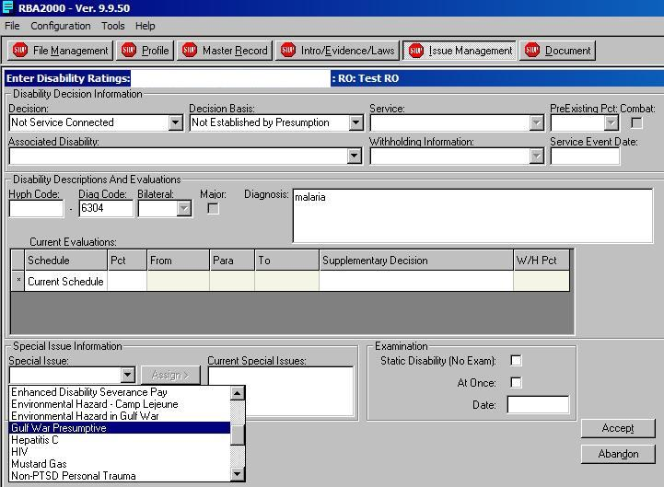

Once this entry has been selected, the Special Issue Basis field is enabled, and the field user must select the appropriate infectious disease from the drop-down list as shown in the screenshot below.

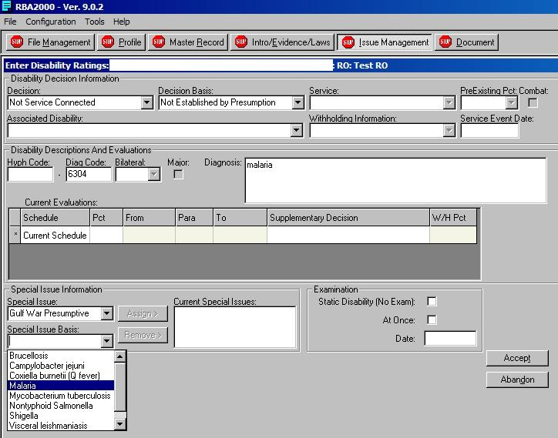

After completing all entries, click the Accept button to generate the text (an additional text selection box may appear depending upon the decision entered, but that is the same functionality as currently exists).

For all grants and denials of service connection (other than a denial as not established by presumption), the generated text should be correct and ready for the field user to customize for the specific claim that is being rated.

For a denial of service connection as not established by presumption, the generated analysis text must be deleted and replaced with the appropriate text from Enclosure 2. The “Issue” text and “Decision” text should be correct but must still be reviewed and edited, as necessary.

The Analysis text will vary based upon the reason(s) for the denial. There is a general paragraph that must be used for all issues and then one or more specific denial reason paragraphs must be added based upon the denial reason(s). Please see Enclosure 2 for the general paragraph and the specific denial reason paragraphs. Note that these paragraphs require the field user to enter information such as the disability name, date, etiology, etc.
Specific denial paragraphs are available for the following reasons:
- All Other Conditions – Not Within 1 Year
- Illness Not Chronic
- Less Than 10 Percent Disabling
- Malaria - Not Within Time Period
- No Diagnosis
- No Nexus
- No Qualifying Period Of Service
- Not SC
- Other Etiology
- Supervening Condition Or Event
- Willful Misconduct

Rating Decision Procedures – Service Connection for Cause of Death

When completing a cause of death rating claimed as due to infectious disease under 38 CFR § 3.317(c), the field user must select “Gulf War Presumptive” from the drop-down Special Issue Information List on the Enter Death Ratings screen as shown in the screenshot below.

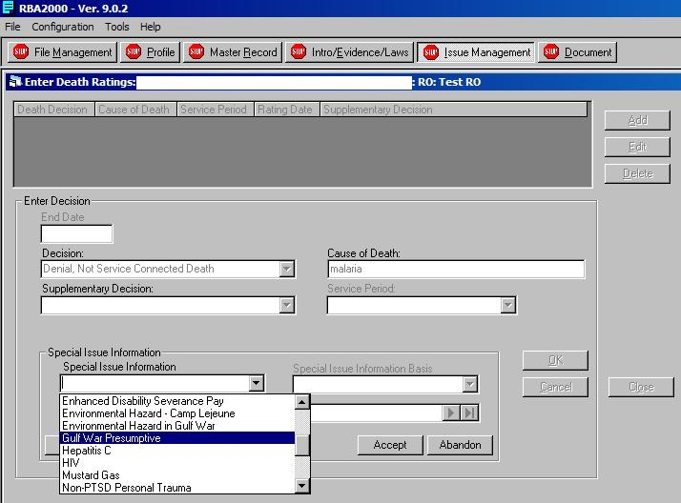

Once this entry has been selected, the Special Issue Information Basis field is enabled and the field user must select the appropriate infectious disease from the drop-down list as shown in the screenshot below.

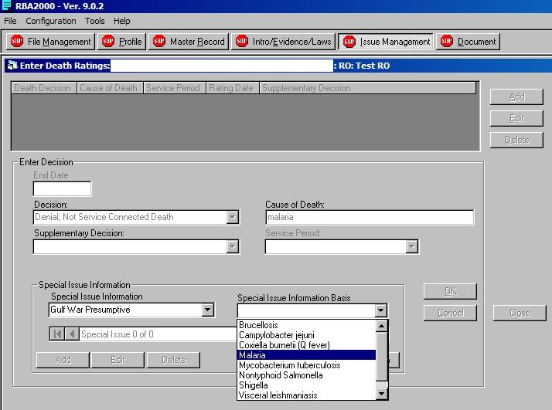

After completing all entries, click the Accept button and then the OK button to generate the text (an additional text selection box may appear depending upon the decision entered, but that is the same functionality as currently exists).

For all grants of service connection, the generated text should be correct and ready for the field user to customize for the specific claim that is being rated.

For a denial of service connection for the cause of death, the generated analysis text must be deleted and replaced with the appropriate text from Enclosure 2. The “Issue” text and “Decision” text should be correct but must still be reviewed and edited, as necessary.

The Analysis text will vary based upon the reason(s) for the denial. There is a general paragraph that must be used for all issues and then one or more specific denial paragraphs must be added based upon the denial reason(s). Please see Enclosure 2 for the general paragraph and the specific denial reason paragraphs. Note that these paragraphs will require the field user to enter information such as the disability name, date, etiology, etc

Specific denial paragraphs are available for the following reasons:
- No Diagnosis
- No Nexus
- Not SC

.

Enclosure 2 – Rating Decision Analysis Text

Rating Decision Text – Live Service Connection

General denial paragraph for all issues of denial of service connection as not established by presumption:

Under the authority granted by 38 U.S.C. §§ 1117 and 1118, VA has determined that presumption of service connection may be established for certain infectious diseases based on active military, naval, or air service in the Southwest Asia theater of operations during the Persian Gulf War or a period of active military, naval, or air service in Afghanistan on or after September 19, 2001. These diseases include Brucellosis, Campylobacter jejuni, Coxiella burnetii (Q fever), Nontyphoid Salmonella, Shigella, and West Nile virus, which must become manifest to a degree of ten percent or more within 1 year from the date of separation from a qualifying period of service; Malaria, if the disease becomes manifest to a degree of ten percent or more within 1 year from the date of separation from a qualifying period of service or at a time when standard or accepted treatises indicate that the incubation period commenced during a qualifying period of service; and Visceral leishmaniasis and Mycobacterium tuberculosis, for which there is no time limit to become manifest to a degree of ten percent or more.

Text for specific denial reasons:

All Other Conditions – Not Within 1 Year
Service connection for {drop in claimed disability} is denied because there is affirmative evidence that the disease did not become manifest to a degree of ten percent or more within one year from the date of separation from a qualifying period of service.

Illness Not Chronic
The disability must have persisted for a period of at least six months. Presumptive service connection for {drop in claimed disability} is denied since this disability first manifested on {date} and lasted less than six months.

Less Than 10 Percent Disabling
Presumptive service connection for {drop in claimed disability} is denied because this disability has not become manifest to a degree of 10 percent or more disabling.

Malaria - Not Within Time Period
Service connection for malaria is denied because there is affirmative evidence that the disease did not become manifest to a degree of ten percent or more within one year from the date of separation from a qualifying period of service or at a time when standard or accepted treatises indicate that the incubation period commenced during a qualifying period of service.

No Diagnosis
Presumptive service connection for {drop in claimed disability} is denied because the evidence of record fails to establish a diagnosis for this disability.

No Nexus
The available scientific and medical evidence does not support the conclusion that {drop in claimed disability} is associated with the veteran’s active military, naval, or air service in the Southwest Asia theater of operations during the Persian Gulf War or a period of active military, naval, or air service on or after September 19, 2001, in Afghanistan.

No Qualifying Period Of Service
Presumptive service connection for {drop in claimed disability} is denied because the evidence of record reflects no qualifying period of service.

Not SC
Presumptive service connection for {drop in claimed disability} is denied since this disability was not incurred in or aggravated by active military, naval, or air service in the Southwest Asia theater of operations during the Persian Gulf War or on or after September 19, 2001, in Afghanistan.

Other Etiology
Service connection under this provision is precluded if there is affirmative evidence that the disability was unrelated to service in the Southwest Asia theater of operations during the Persian Gulf War or a period of active military, naval, or air service on or after September 19, 2001, in Afghanistan. Service connection for {drop in claimed disability} is denied because evidence establishes that this disability resulted from {enter etiology}.

Supervening Condition Or Event
Service connection is denied because there is affirmative evidence that {drop in claimed disability} was caused by a supervening condition or event that occurred between the veteran’s most recent departure from a qualifying period of service and the onset of the disease.

Willful Misconduct
Service connection is denied because there is affirmative evidence that {drop in claimed disability} is the result of the veteran’s own willful misconduct or the abuse of alcohol or drugs.
Rating Decision Text – Service Connection for Cause of Death

General denial paragraph for all issues of denial of service connection for the cause of death:

Under the authority granted by 38 U.S.C. §§ 1117 and 1118, VA has determined that presumption of service connection may be established for certain infectious diseases based on active military, naval, or air service in the Southwest Asia theater of operations during the Persian Gulf War or a period of active military, naval, or air service in Afghanistan on or after September 19, 2001. These diseases include Brucellosis, Campylobacter jejuni, Coxiella burnetii (Q fever), Nontyphoid Salmonella, Shigella, and West Nile virus, which must become manifest to a degree of ten percent or more within 1 year from the date of separation from a qualifying period of service; Malaria, if the disease becomes manifest to a degree of ten percent or more within 1 year from the date of separation from a qualifying period of service or at a time when standard or accepted treatises indicate that the incubation period commenced during a qualifying period of service; and Visceral leishmaniasis and Mycobacterium tuberculosis, for which there is no time limit to become manifest to a degree of ten percent or more.

Text for specific denial reasons:

No Diagnosis
Service connection for cause of death based on active military, naval, or air service in the Southwest Asia theater of operations during the Persian Gulf War, or a period of active military, naval, or air service on or after September 19, 2001, in Afghanistan, is denied. The evidence of record does not show diagnosis of a condition for which VA has found a positive association exists between service in Southwest Asia during certain periods and subsequent development of the condition.

No Nexus
Service connection for cause of death from {drop in Cause of Death} is denied because the available scientific and medical evidence does not support the conclusion that the cause of death is associated with active military, naval, or air service in the Southwest Asia theater of operations during the Persian Gulf War or a period of active military, naval, or air service on or after September 19, 2001, in Afghanistan.

Not SC
There is no basis in the available evidence of record to establish service connection for cause of death from {condition name}. This condition was not
incurred in or aggravated by active military, naval, or air service in the Southwest Asia theater of operations during the Persian Gulf War or on or after September 19, 2001, in Afghanistan.

